The Spahr Machine MFG. Company was located in Kearney, NE. The business provided various construction work and materials. In 1950, it was located at 820 E. R.R. St. Its advertisement can be seen on the Poole School curtain.
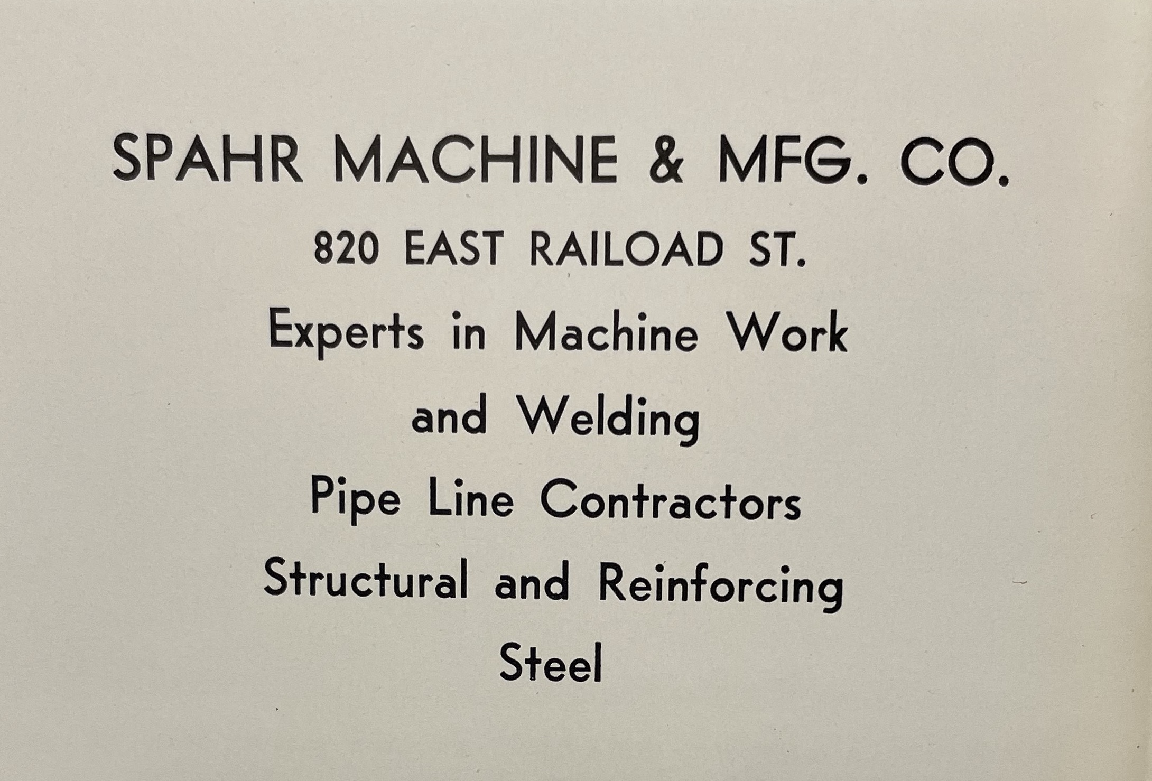
(Log: 1959)

