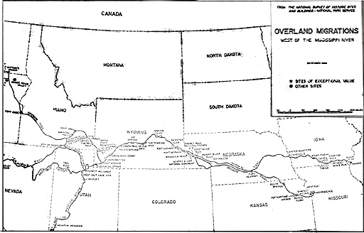
Primary Source Analysis: John D. Randall Journey
Geography
Using the map above, map outline John Randall’s journey west!

Outline the state of “Nebraska and Missouri”

Draw a square around Kansas City, Missouri.

Circle Fort Kearny.

Highlight the route between Fort Kearny and Kansas City, Missouri.

Continue west highlighting the fastest route to California.

Who was John D. Randall? Why do you think he kept a diary?

How did Randall describe the Platte River and surrounding Prairie?

Where is Fort Kearny located according to Randall?

How many soldiers were stationed at Fort Kearny according to Randall?

Where did Randall and his family settle finally settle after traveling west?

Why was Fort Kearny an important factor in westward expansion?

