The Ravenna Creamery was located in Ravenna, NE. According to the Kearney Hub, (11/27/1996) a Mr. Wilson was the manager of the business at one point and a Bethyne Hanna was a secretary. In an article titled, “85 Years Ago”, in 1926 there was a contest held by the creamery where one had to write an essay and answer the question, “why I should drink at least a quart of pasteurized milk a day?” (Hub: 4/15/2011). The Ravenna Creamery advertisement can be found in the World Theatre curtain.
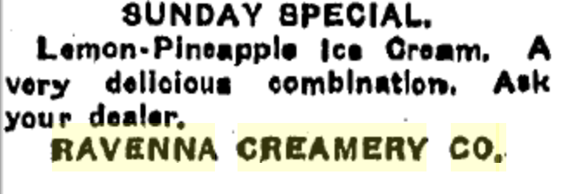
(Hub: 7/11/1930)
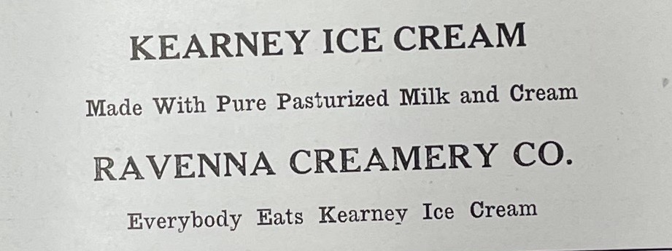
(Echo: March 1919)

