The Wilson Freight Line was owned by Glen Wilson in the early 20th century. According to the Kearney Hub (4/29/1939) the business closed in the 1930s. Its advertisement is located on the Elm Creek curtain.
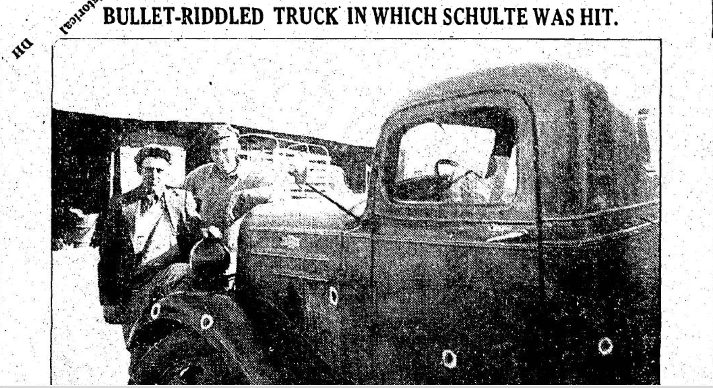
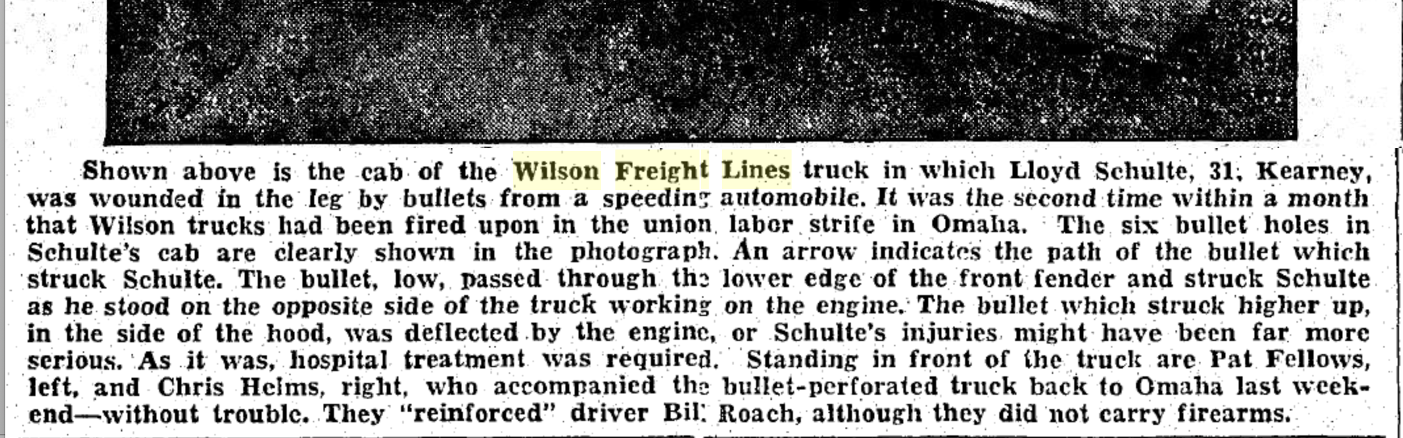
(Hub: 11/14/1938)

