The City National Bank was a local bank in Kearney, NE. Its advertisement is located on the Kearney Opera House Curtain. If anyone has additional information about the business, please contact the BCHS. Thank you!
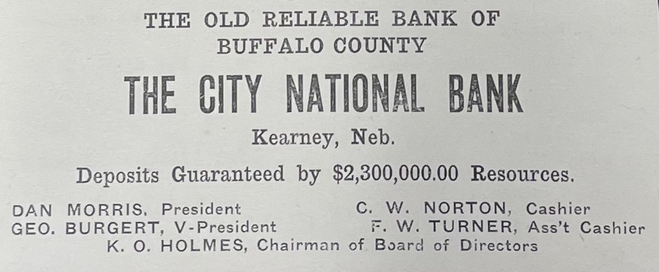
(Echo: January 1918)
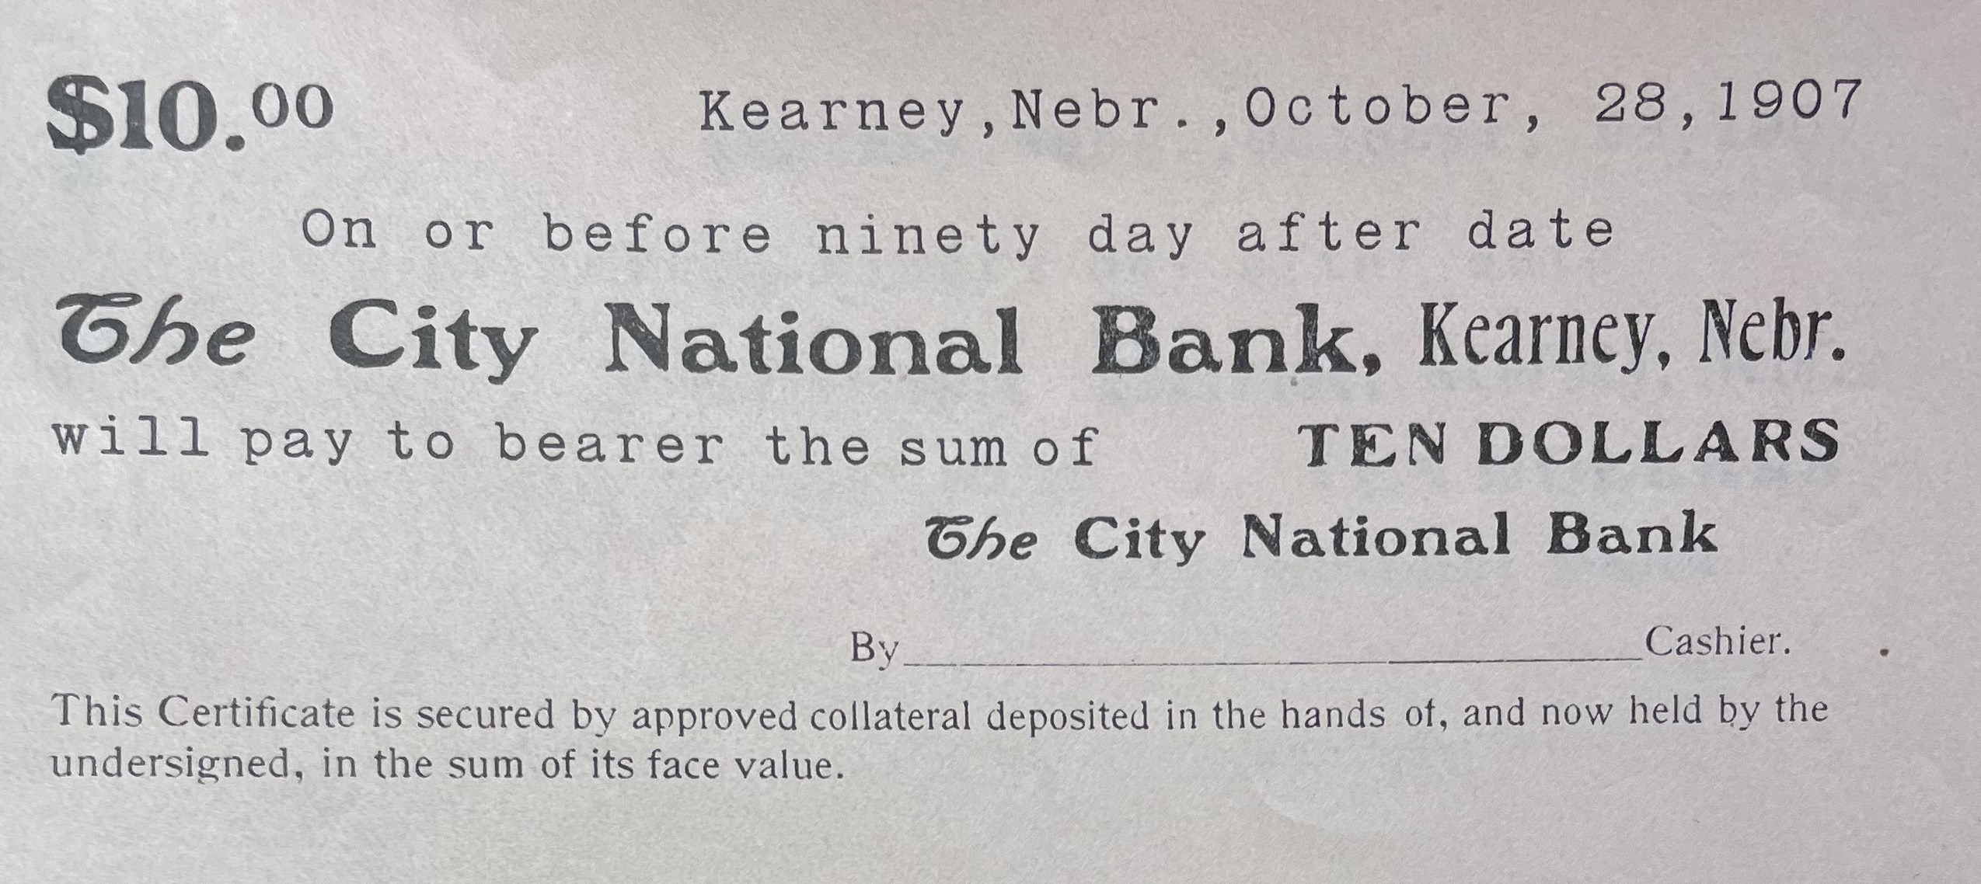
Bank Note from the BCHS archives dated 10-28-1907.
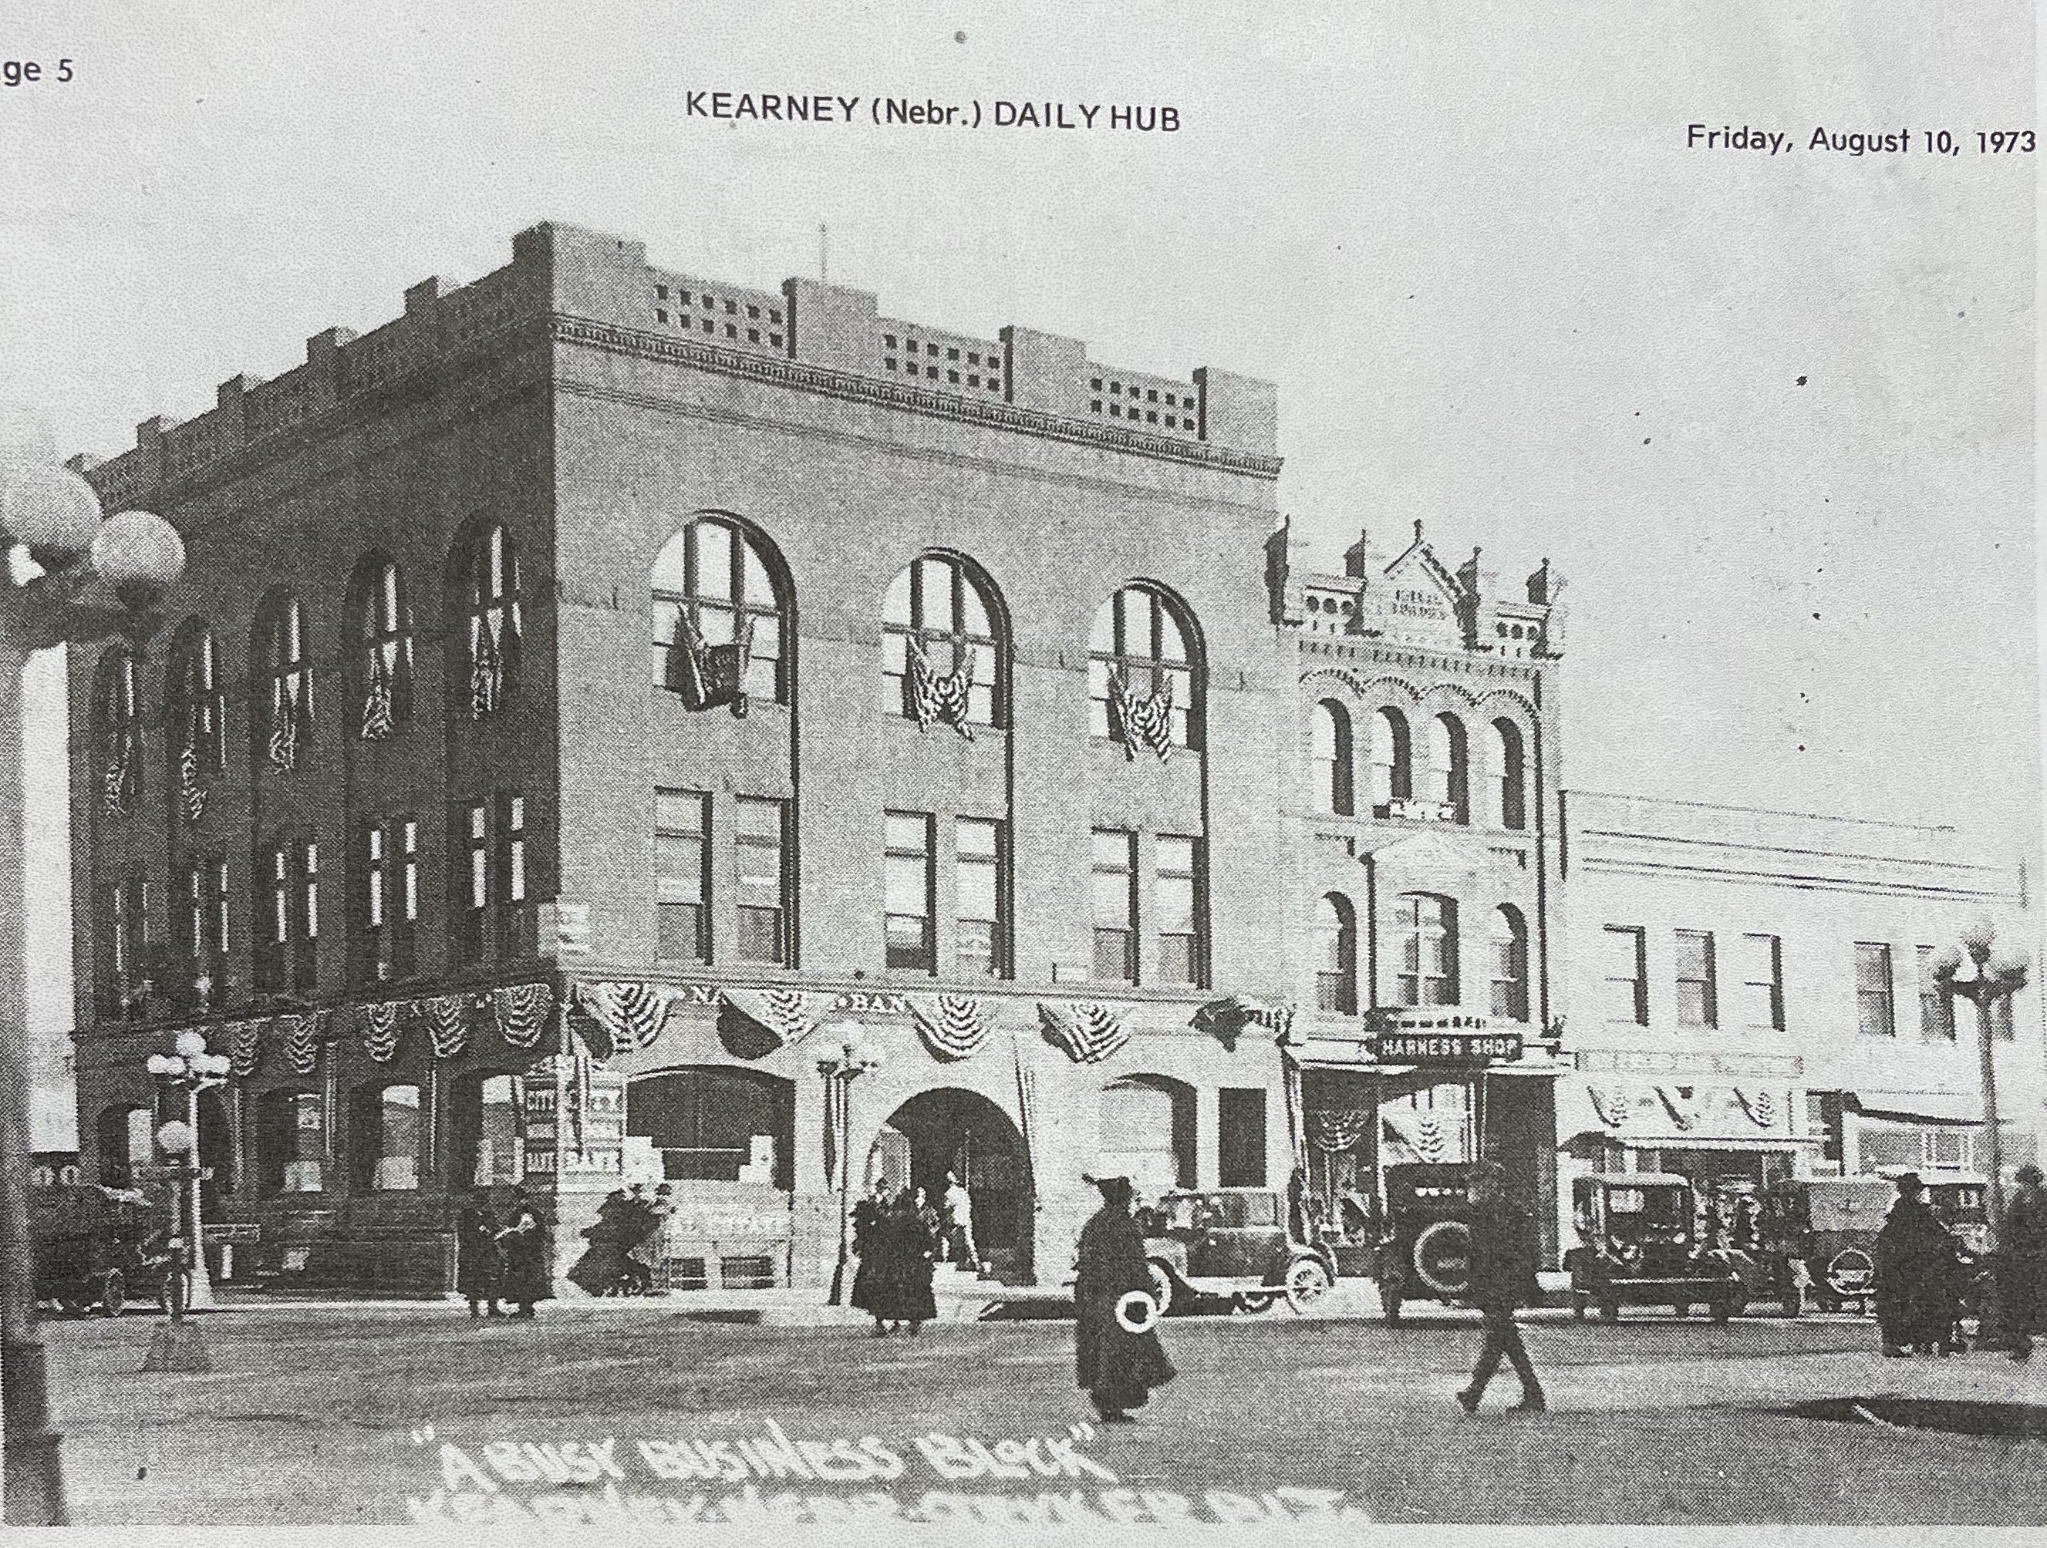(Kearney Hub)

