Milady’s Shop was located in Kearney, NE. It was a retail store that sold primarily undergarments. Milady’s was located at 2205 Central Avenue. According to the Kearney Hub (8/12/1946) one of the owner’s was Mrs. F. L. Empey. The advertisment can be seen on the World Theatre curtain.
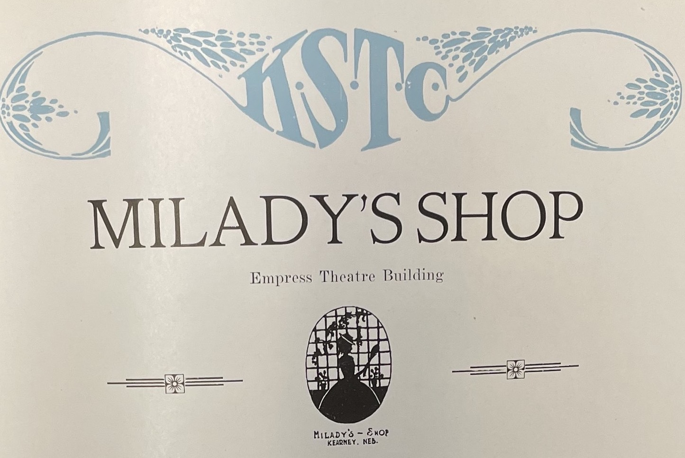
(Blue and Gold)
