The Tollefsen Elliot Lumber Company was located in Kearney, NE and was a local truck company that began in 1906. The business was owned by Joe B. Elliot Sr. According to the Kearney Hub (6-7-1948) it was located at 2000 1st Avenue. Its advertisement can be seen on the Poole School curtain.
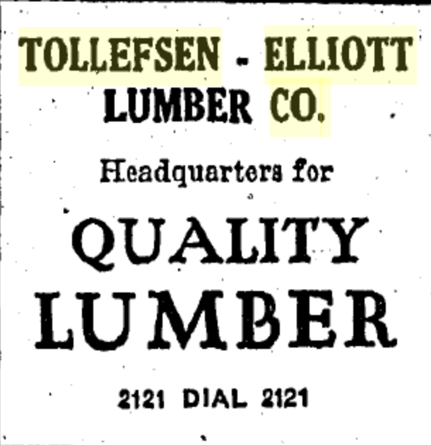
(Hub: 6-18-30)
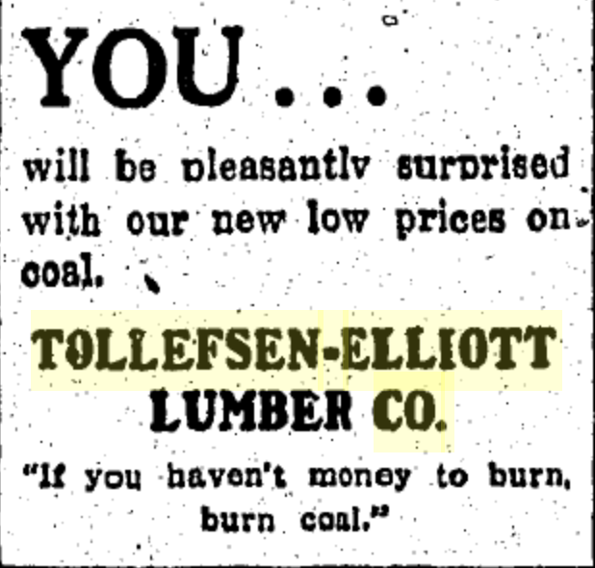
(Hub: 12-11-1931)

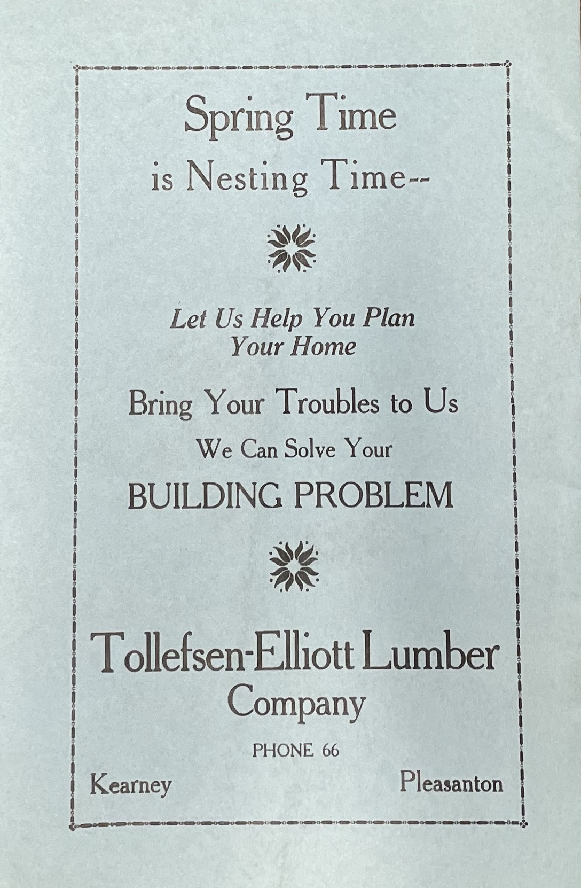
(Bearcat Review: 1924)

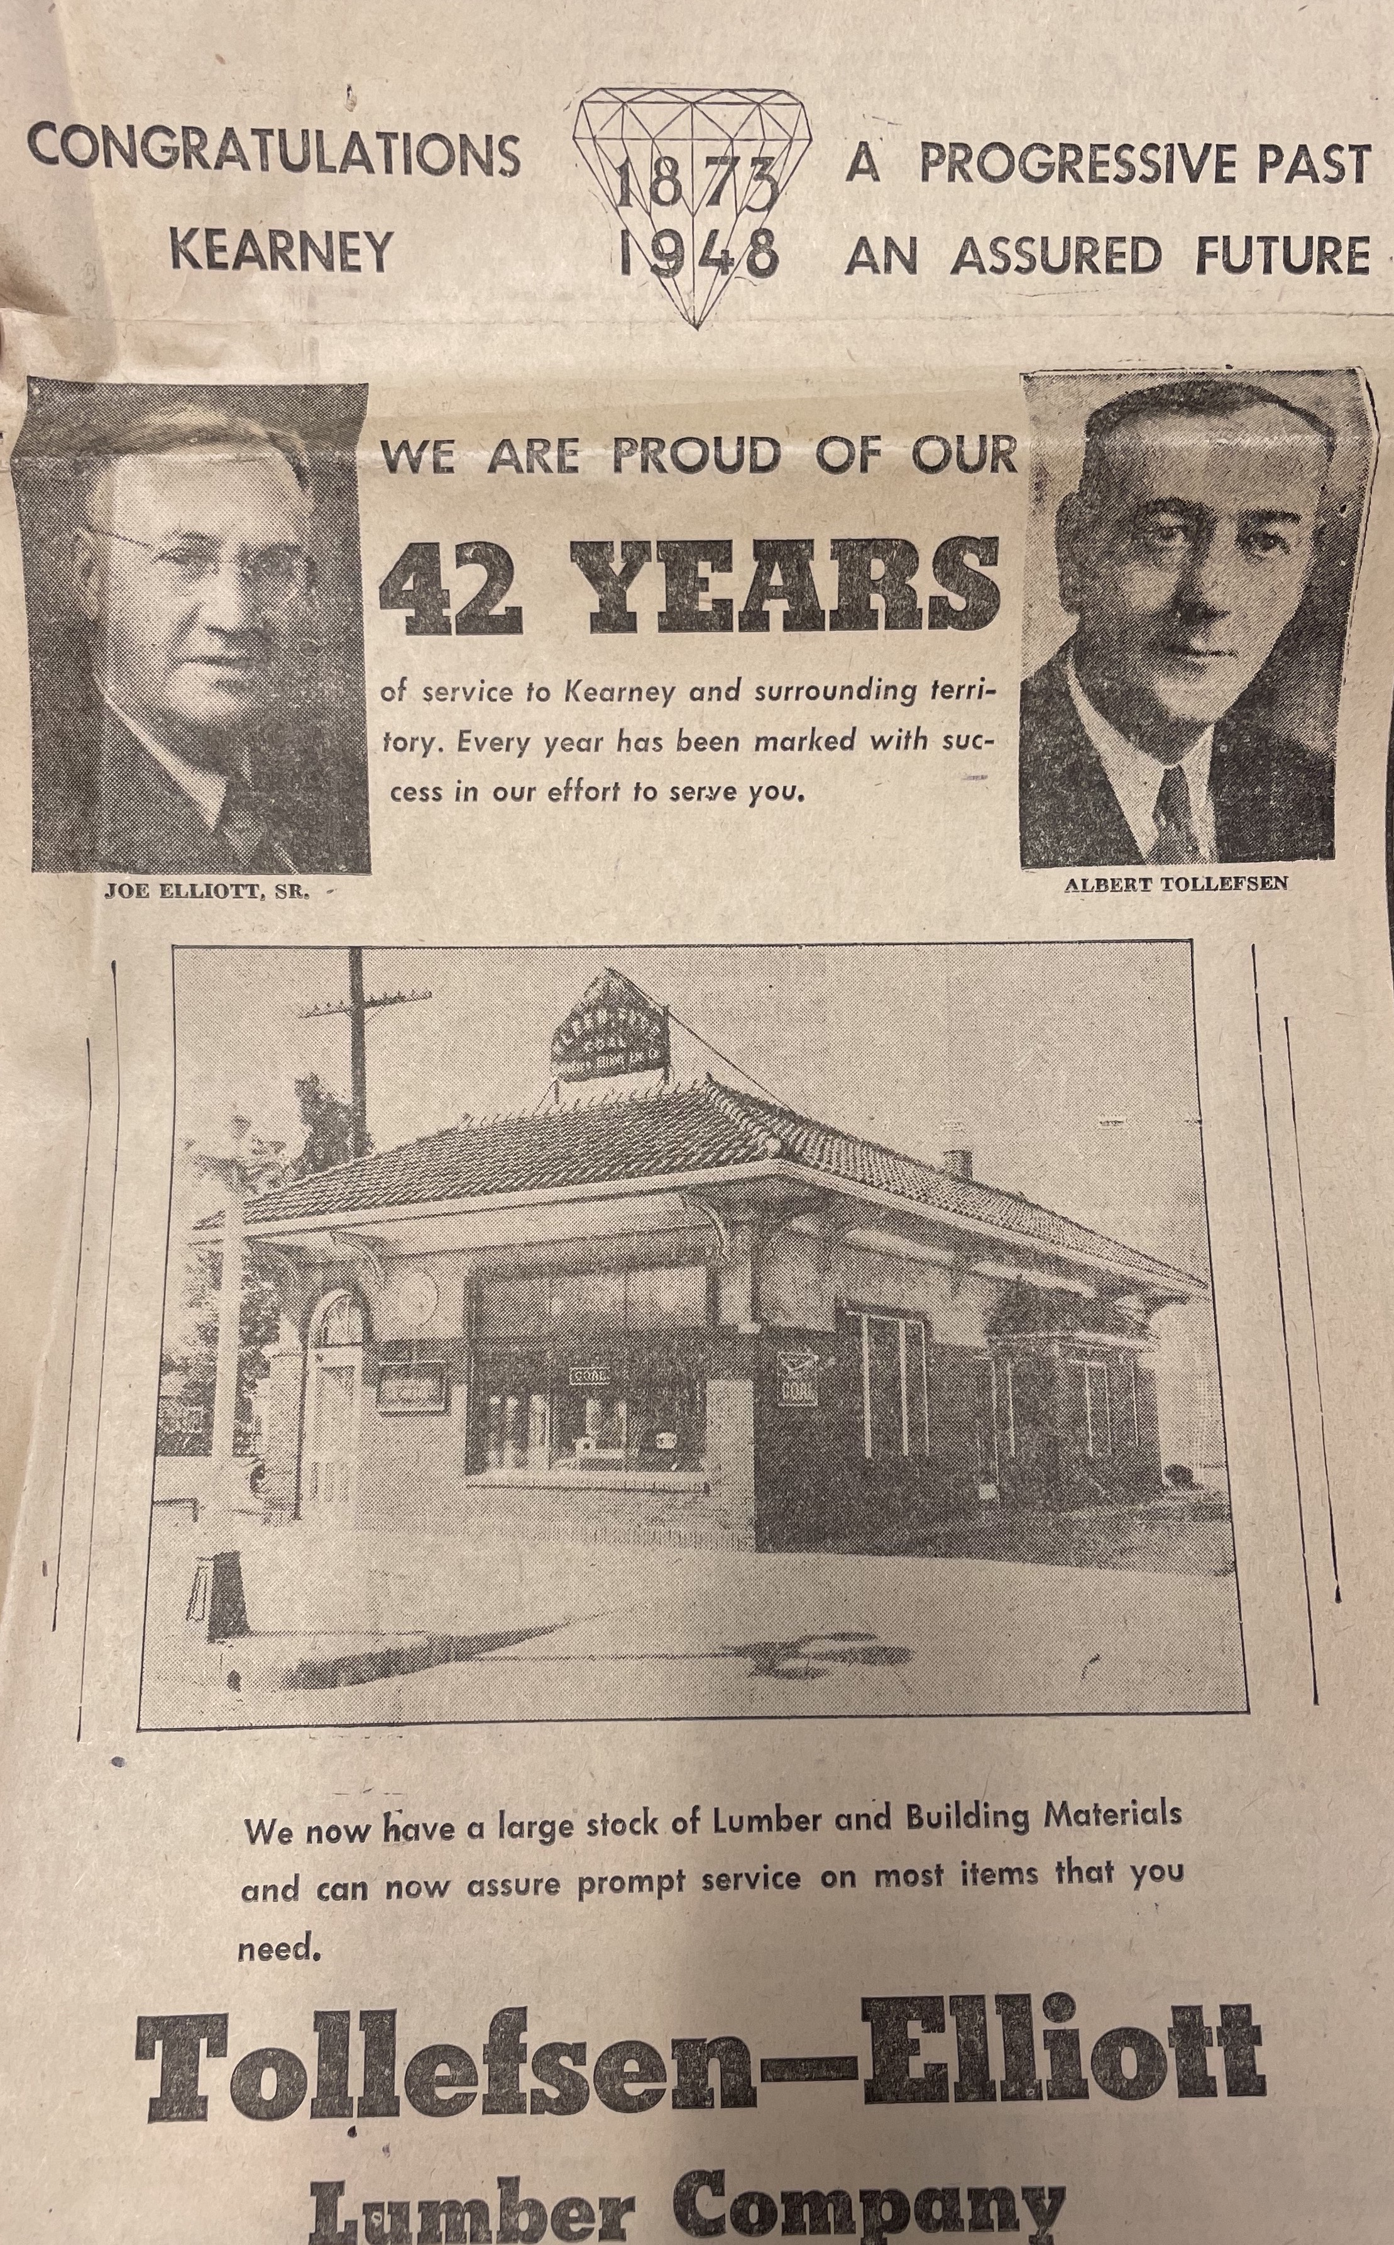
(Hub: 6-7-1948)

