Ira C. Anderson’s business was located in Kearney, NE. Anderson was the director of the funeral home for 26 years while also serving as the Director of the Chamber of Commerce and the Funeral Directors Association. According to the Kearney Hub, (May 9, 1998) The Anderson Funeral Home began in 1920 and was located on 22nd Avenue A. In 1924 the location moved to 2421 Avenue A. Ira passed away in 1946 and the business was taken over by Robert Johnson. The home thus was called Anderson-Johnson Funeral Home. When Jack M. Horner became an owner the name changed to Anderson-Johnson-Horner. Ron Lieske joined in 1971 and the name changed yet again to Horner-Leiske. Jack Horner II took over in 1985, making the name Horner-Leiske-Horner. Finally, Mark McBride headed the business in 1996, making it Horner-Lieske-McBride and Kuhl. The business’ advertisements appear on the Kearney Opera House, World Theatre and the Elm Creek curtains.
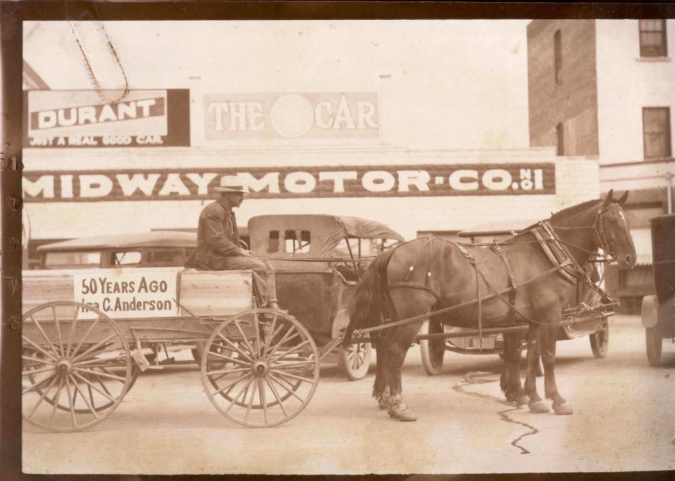
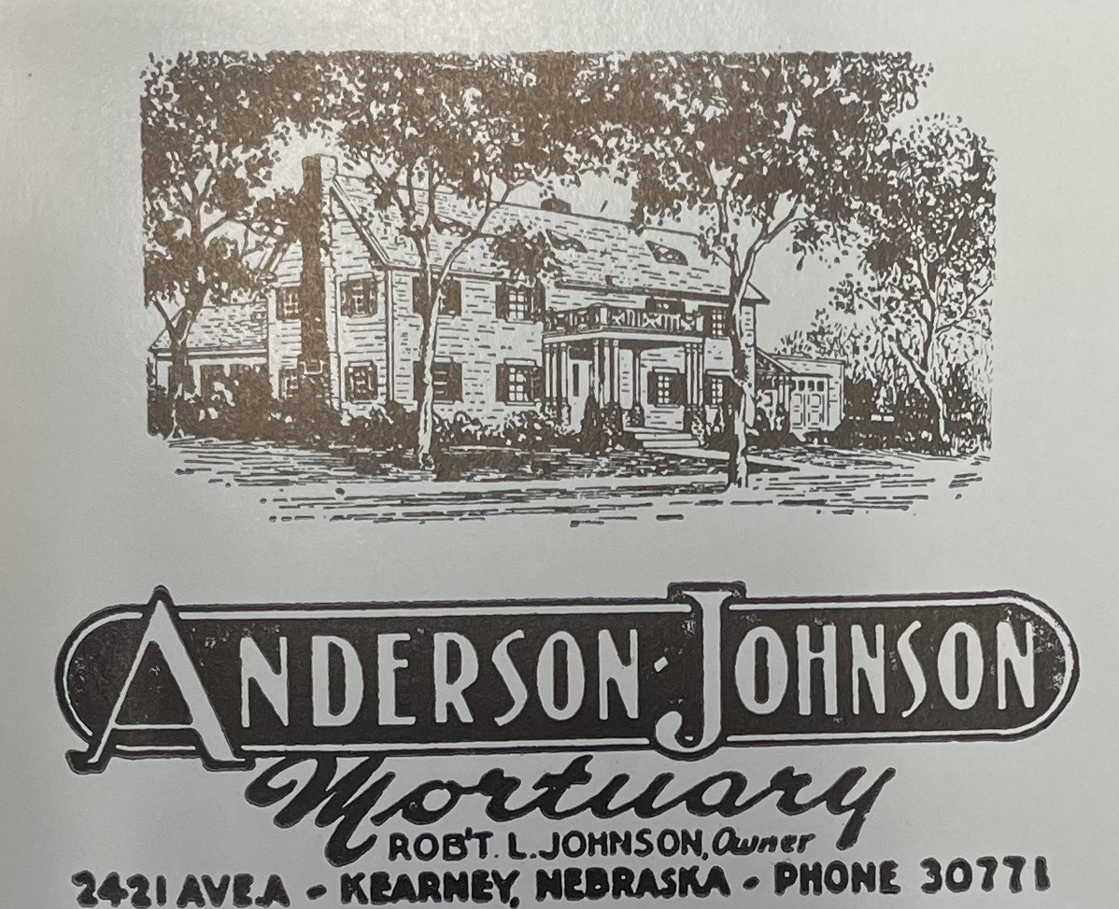 (1940s advertisement)

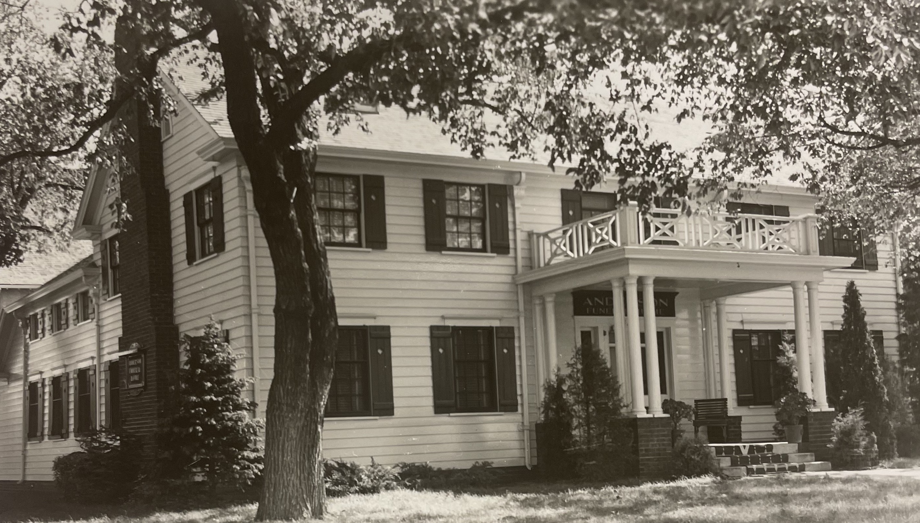 (1940s)
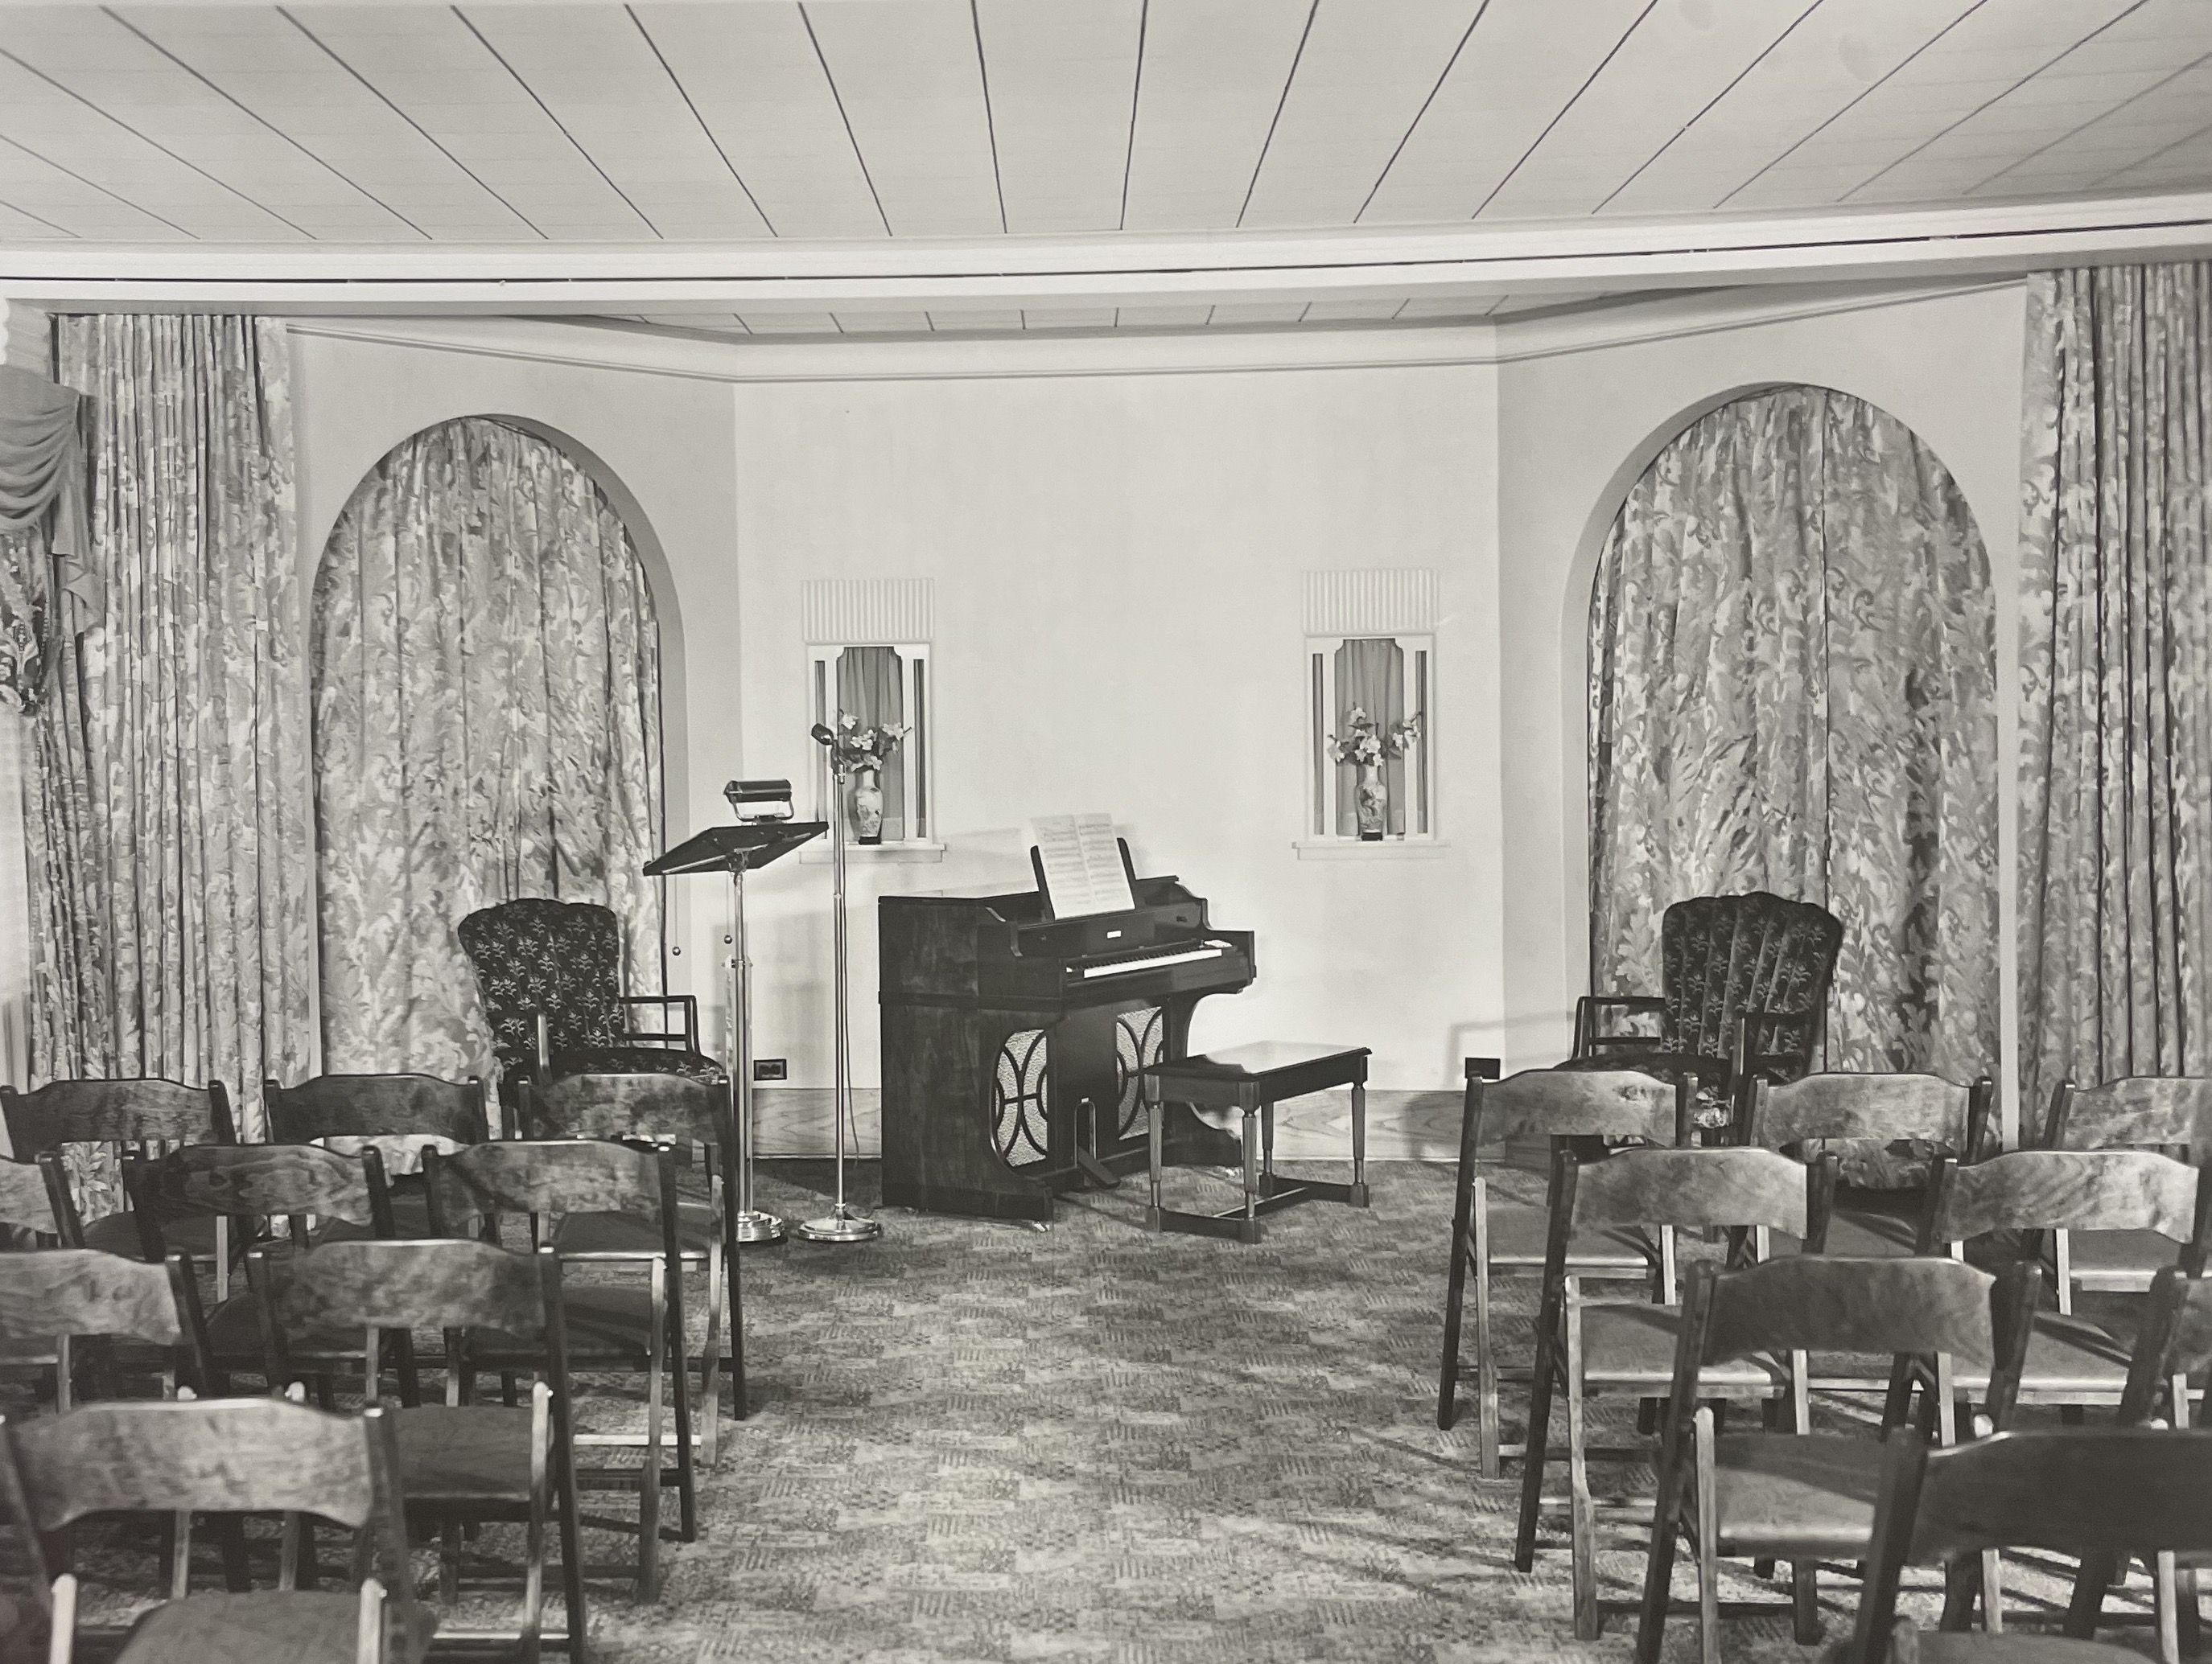
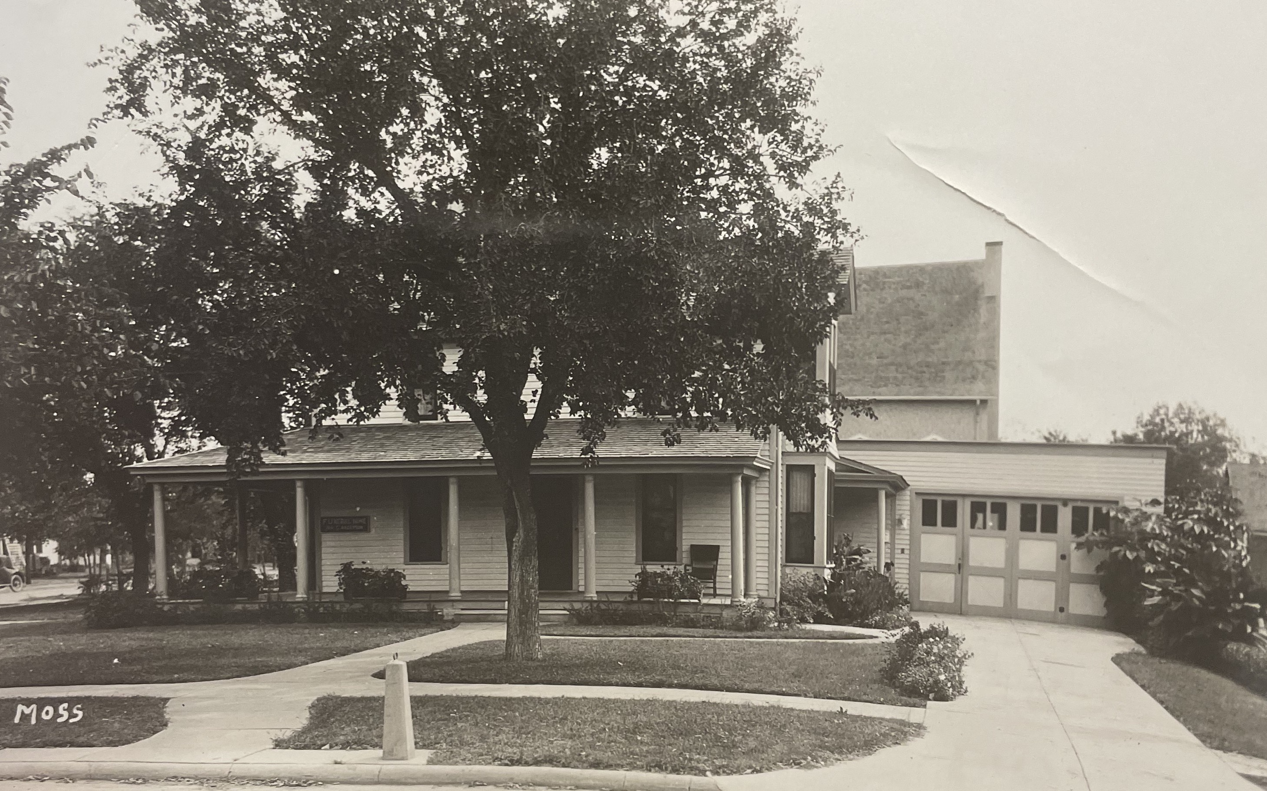 (1924)

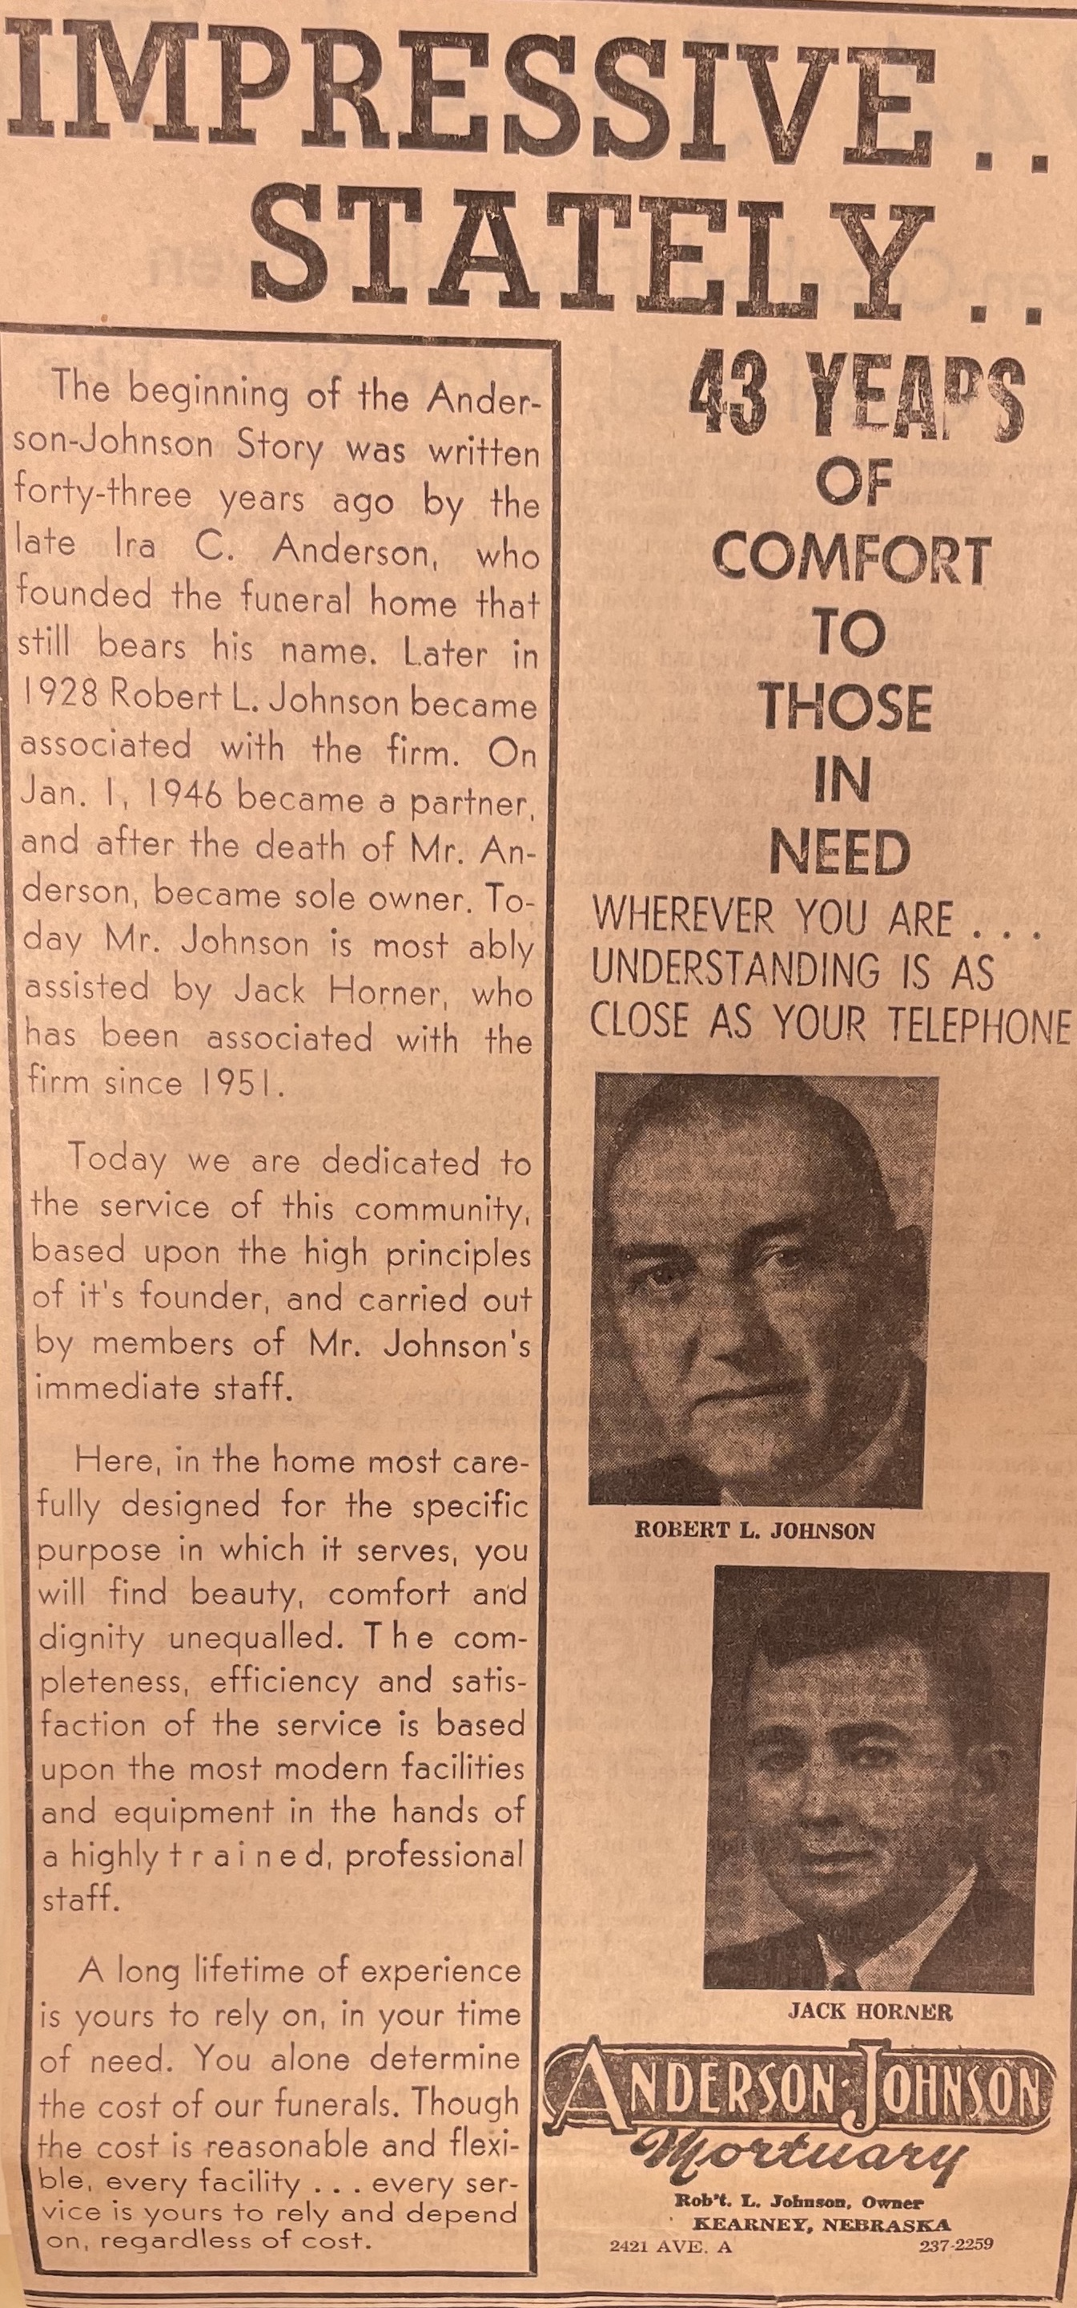
(Hub: 1963)

