Kearney Floral and Nursery Company is a staple of the Kearney community. Providing locals with flowers and vegetables, there is no wonder there is a plethora of advertisements and photographs that can be found on this business. In 1907 the owner was George Downing. In 1912 it was sold to William and Frank Davidson. 1915 brought ownership to Emil Charleson and by 1924 the floral business was owned by O.L. Erikson. His son, Jack, became a junior partner in 1951, and then came to own it when O.L. passed away in 1969. Located at 210 W 21st St. Kearney Floral is now Divas at Kearney Floral Co. and is owned by Stacy Schulte, Chelsie Bebensee, and Megan Axmann. Prior to these women the most recent owners were Todd and Lois Thalken (Hub: 12/26/1997). It can be seen on the World Theatre and Elm Creek curtains.
.
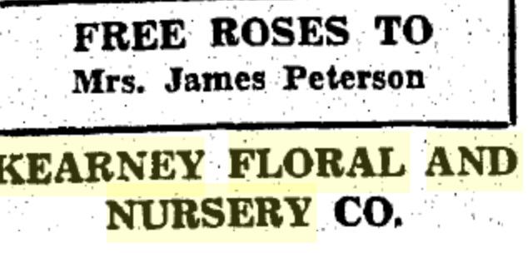
(Hub: 12-31-1936)
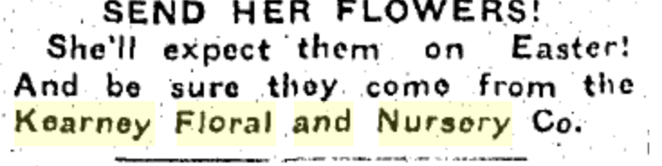
(Hub: 1936)

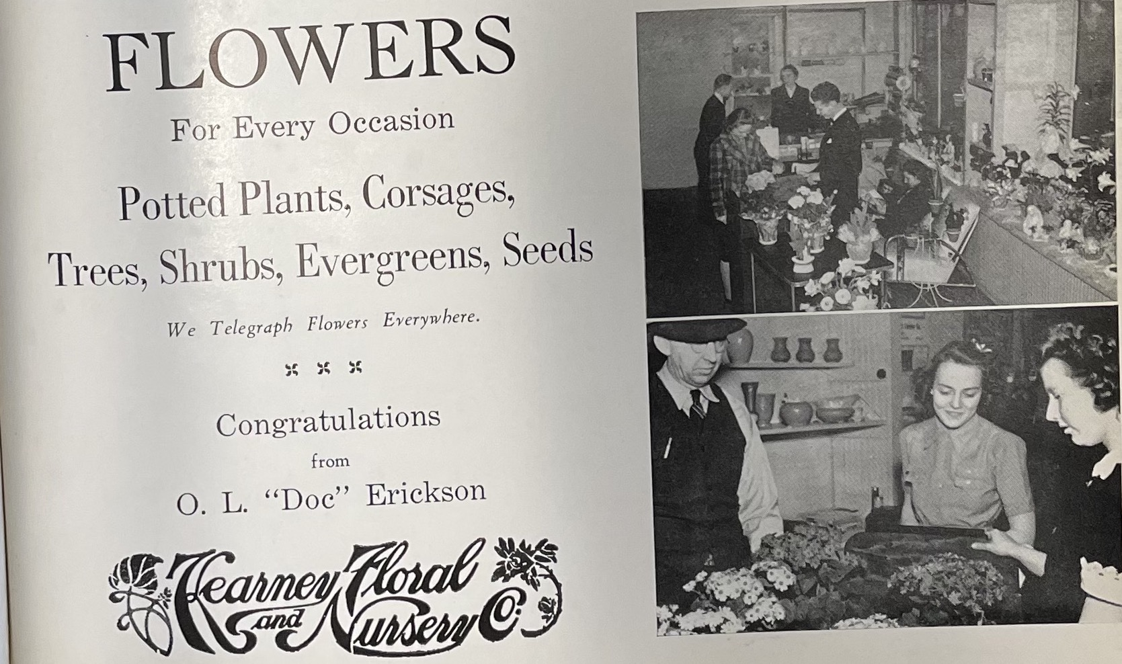
(Log, 1943)
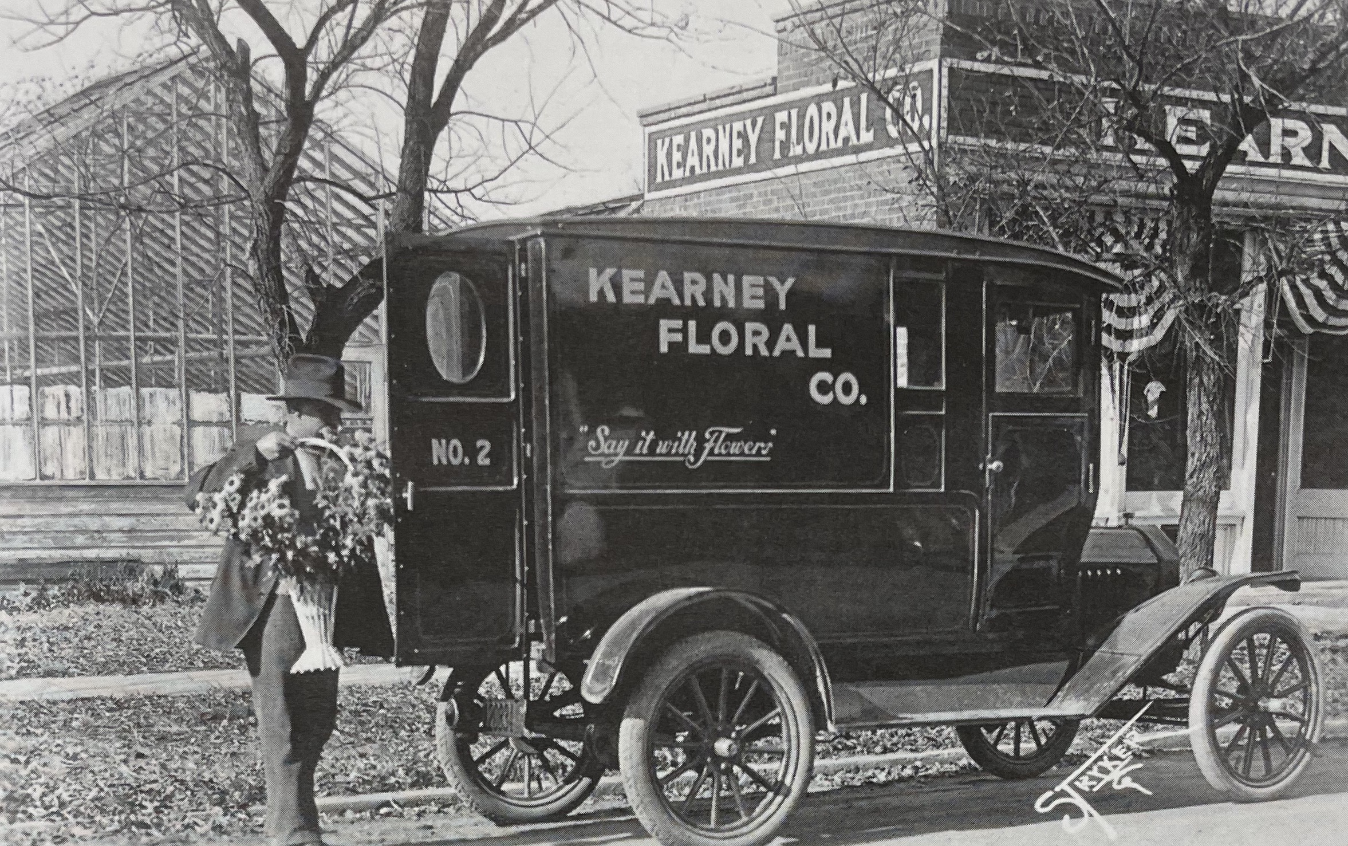
(Kearney by Mark Ellis and Heather Stauffer)
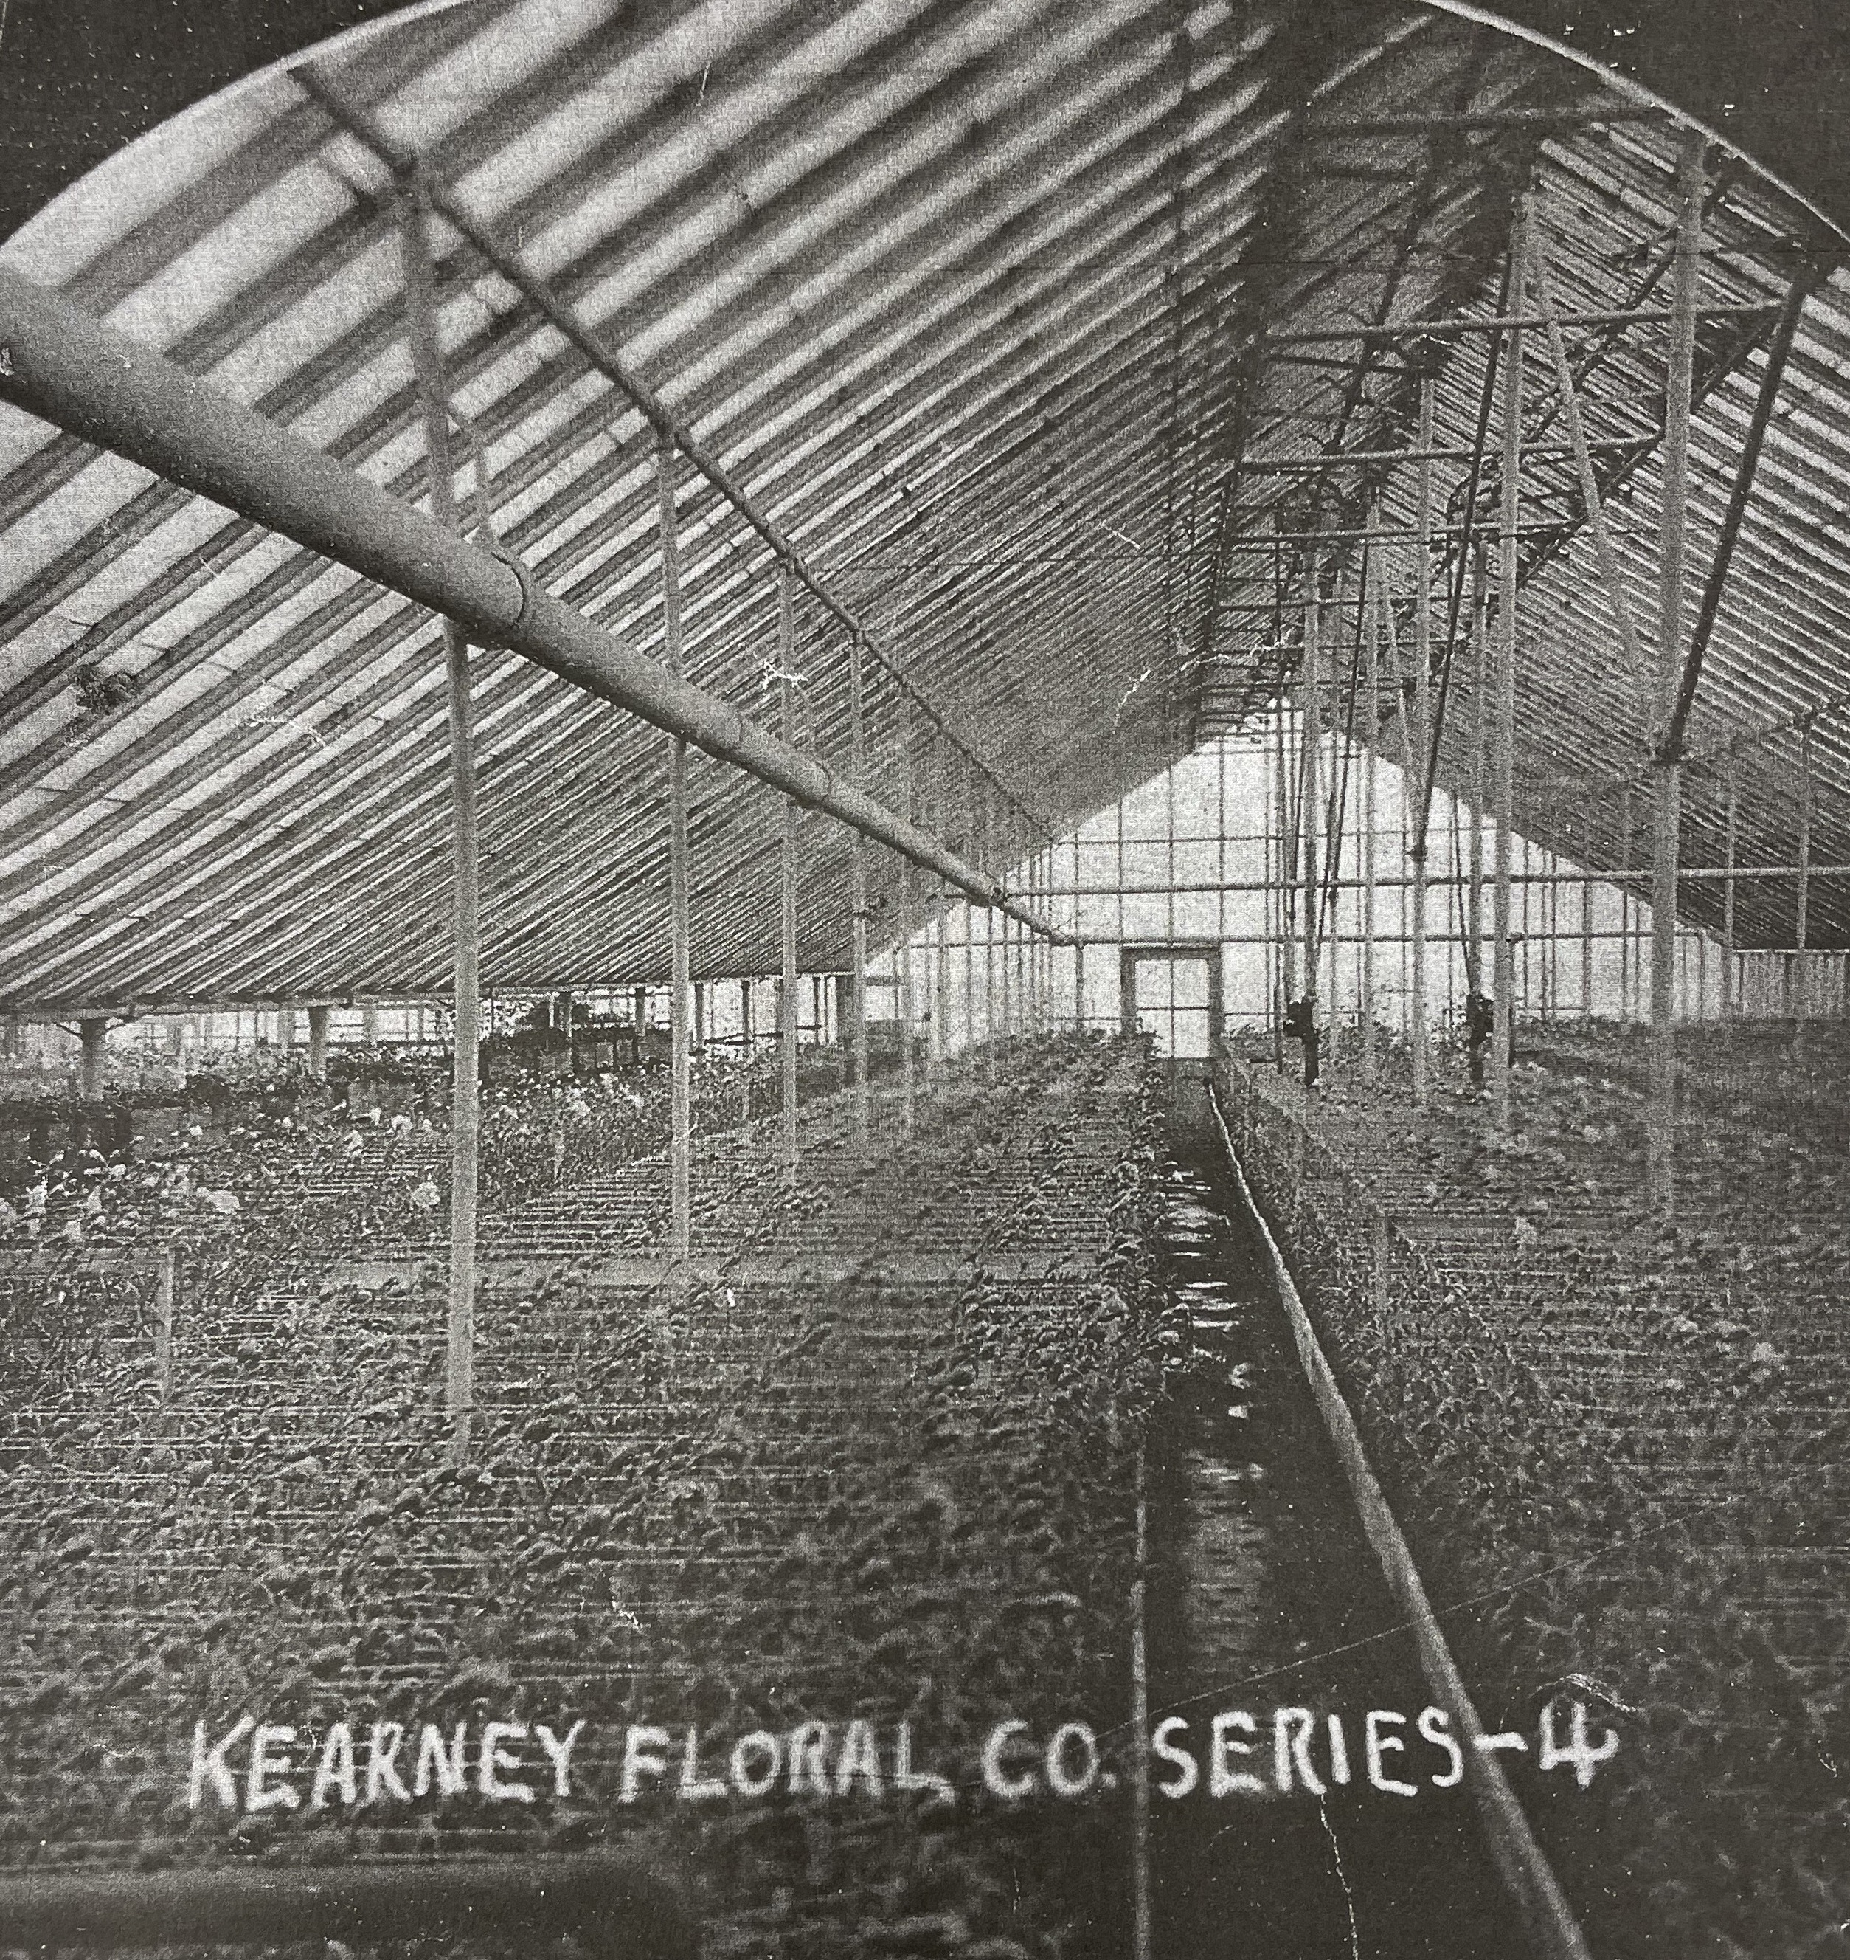
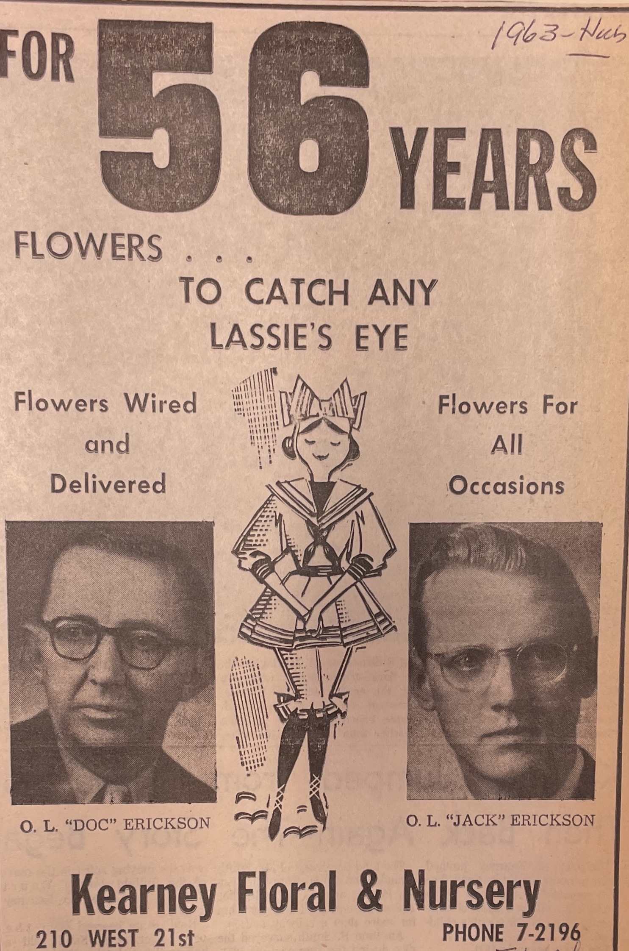
(Hub: 1963)

