Stan F. Roy Hatchery was from Ravenna, NE and owned a store called Stan F. Roy Hatchery and Feeders Supply Store. According to the Kearney Hub (10-17-1978) Roy was born in Loup City in 1908. He went to Kearney State College and then went into business with his son. Roy passed away in 1978. His advertisement can be seen on the Poole School curtain.

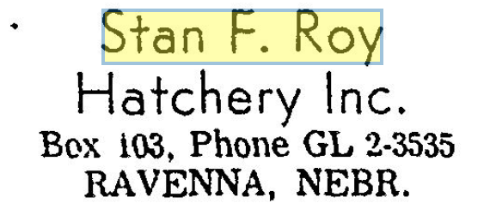
(Hub)

