The Gaston Music Company could fill all music needs! It was in Kearney, NE and was located at 2220 Central Avenue. There were always advertisements for students to buy instruments, radios and records. Its advertisement is located on the Kearney Opera House curtain.
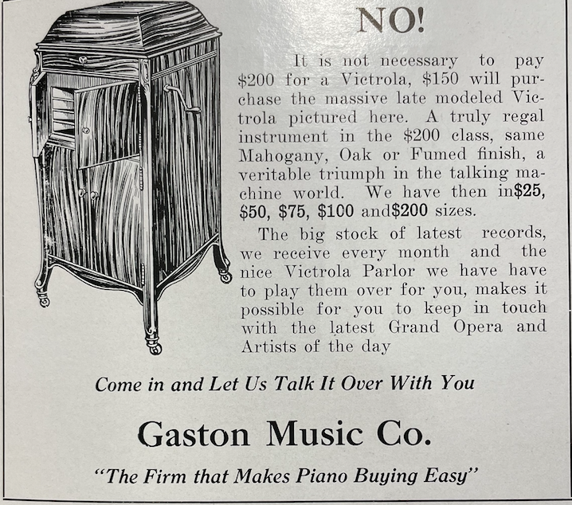
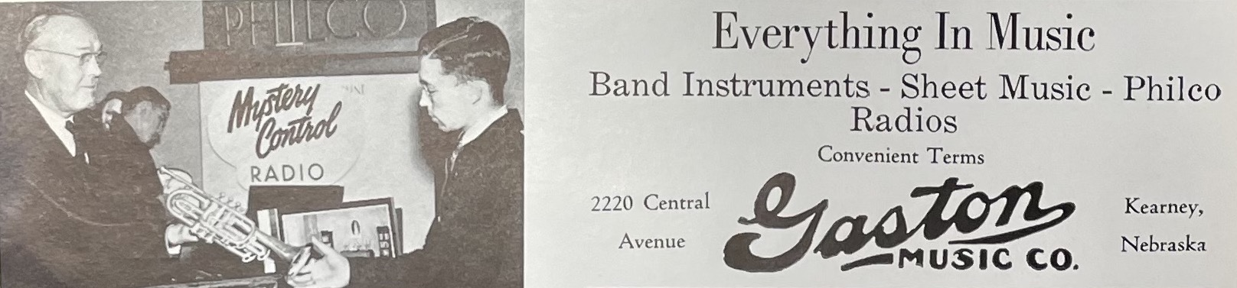 (Log 1939)
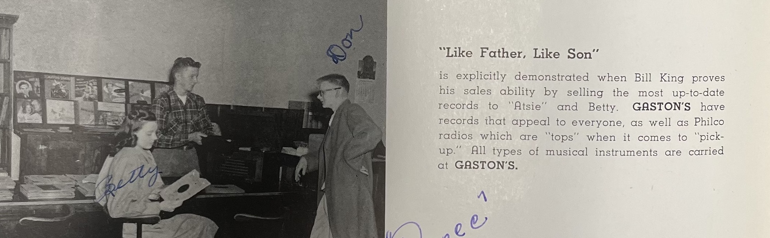 (Log 1947)

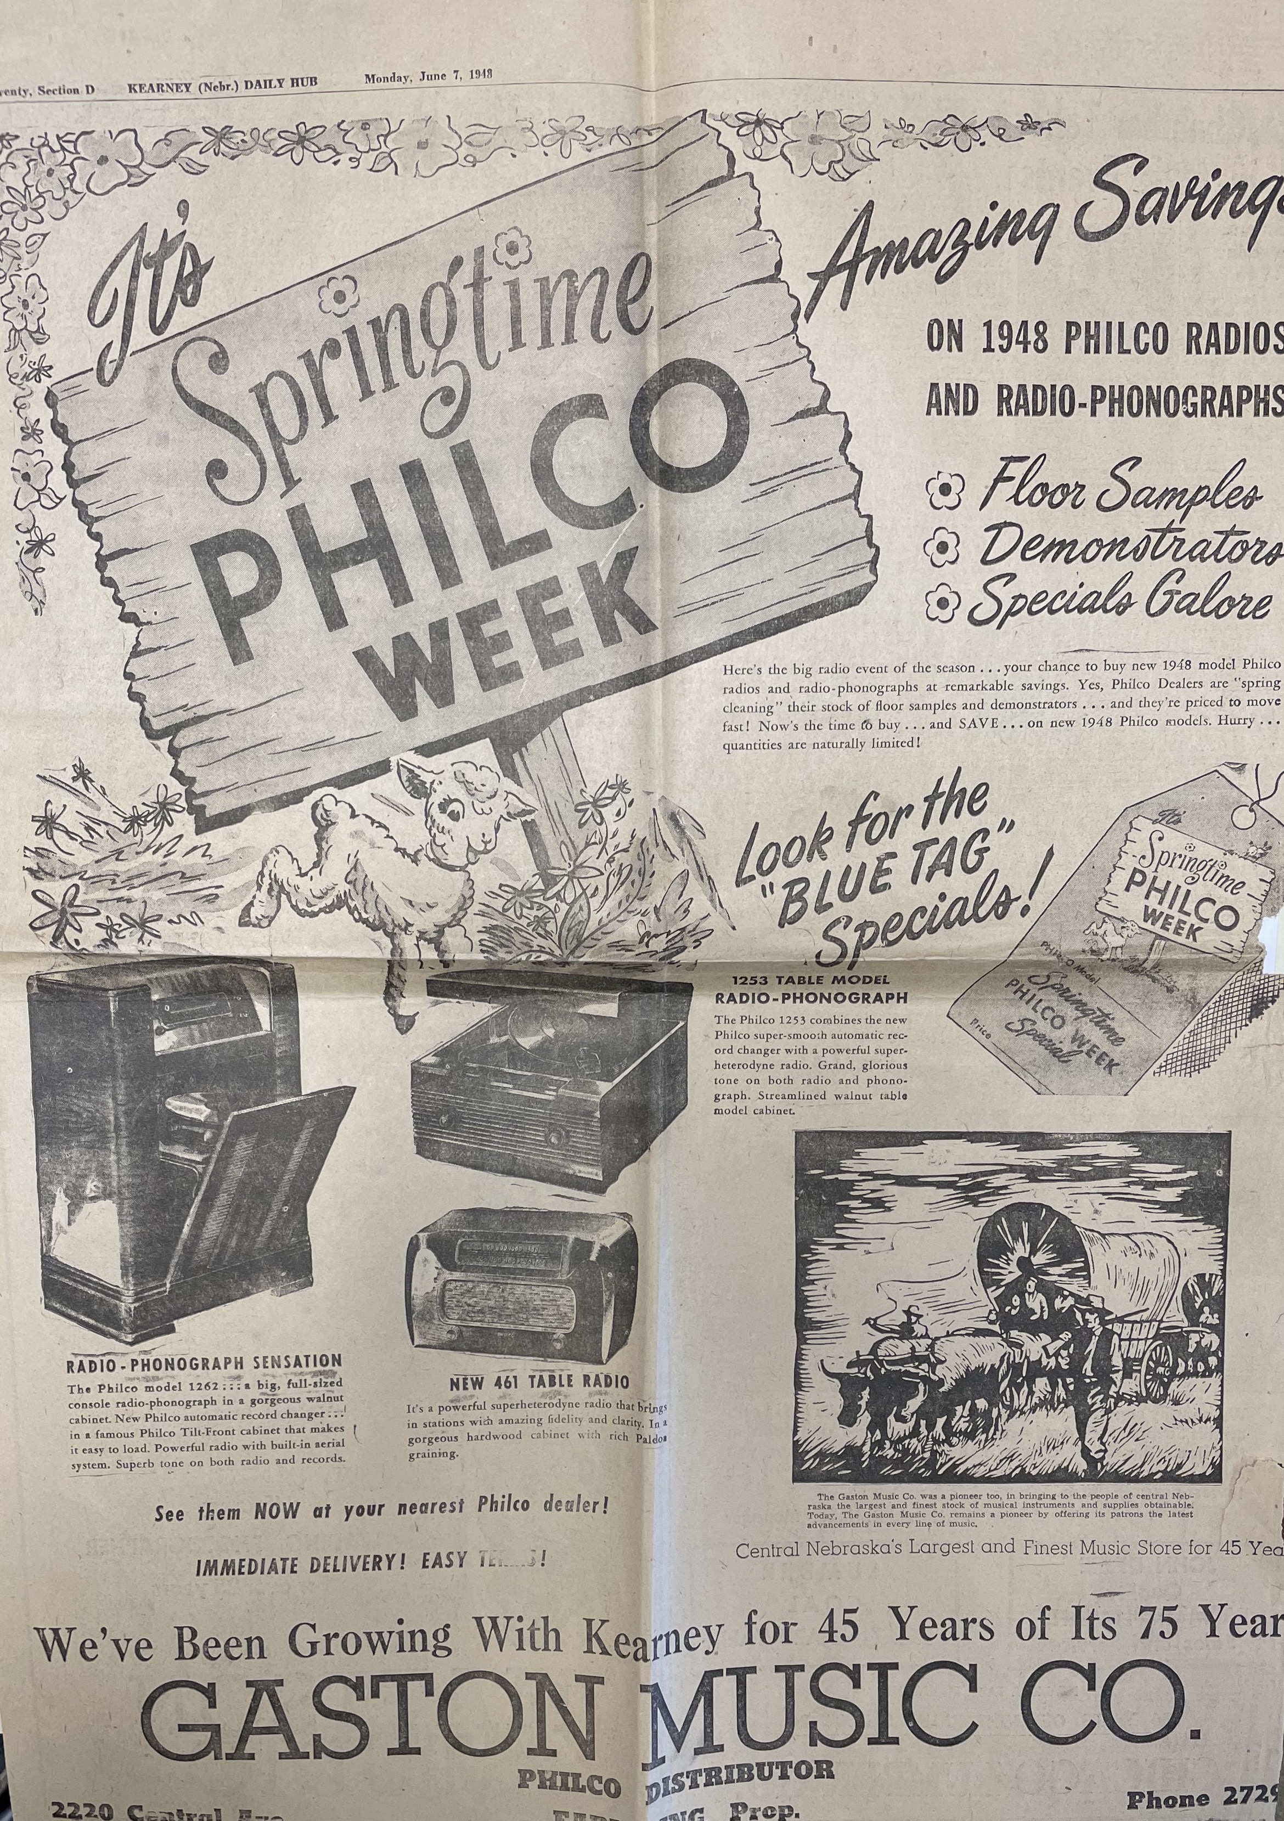 (Kearney Hub: 6-7-1948)
