The Kizzier Chevrolet Company was located in Kearney, NE. It was located along W. Highway 30. Its advertisement can be seen on the Kearney Area curtain.
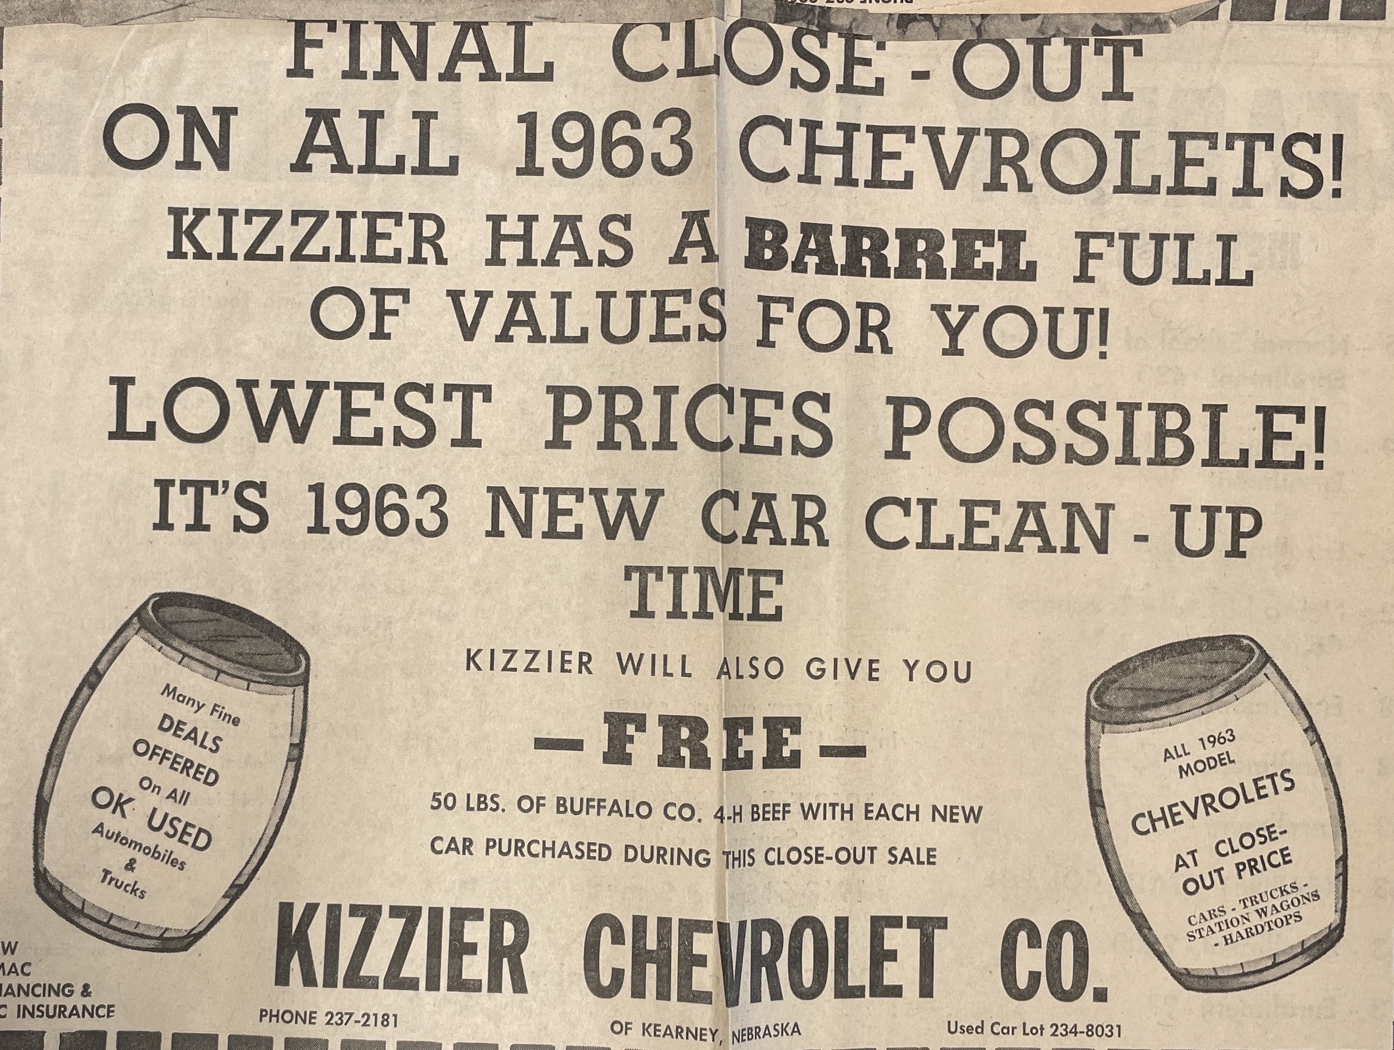
(Hub: 9/17/1963)

