The Worthing Drug Store was originally located in Elm Creek, NE. According to the Kearney Hub (2/25/1933), the store was created by H.T. Worthing and Dr. Boardman. It was even the location of the first library within the town. When the store was moved to Overton, NE, Ben A. Armitage took over the Elm Creek institution. The business can be seen located on the Elm Creek Curtain.
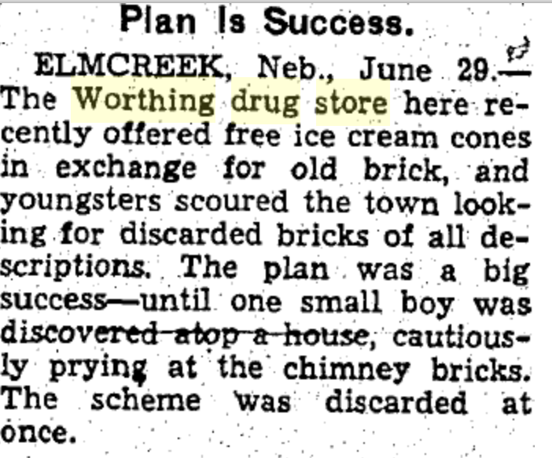
(Hub: 6/30/1937)

