The Lantz Drug Store was located in Kearney and was originally owned by Francis M. Lantz who was the druggist (or pharmacist) for the business. The Kearney Hub (12/26/1979) he was born on Jan. 11th, 1917. He graduated Kearney High School in 1934 and Creighton University in 1938. His brother, Ford (Alford) was his partner until 1946. According to the Fremont Tribune, (5/16/1961) Lantz owned and operated the store from 1918 to 1948. Its advertisement can be seen on the World Theatre curtain.
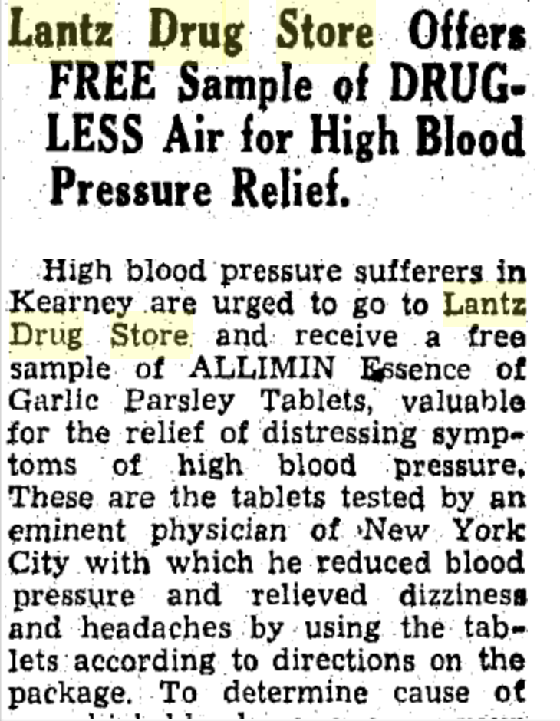
(Hub: 6/29/1938)
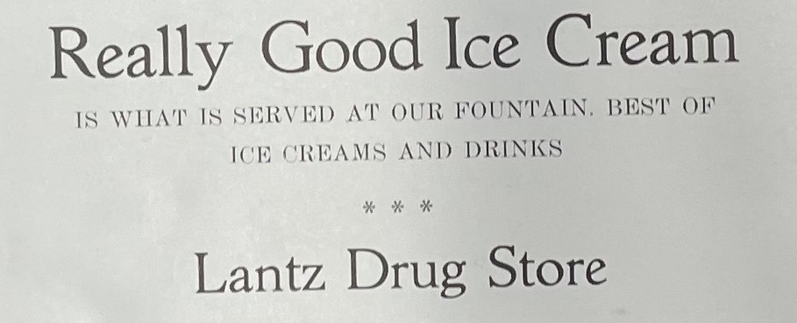
(Log: 1924)
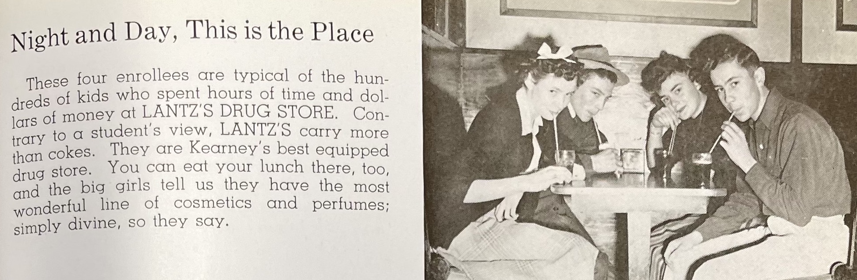
(Log: 1943)
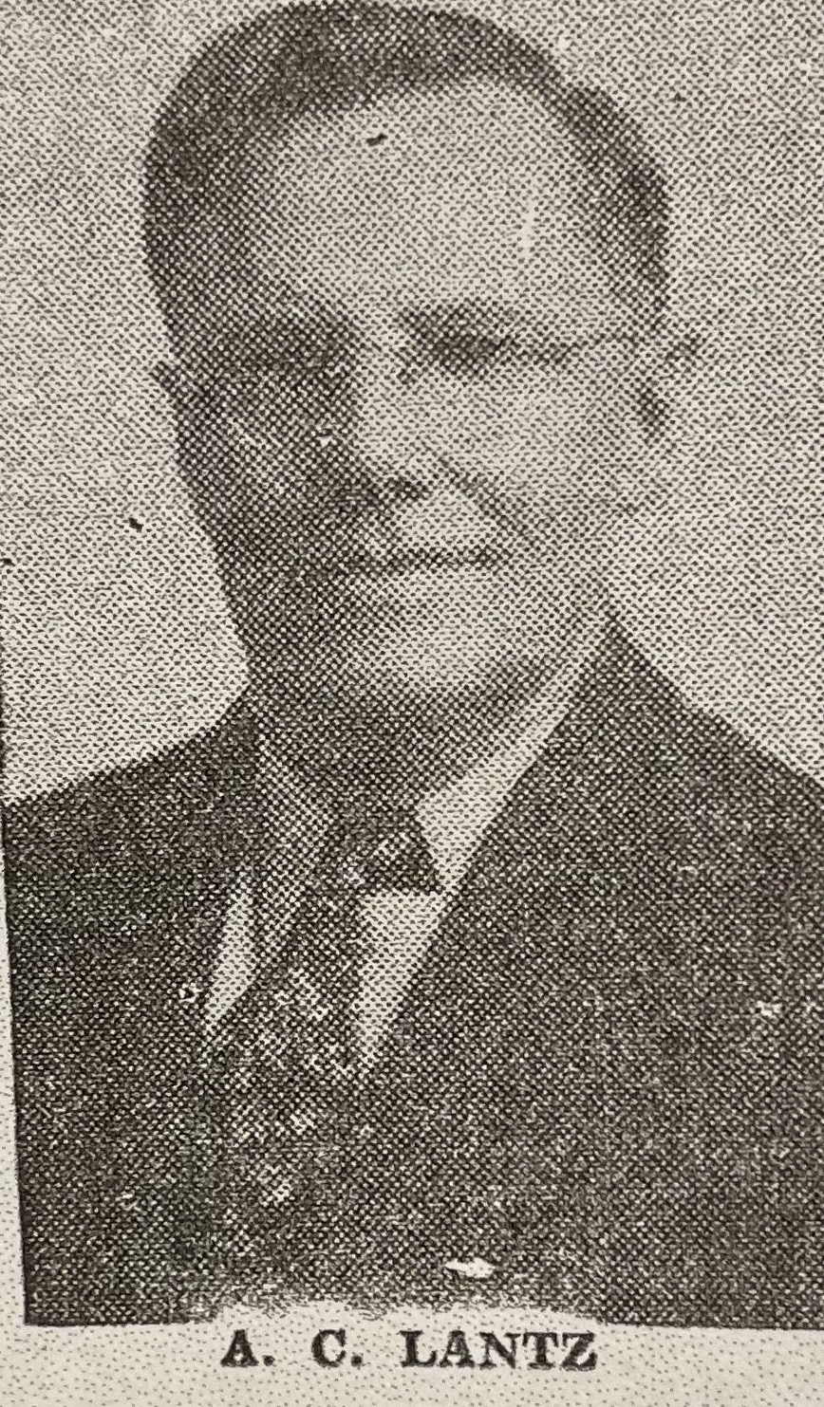
(Hub: 6/7/1948)

