The Central Power Company was an Electric and Gas company in Kearney, NE. Its advertisement is located on both the Kearney Opera House and the World Theatre curtains!
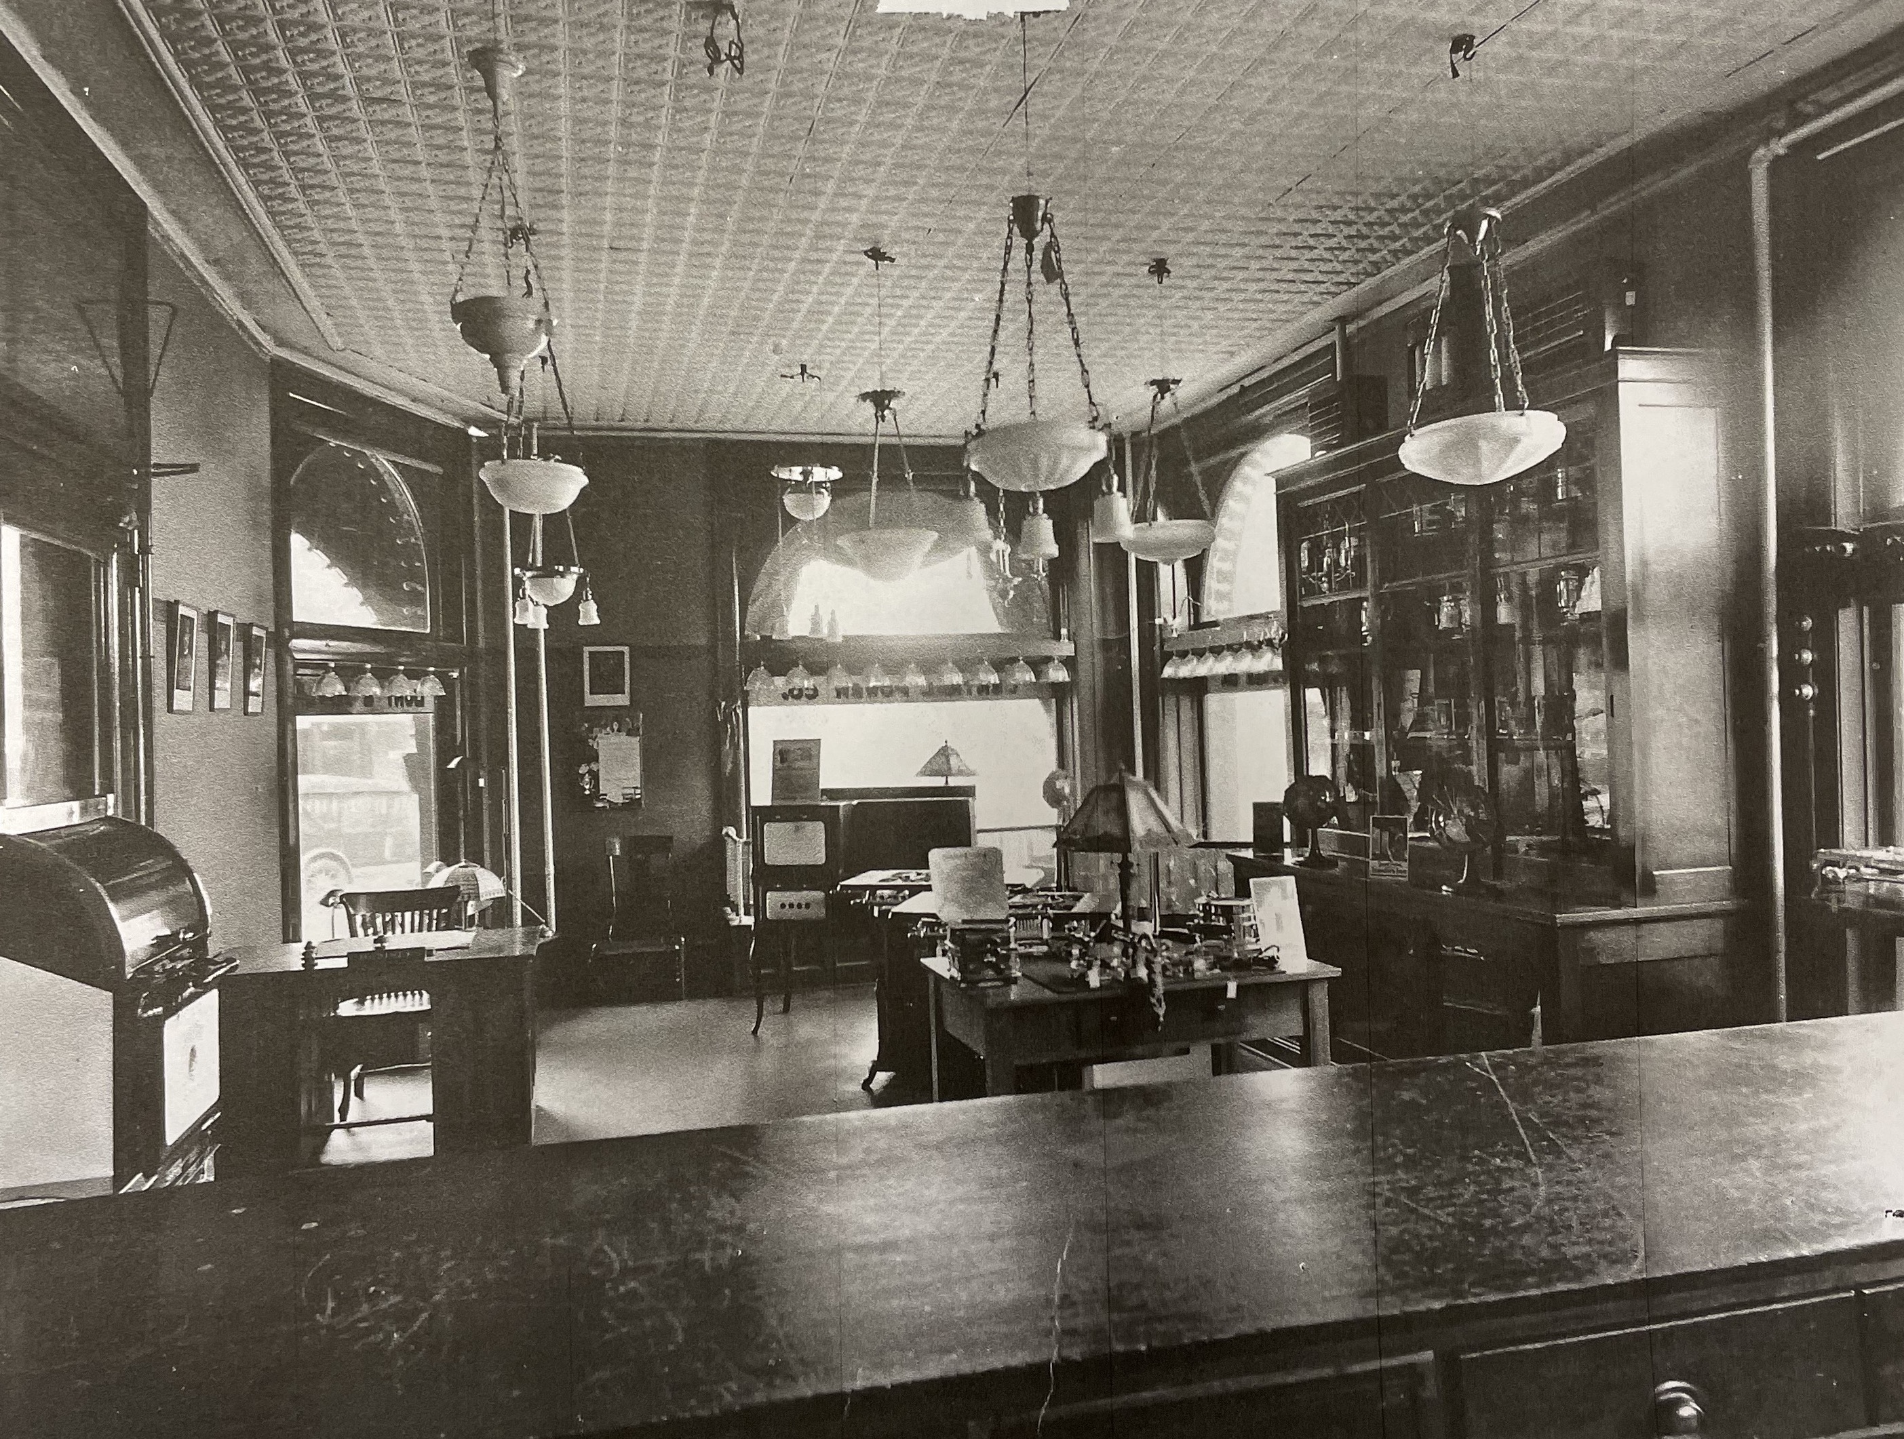

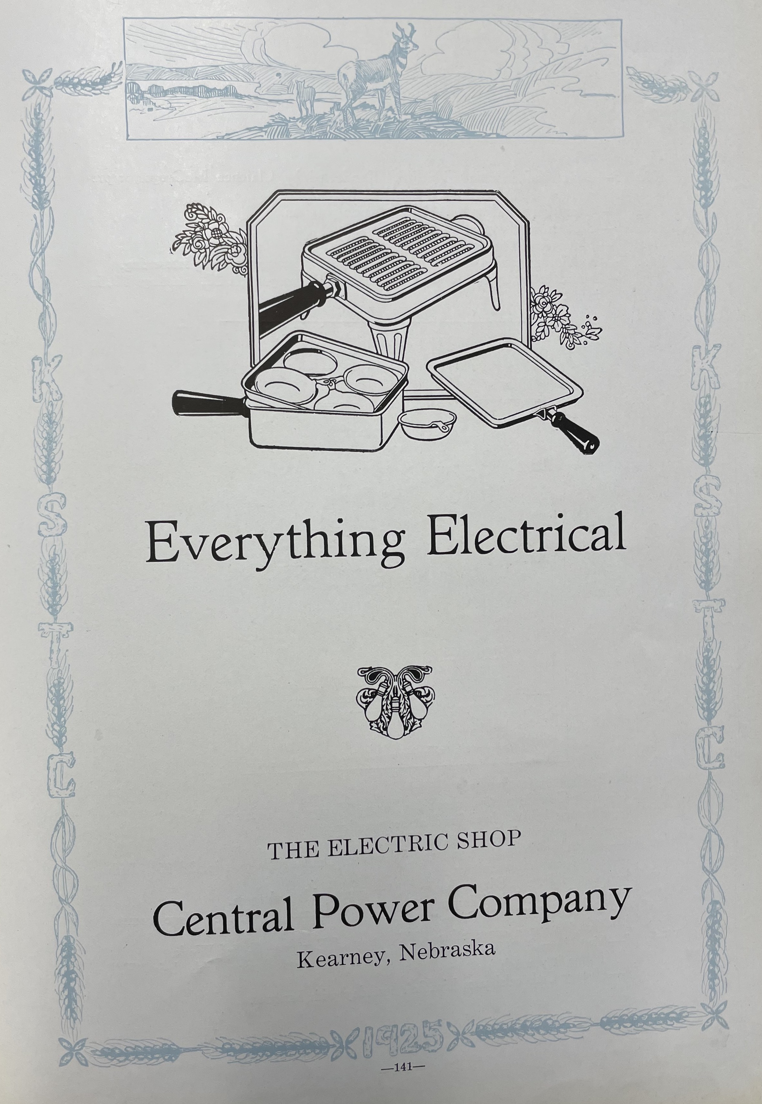
(Blue and Gold: 1924)

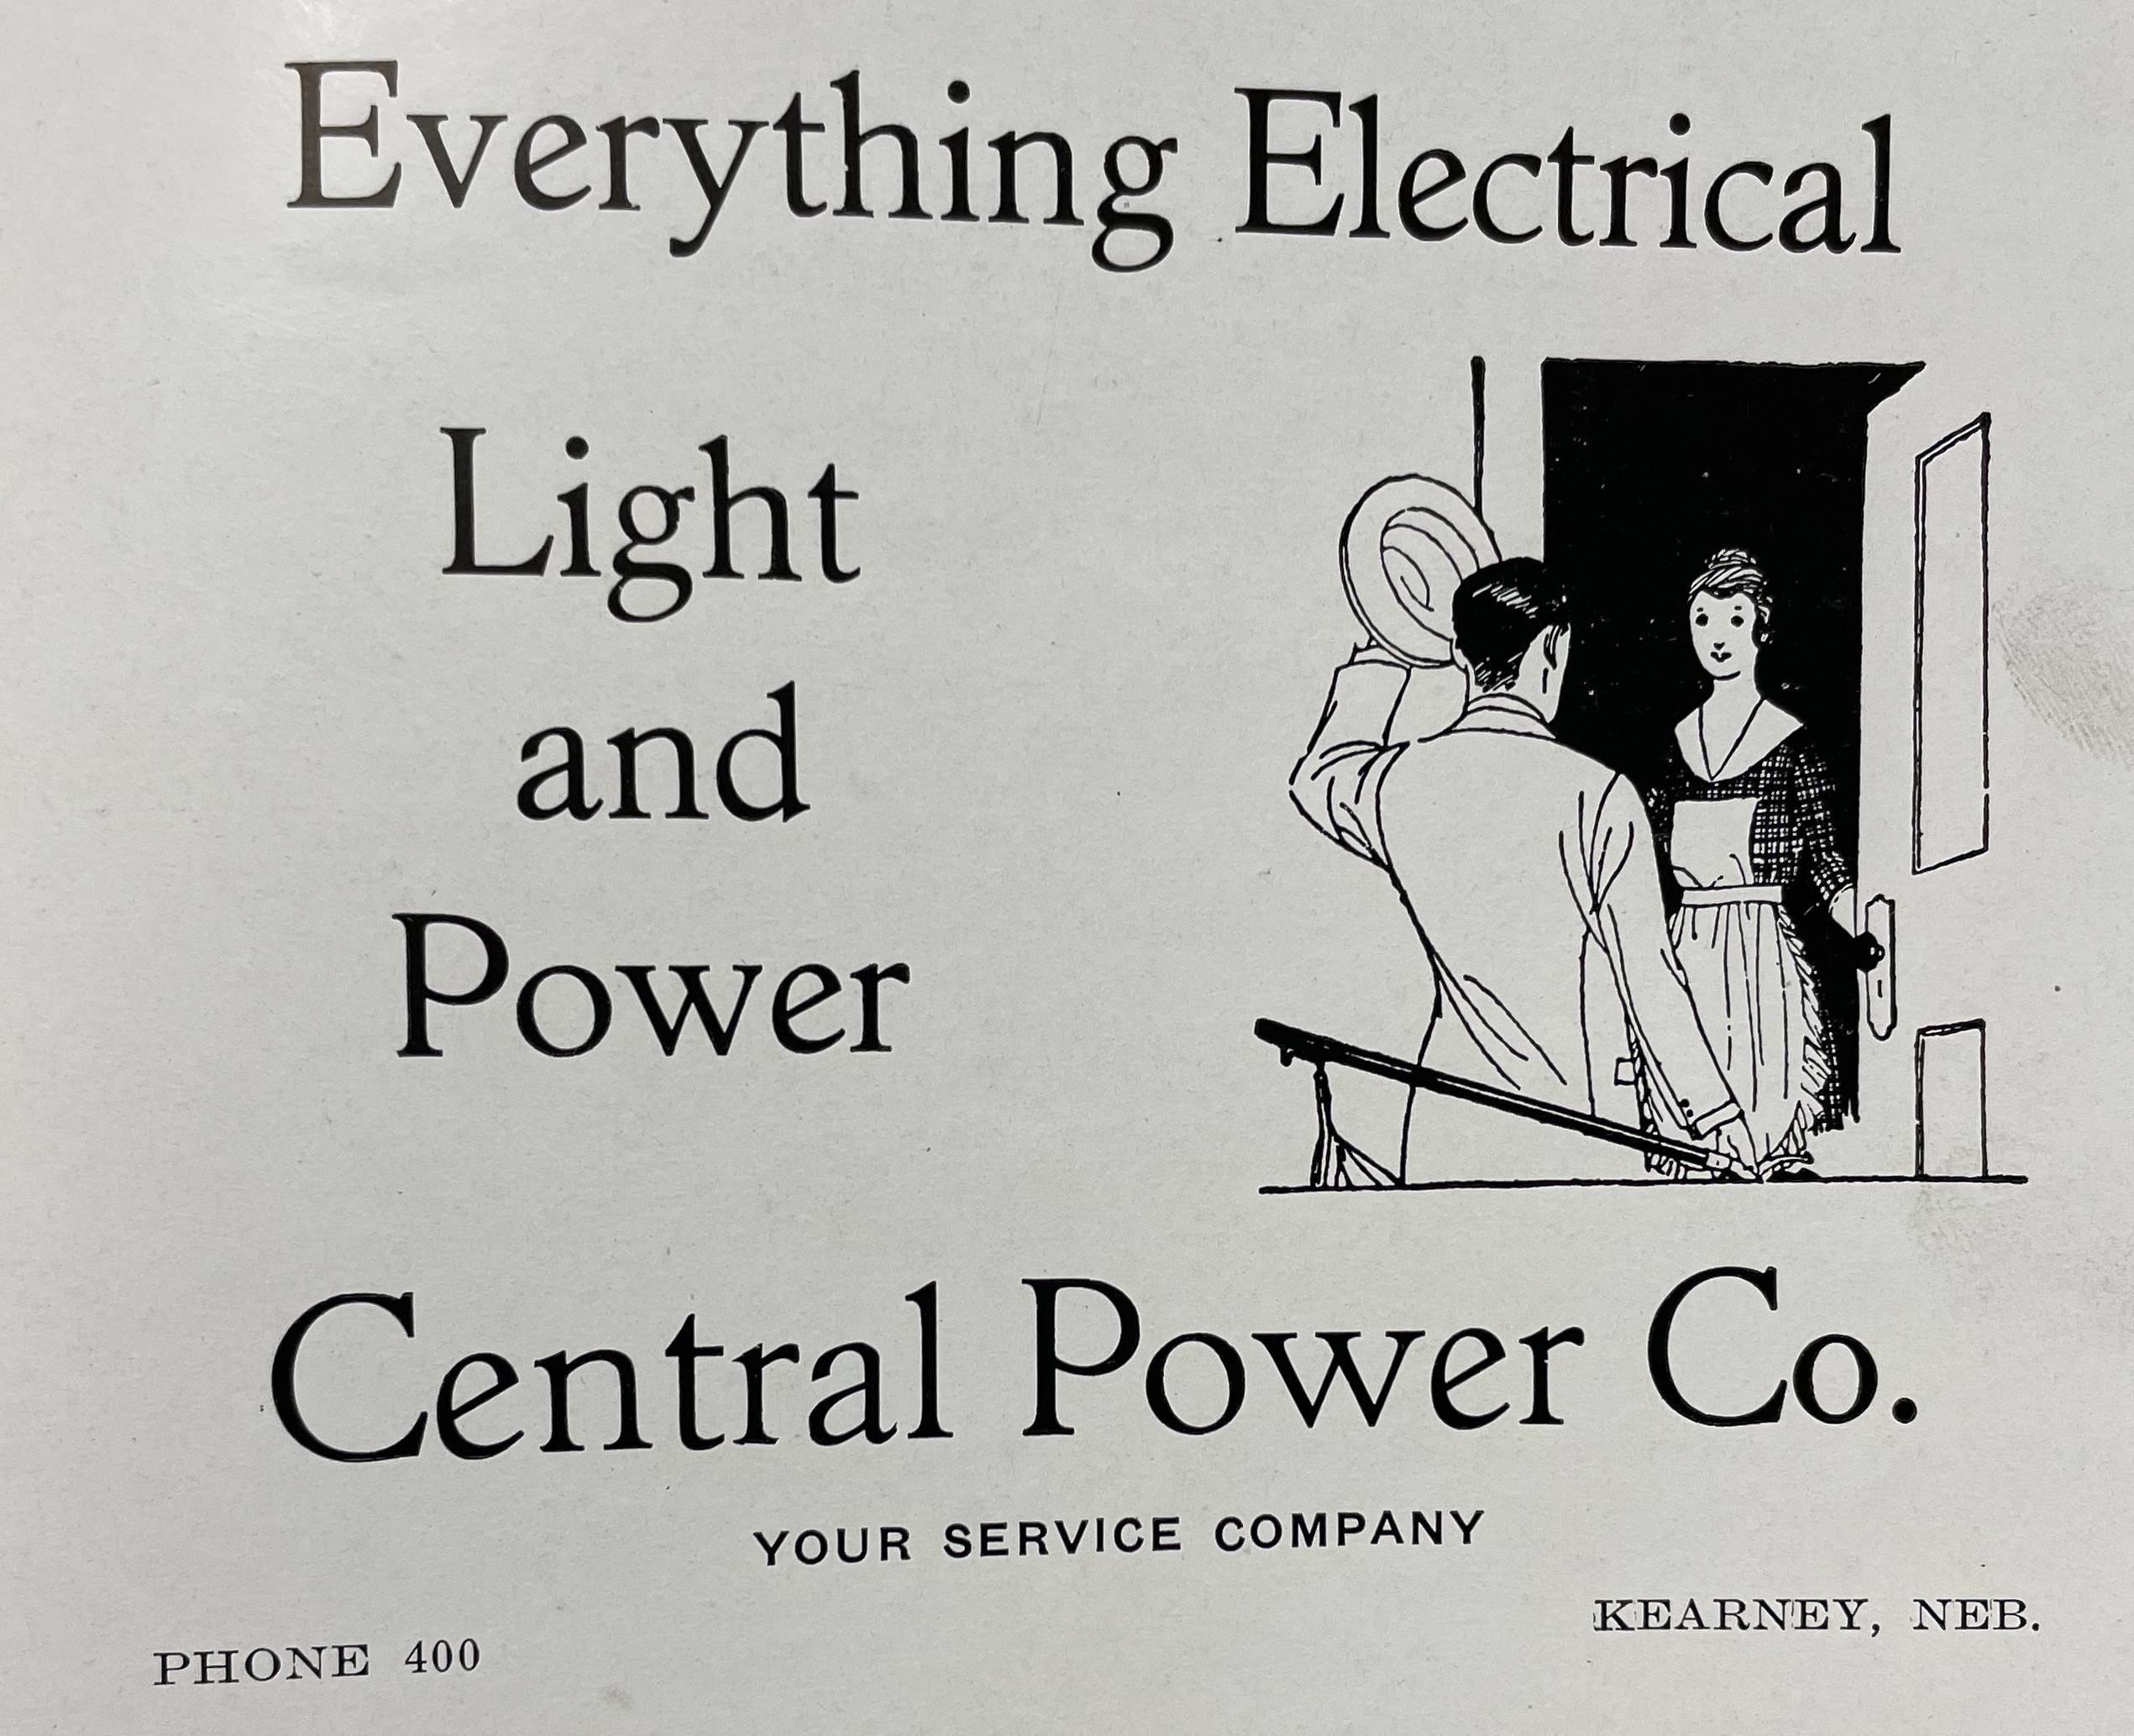
(Kearney High School Annual: 1920)

