The Kearney Rendering Service was located in Kearney, NE and served as a business that would remove dead stock. Its advertisement is located on the Kearney area curtain.
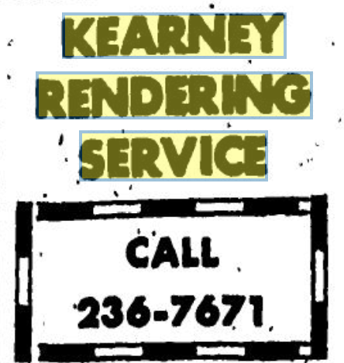
(Hub: 9/9/1971)

