The Johnson Gravel Pit was located in Kearney, NE at 311 Central Ave. Opening in 1947, it provided local folks with their construction needs for large projects. Its advertisement can be seen on the Poole School curtain.

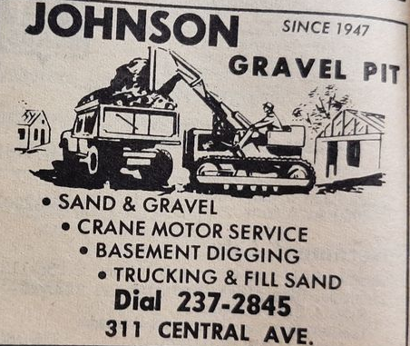
(Hub)

