The Anderson Bros. Plumbing and Heating Company was (and still is) located in Kearney, NE. It was established in 1947 by Joyce Anderson and brothers and was located at 25 W. 22nd St. The advertisement can be seen on the Kearney Area curtain.
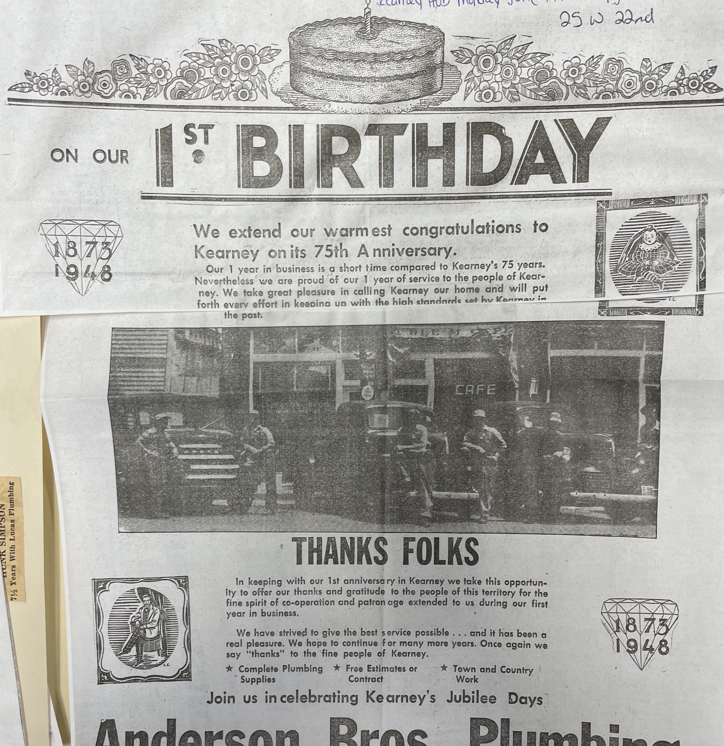
(Hub)

