The Kearney Crete and Block Company was (and still is) located in Kearney, NE. The business is located along Highway 30, East of town. Its advertisement is located on the Poole School curtain.
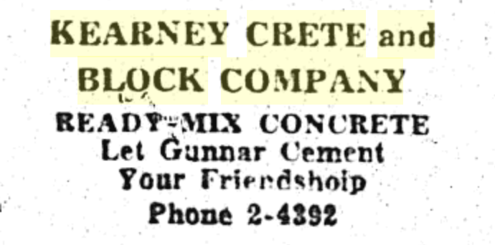
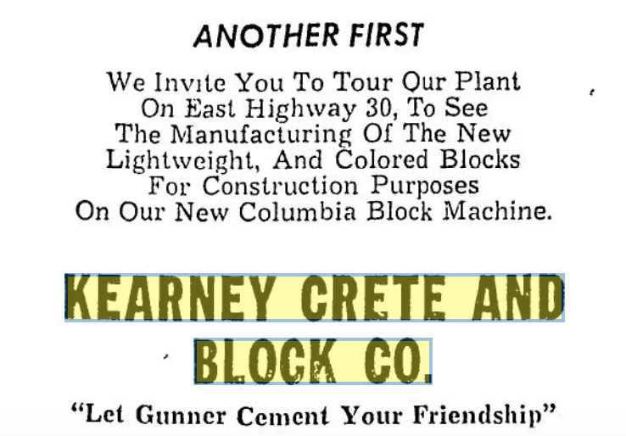
(Hub: 2-27-1959)

