Kearney Hardware Company was located at 2014-16 Central Avenue in Kearney, NE. It opened in 1905. The business supplied household appliances and was thus a need for those within the community. As seen in a photo below, the business even had participated in the 50th Anniversary of Kearney parade in 1923. Its advertisement is located on the Kearney Opera House curtain.

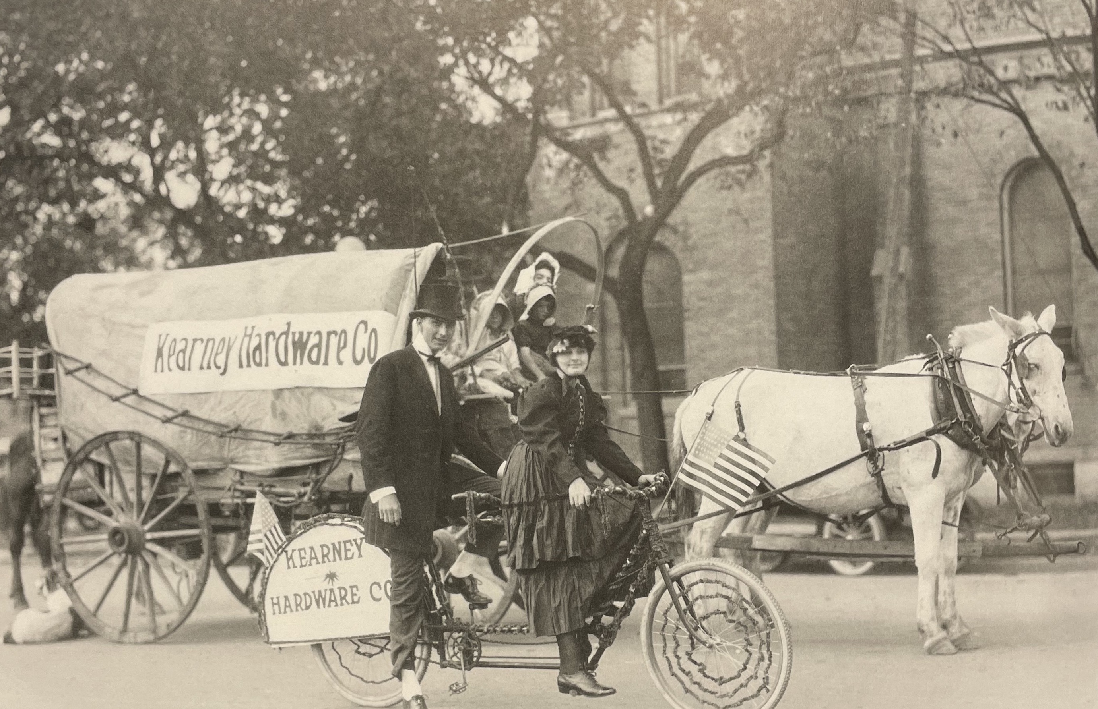 (Kearney Memories)
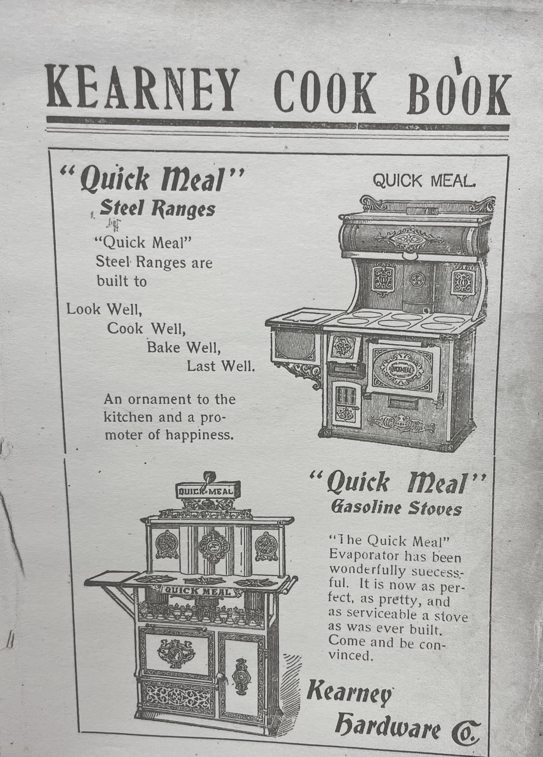

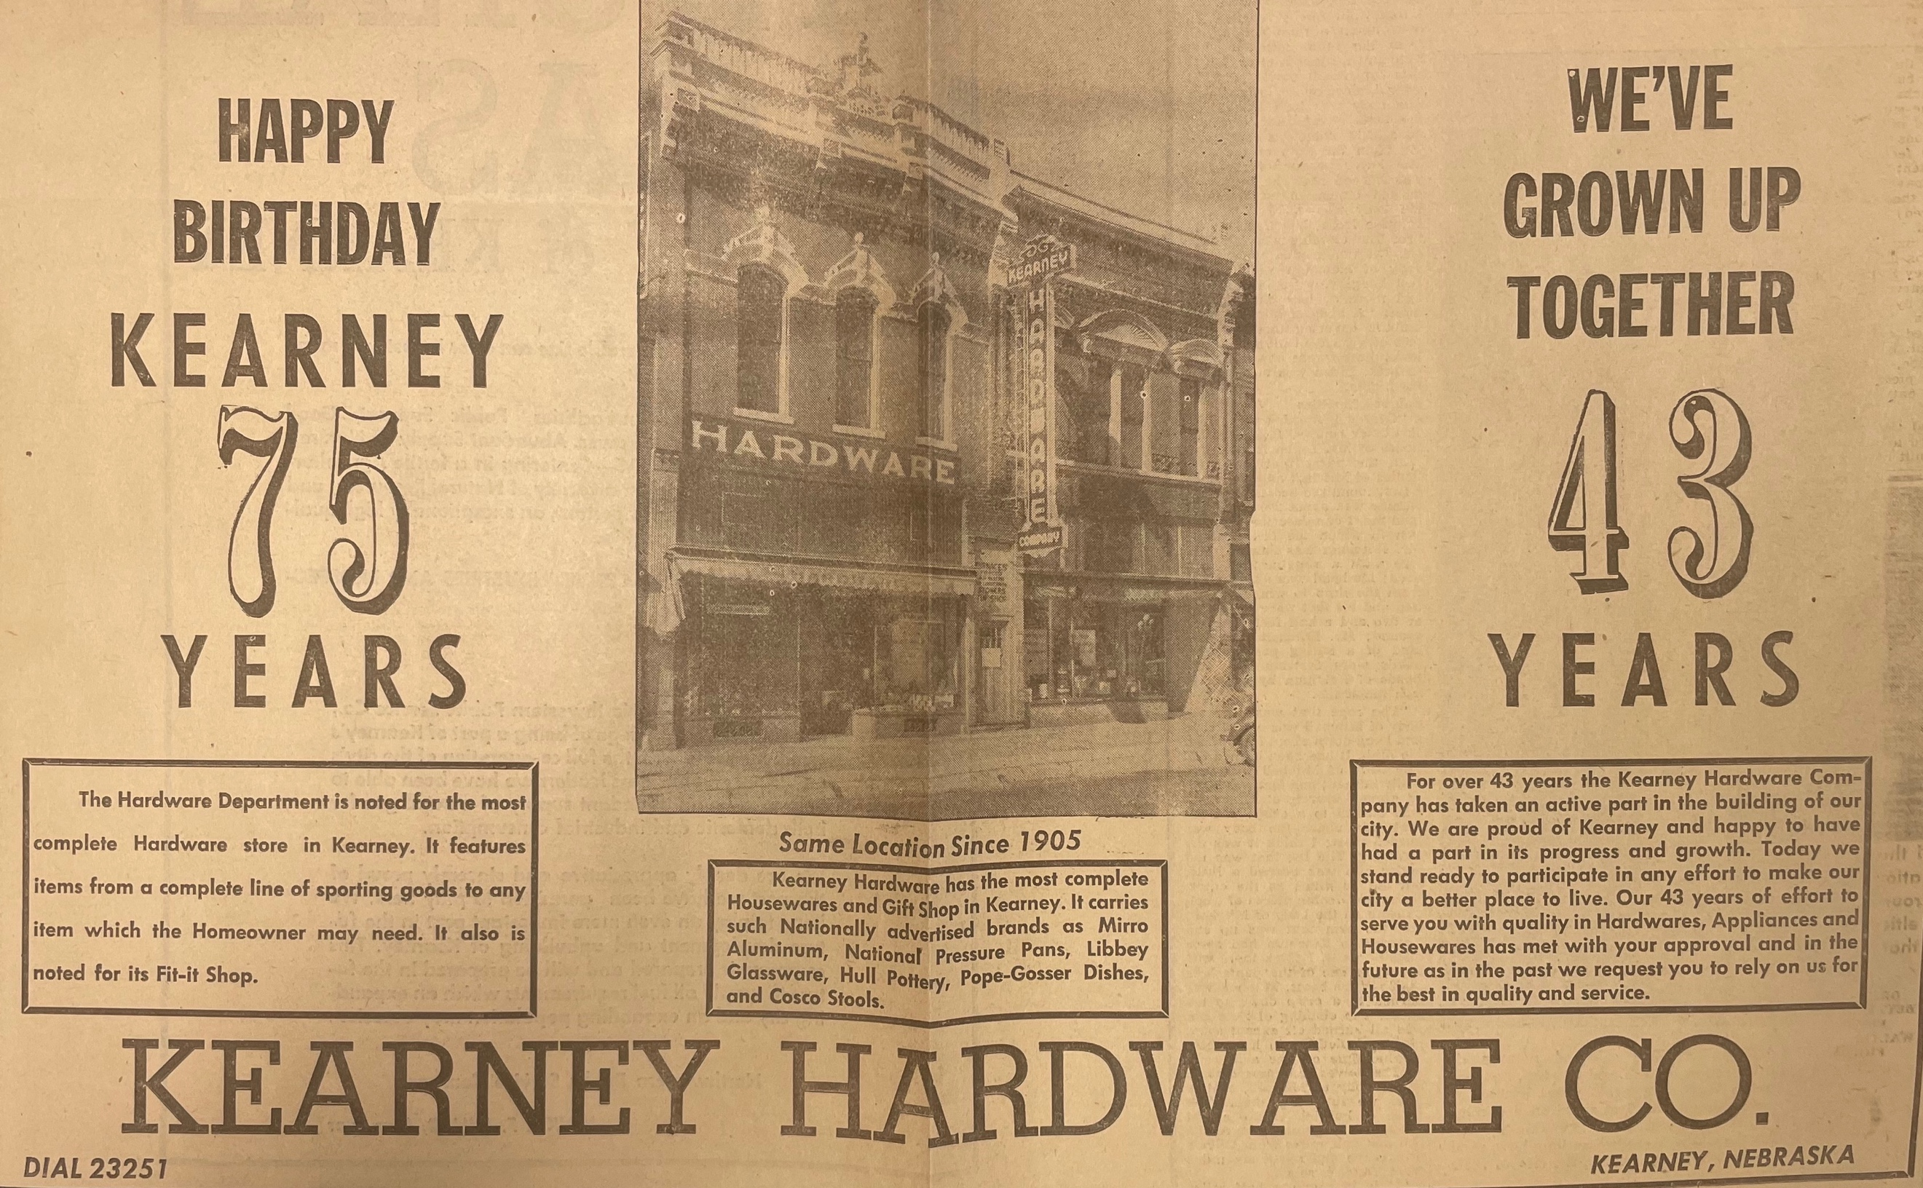
(Kearney Hub: 6-7-1948)

