The Turner Grain Company was located at 19th St. and 3rd Ave in Ravenna, NE. Its advertisement can be seen on the Poole School curtain.
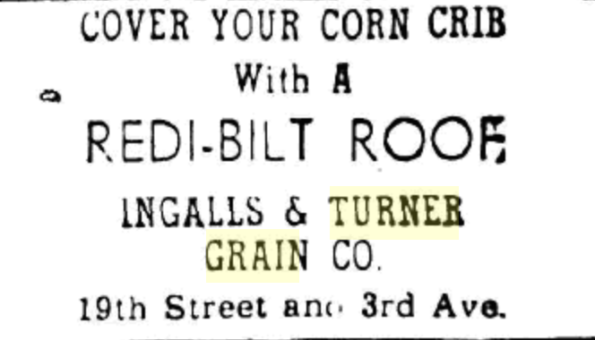
(Kearney Hub: 12-14-1949)

