The South Side Feed Store was located in Kearney, NE. Its advertisement is located on the Elm Creek curtain. If anyone has additional information on this business, please contact the BCHS. Thank you!

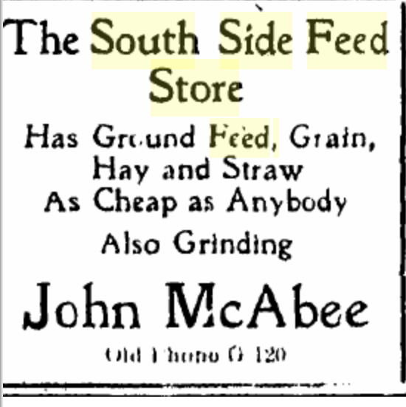
(Hub: 1/30/1906)

