The Robinson Miller Company was located in Kearney, NE. It was a local market located at 2214 Central Avenue. Its advertisement can be seen on the World Theatre curtain.
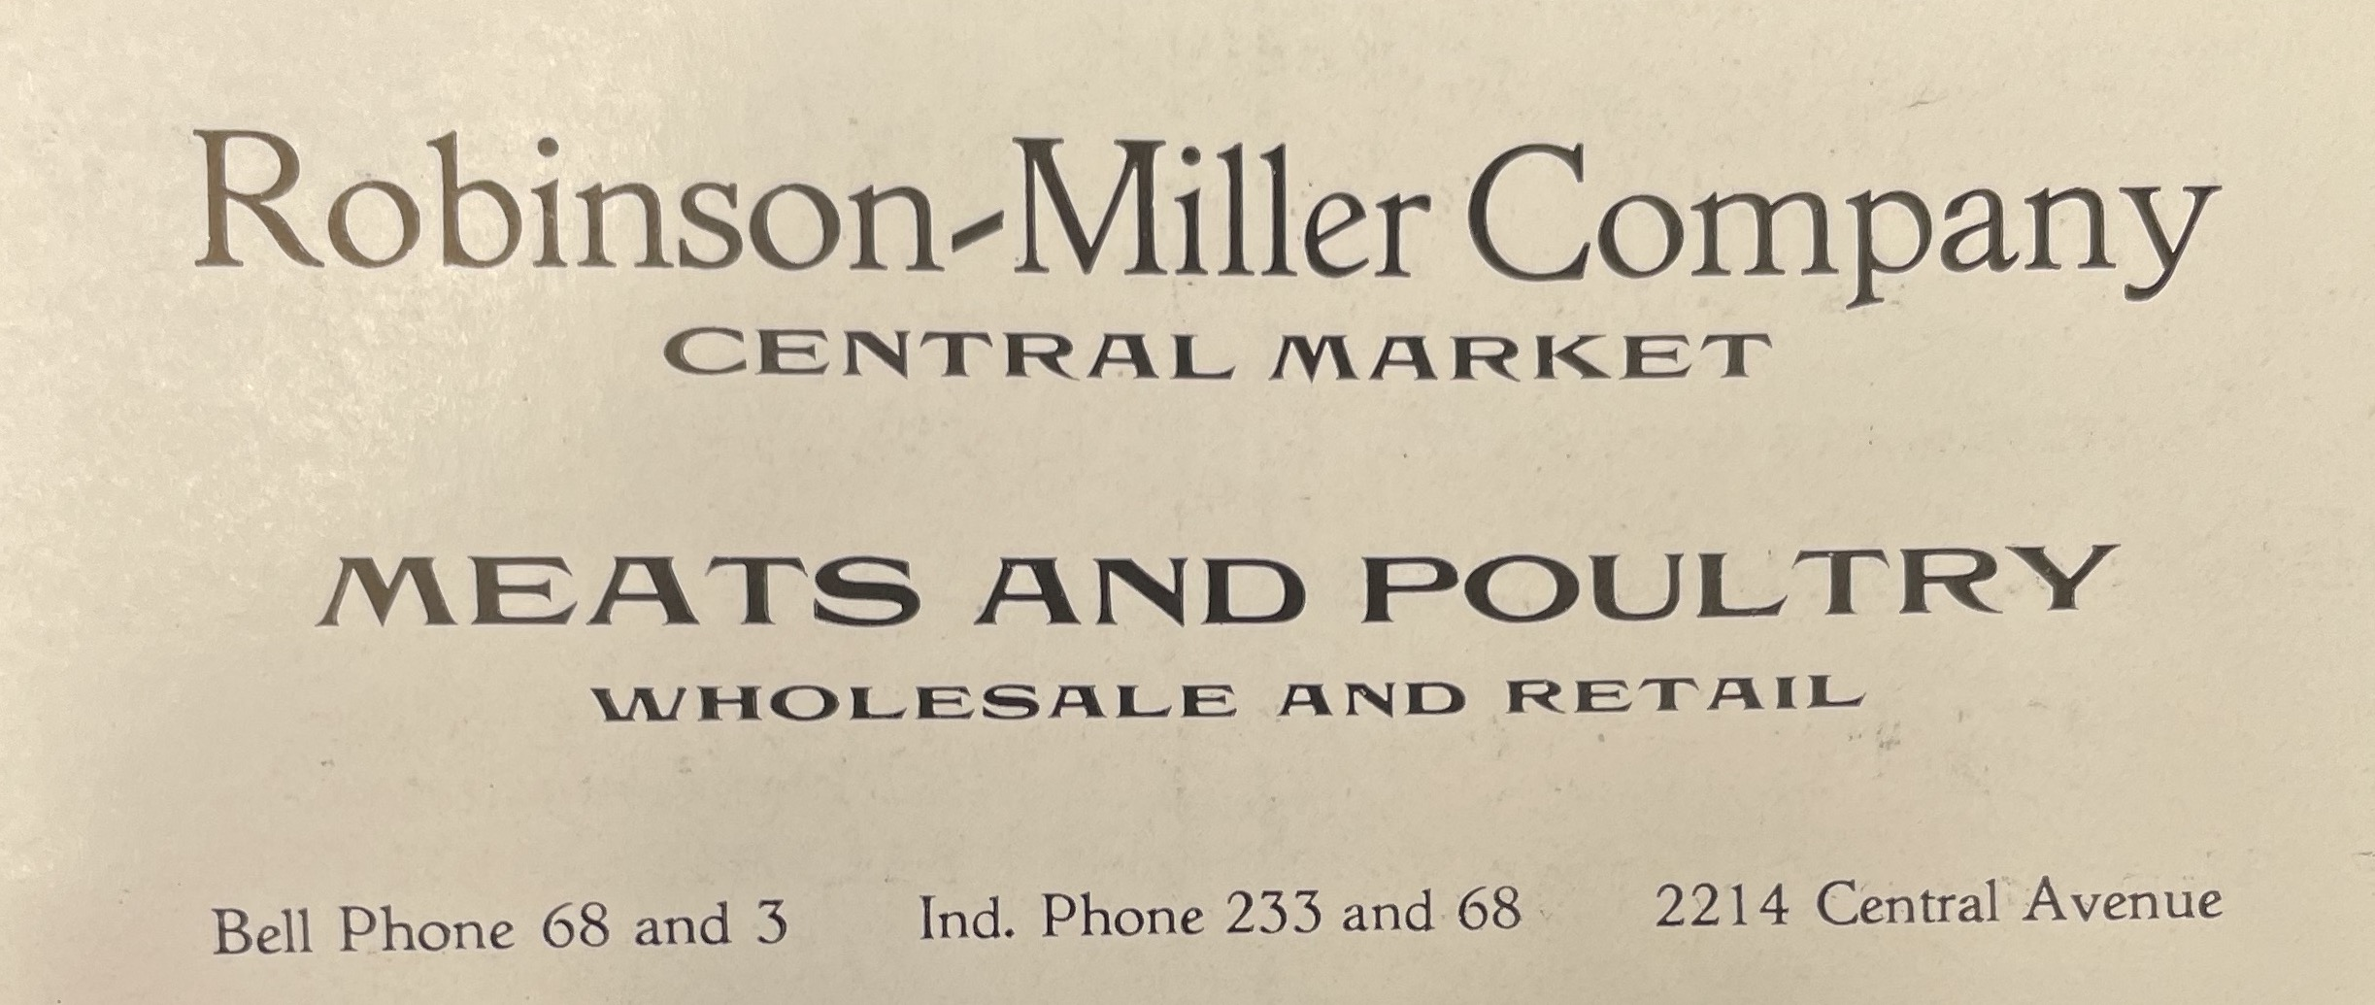
(Kearney High School Annual: 1918)

