The L. Schwarz Hardware Company was located in Kearney, NE. The location was 2303 Central Avenue. Its advertisement can be seen on the World Theatre curtain.
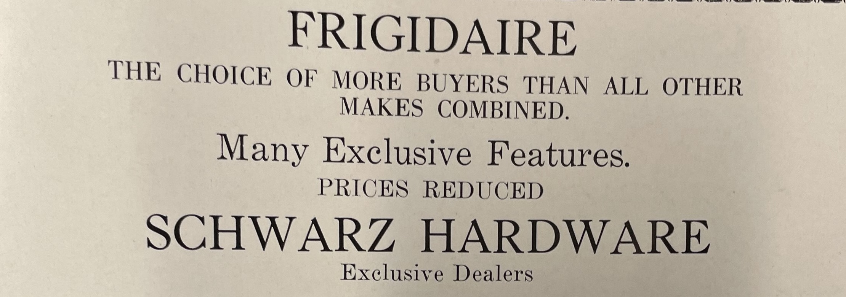
(Log: 1929)

