The Skochdople Agency was located in Ravenna, NE. According to the Ravenna Centennial Book, this business’ location has quite the history of hosting a variety of businesses including a meat market, an electric company, a dress shop, a real estate agency, and finally the Skochople Agency! Its advertisement can be found on the Poole School curtain.

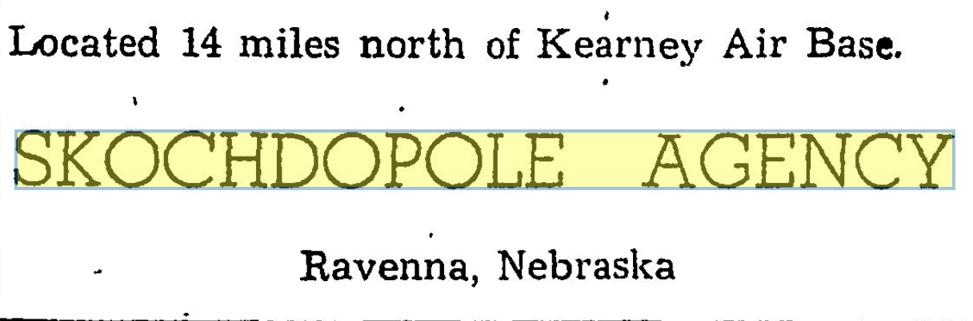
(Hub: 9-24-1960)

