Dr. J. C. Ramer was a vet located out of Miller, NE. He began his service in 1915 and his advertisement can be seen on the Elm Creek curtain.
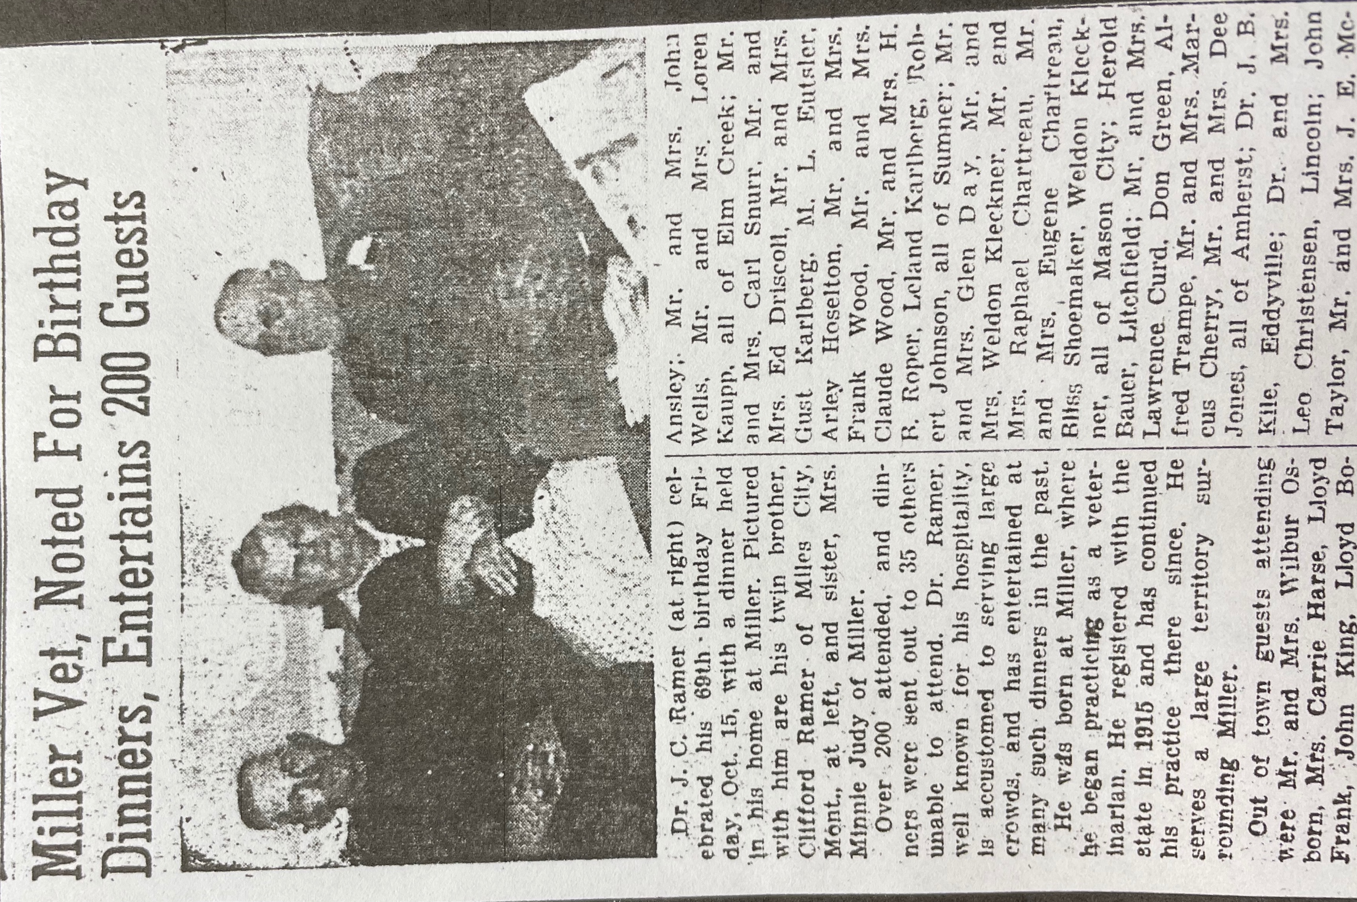
(BCHS archives)

