The Elm Creek Lumber Company was located in Elm Creek, NE. Its advertisement is located on the Elm Creek curtain. If anyone has additional information about this business, please contact the BCHS. Thank you!
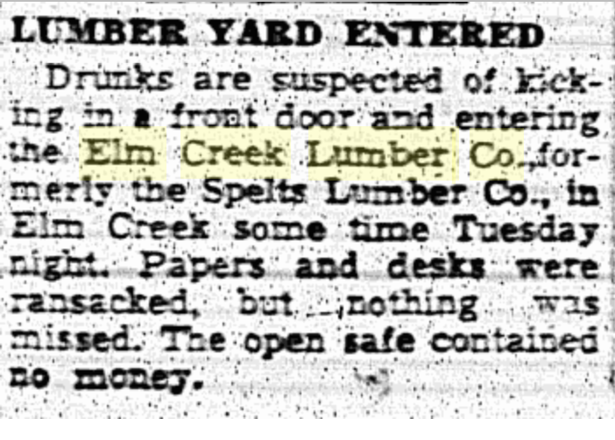
(Hub: 4/21/1948)
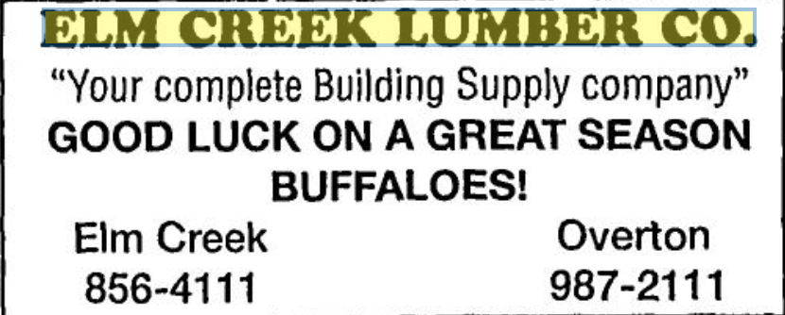
(Hub: 9/2/1993)

