L.D. Martin Lumber Coal was located in Kearney, NE. According to the Kearney Hub (4/28/84) the business began in 1906 with L.D. as the owner. He even served as city mayor from 1924-1928. His son, Dave took over the institution in 1933, and he himself even served as a member of Congress in 1960. Dave and his brother Paul became joint partners in 1956. It was a family business until the 1980s when it was sold to Foster Woodruff. Its advertisement can be seen on the World Theatre curtain.
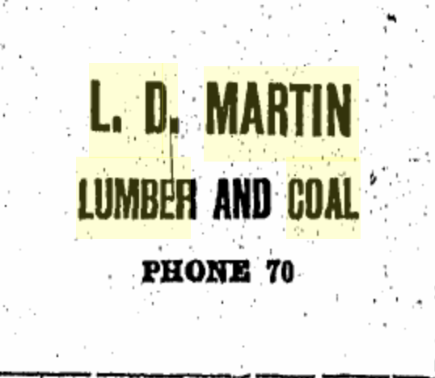

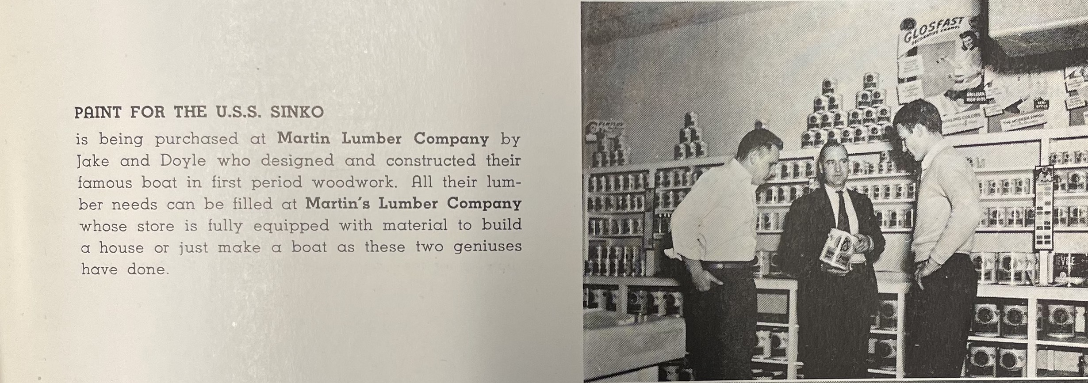
(Log: 1948)
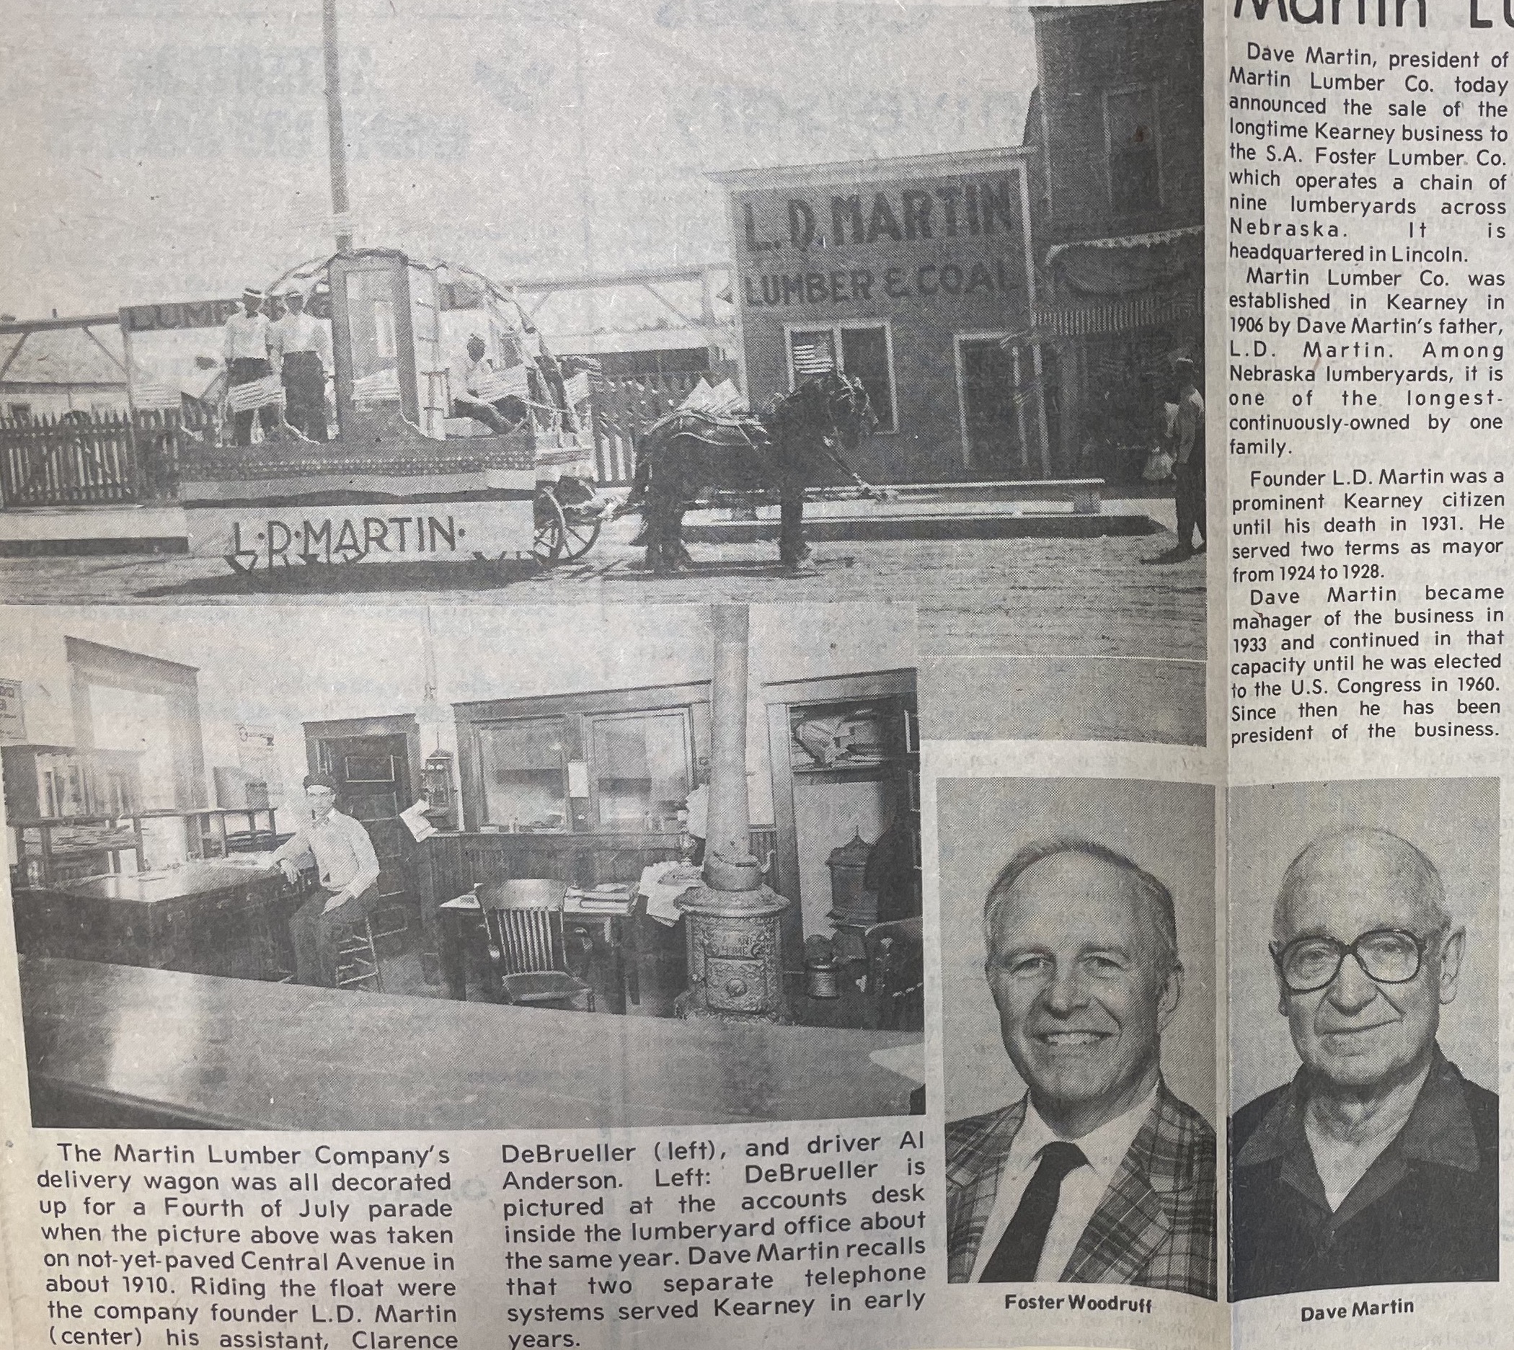
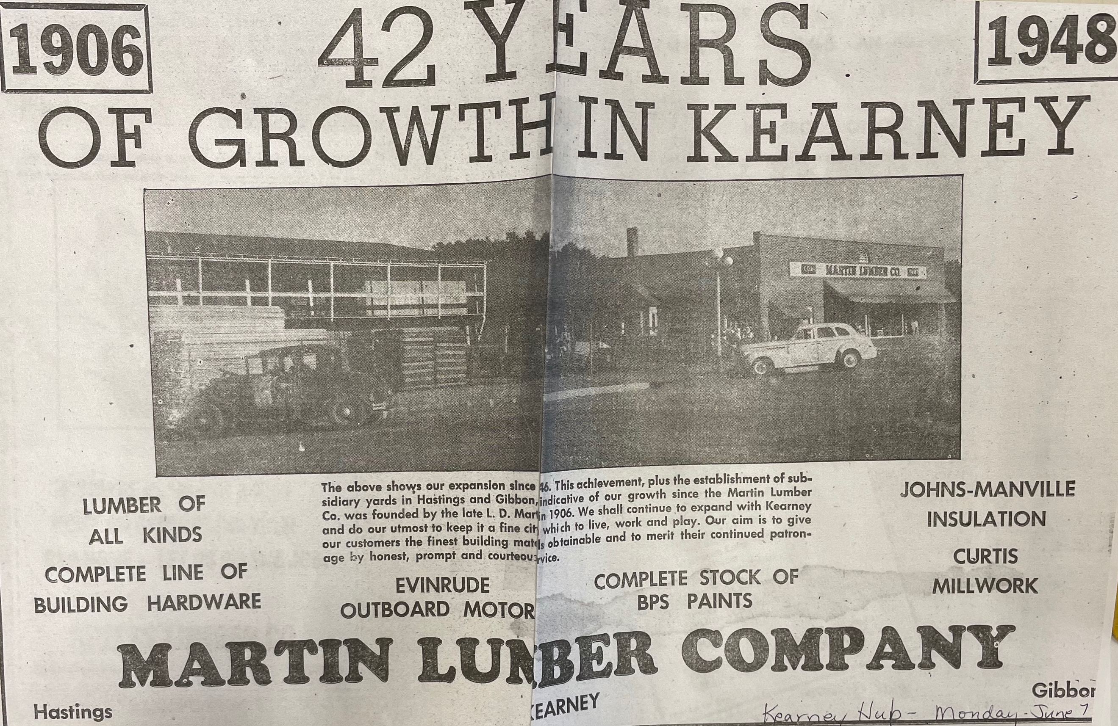
(Hub: 6/7/1948)

