A.G. Bower and Son Funeral Home was located in Kearney, NE. The business was established in 1902. The Bower’s had a big enough business within Kearney, that they were even listed as some of the Boosters of Kearney as of 1910. A.G. Bower passed away in 1945.
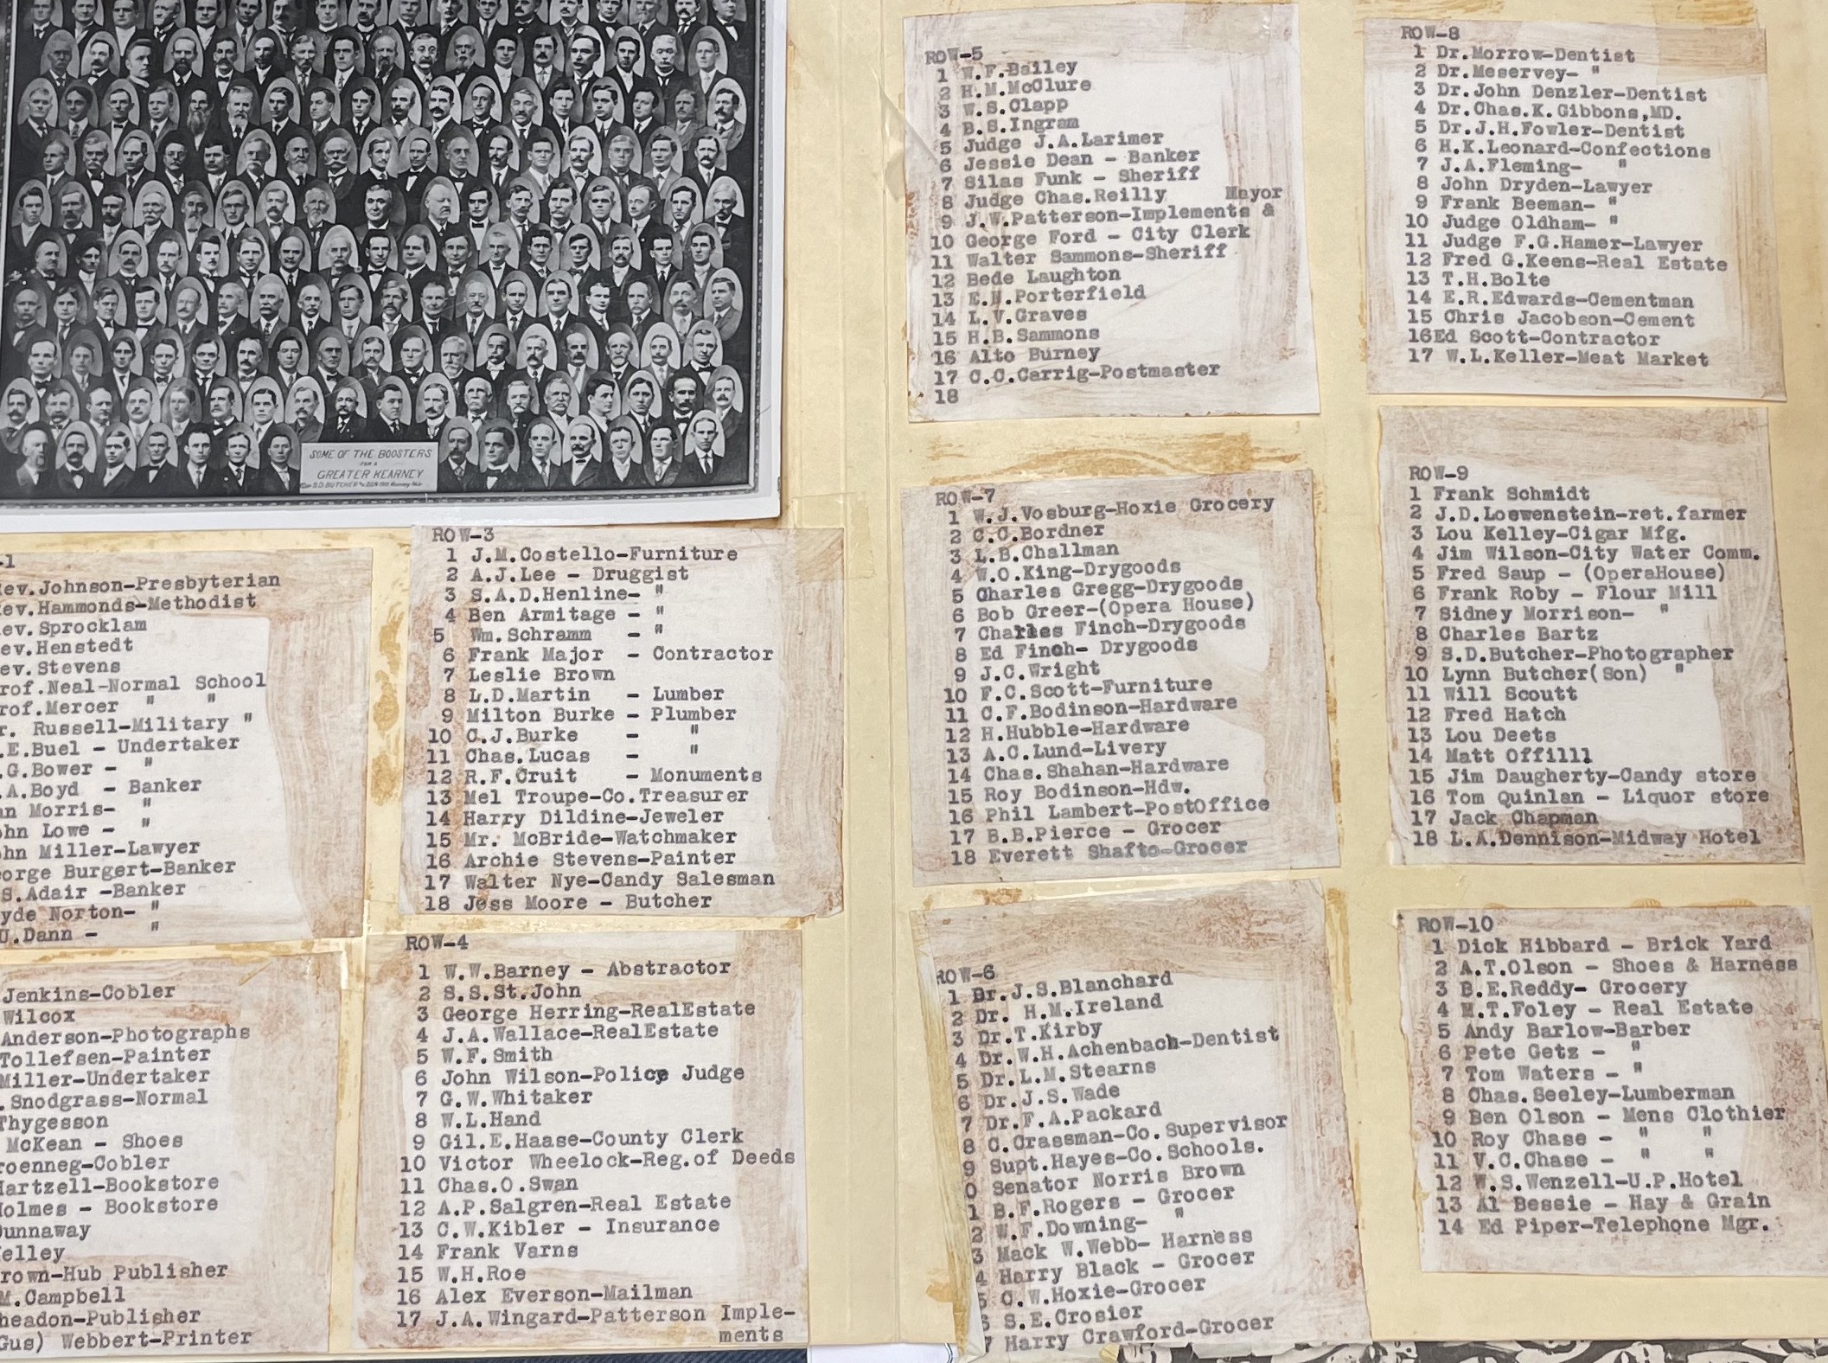
(1910 Kearney Boosters)
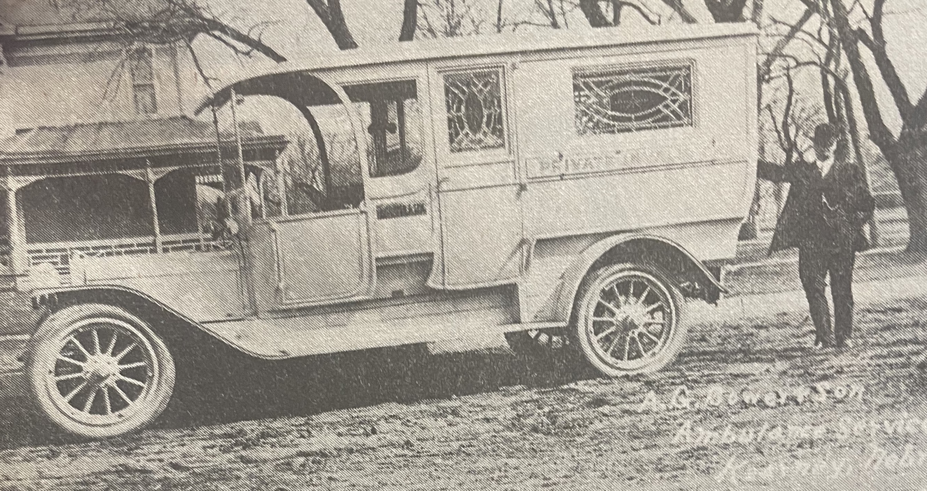

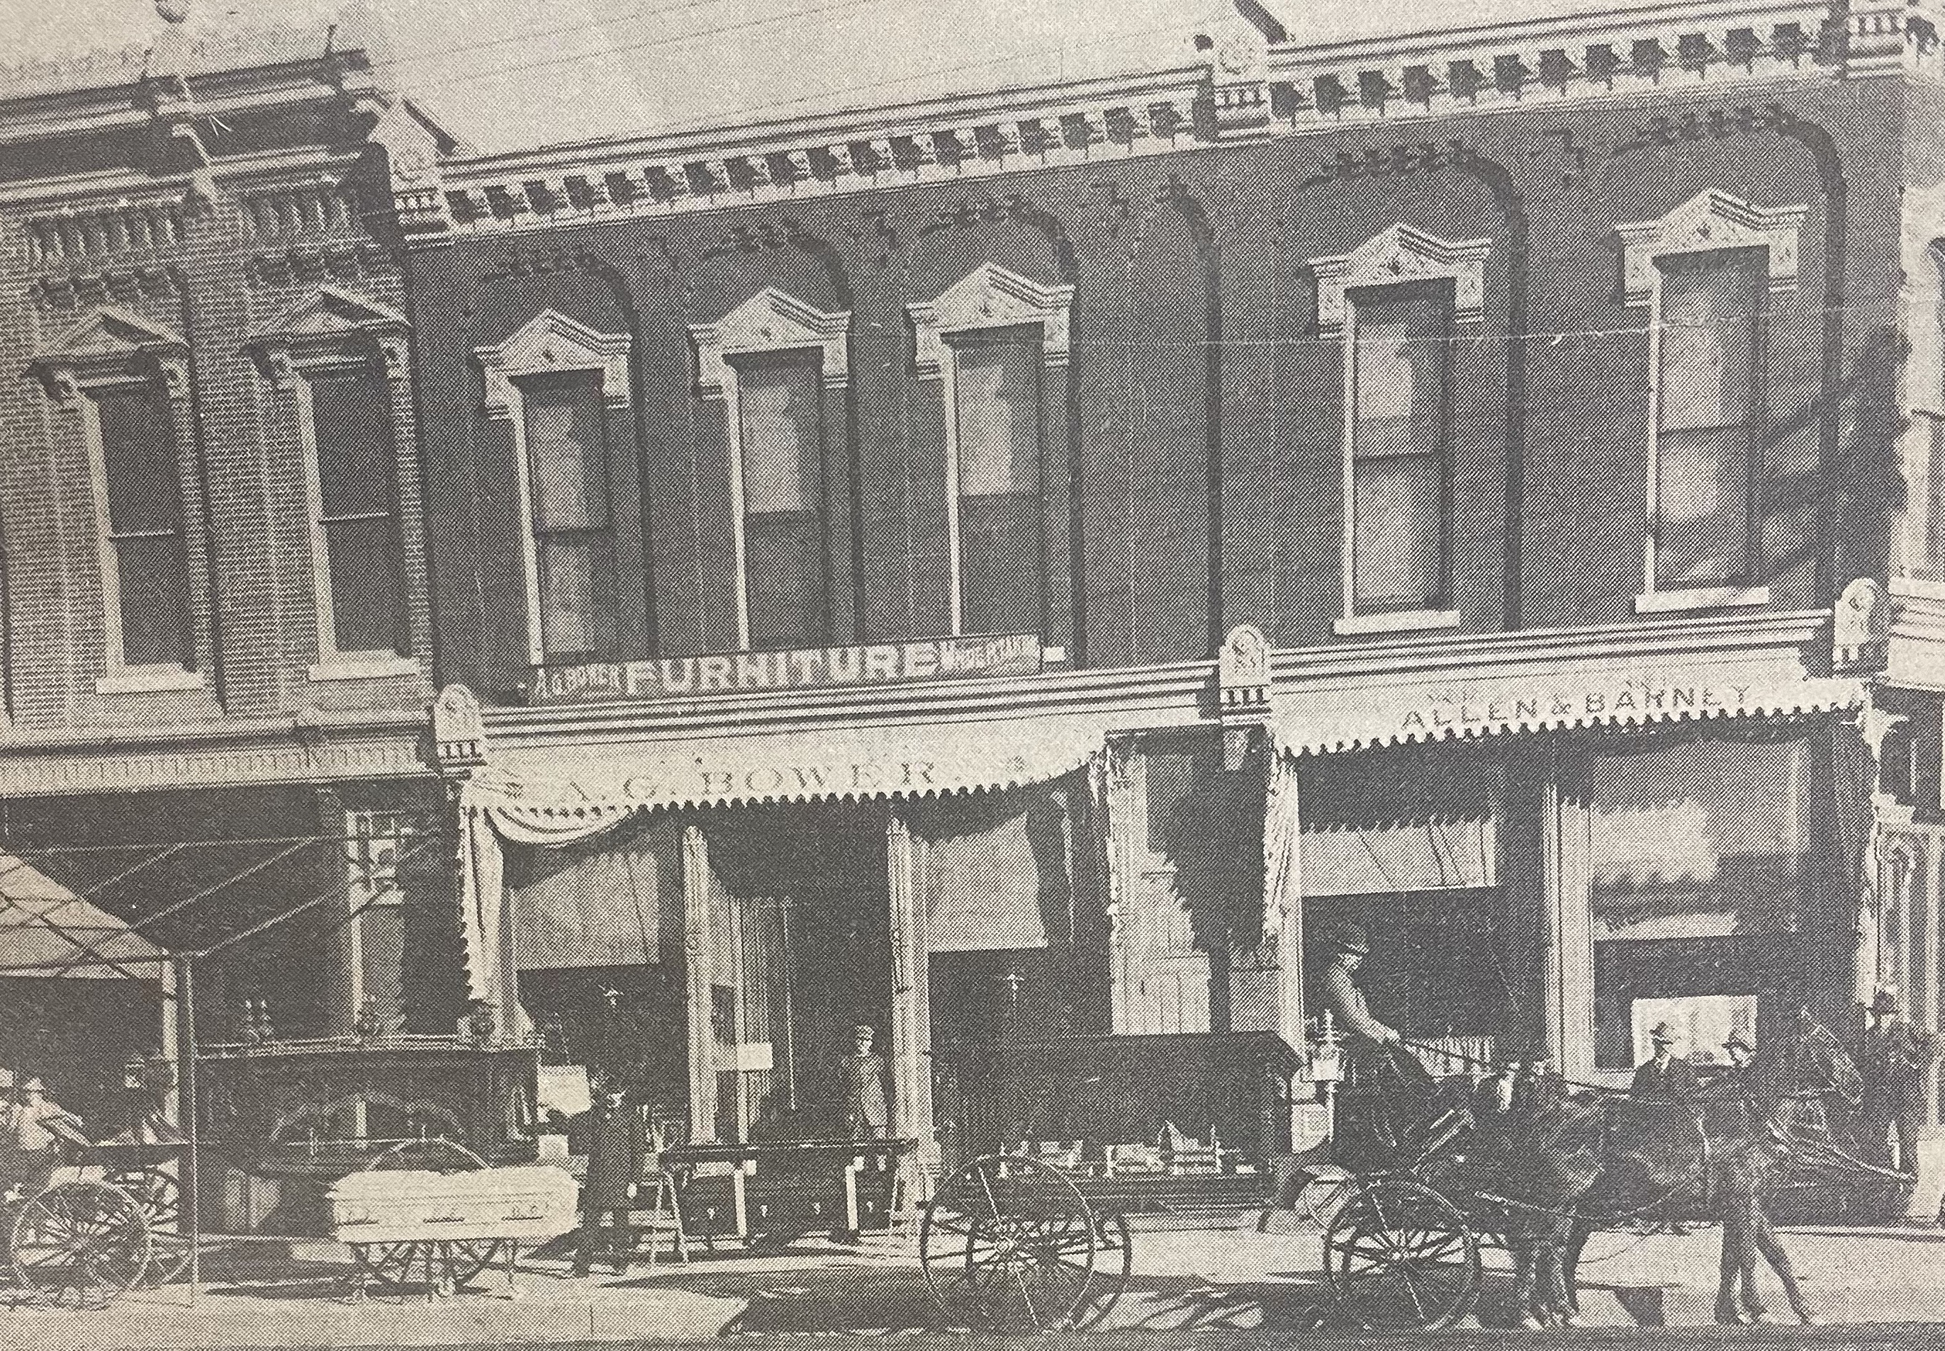
(Hub: 3/13/1973)

