Sunlite Bakery was located in Kearney, NE. The proprietor/owner was L.H. Bahr. Its advertisement can be seen on the World Theatre curtain. If anyone has further information on the business, please contact BCHS. Thank you!
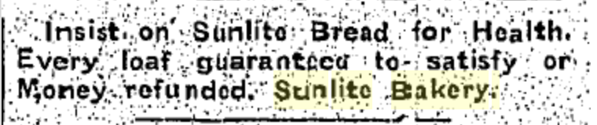
(Hub: 11/24/1933)
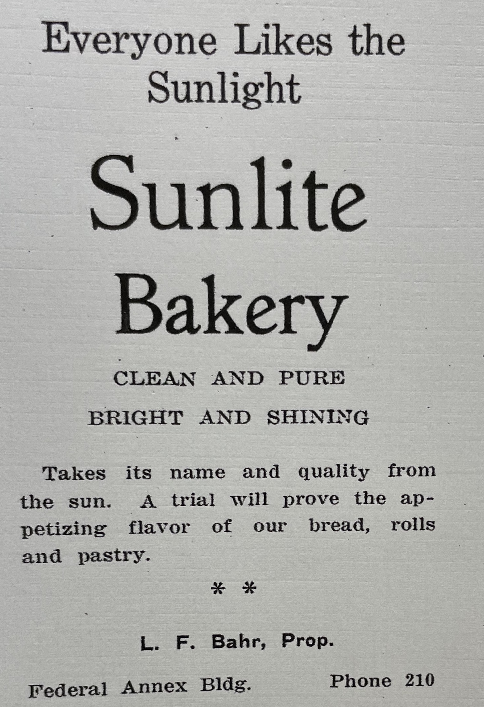
(Blue and Gold: 1923)

