Buck’s Booterie was a shoe store located in Kearney, NE. It was established in 1921. According to the Kearney Hub, a few of the owners over the years include Harold Allen and Francis M. Young (8-19-1941) (9-10-1941). Advertisements appear in local yearbooks as well as on the Kearney Opera House curtain.
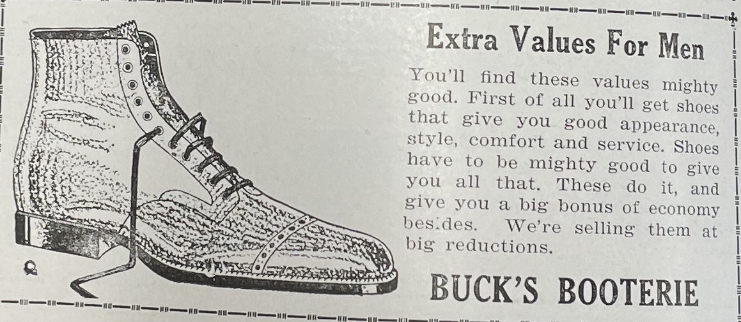
(Echo: December 1921)

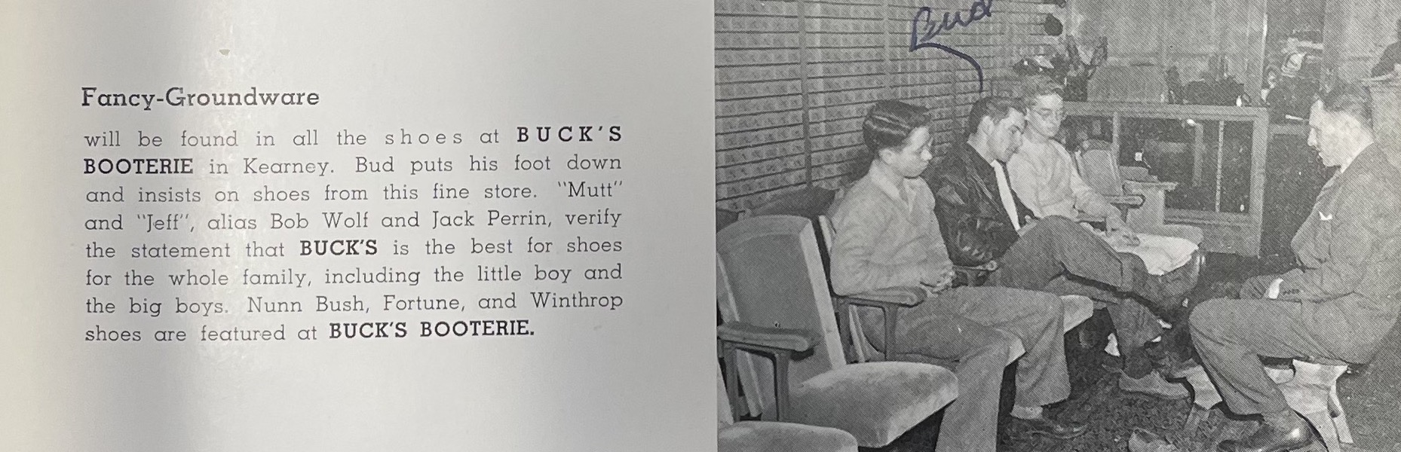
(Log: 1947)

