Photograph Analysis Activity
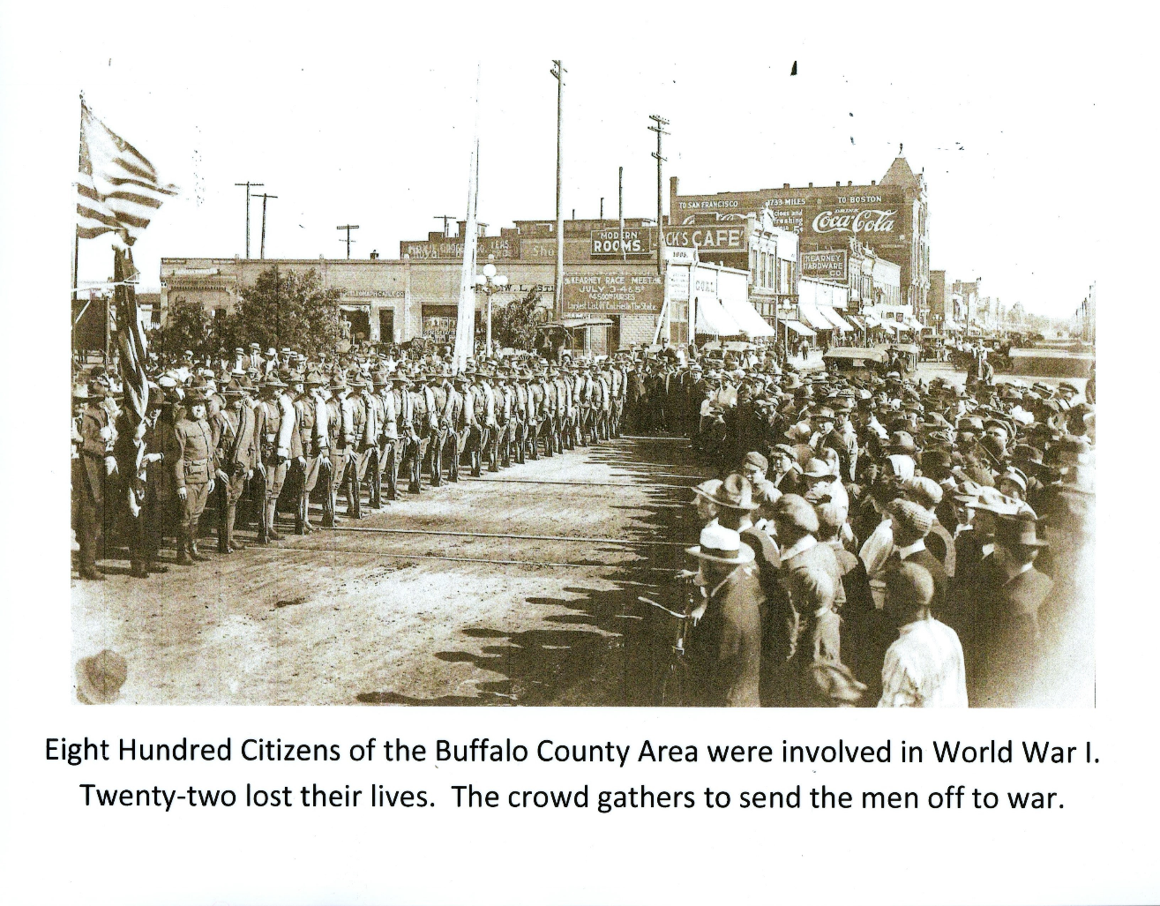
How many Buffalo County citizens were involved in WWI?

Where do you think this picture was taken?

How do you think the soldiers/crowd feel?

What year do you think this photograph was taken?

What else have you noticed about the photograph?

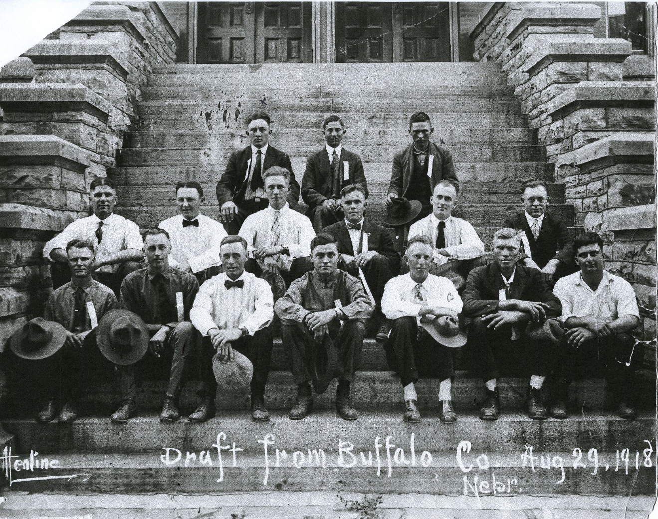

What is the draft?

What year and month was this photograph taken?

How are these men dressed?

Based on your best guess, where do you think this photograph was taken?

How do you think these men feel about being drafted?

