J.D. Hawthorne was a jewelry business located in Kearney, NE and is still a thriving business today! It is one of the oldest businesses in Kearney, and established in 1878. J.D. was originally from Vinton, IA and came to Kearney in 1873. His business can be seen on the World Theatre curtain.
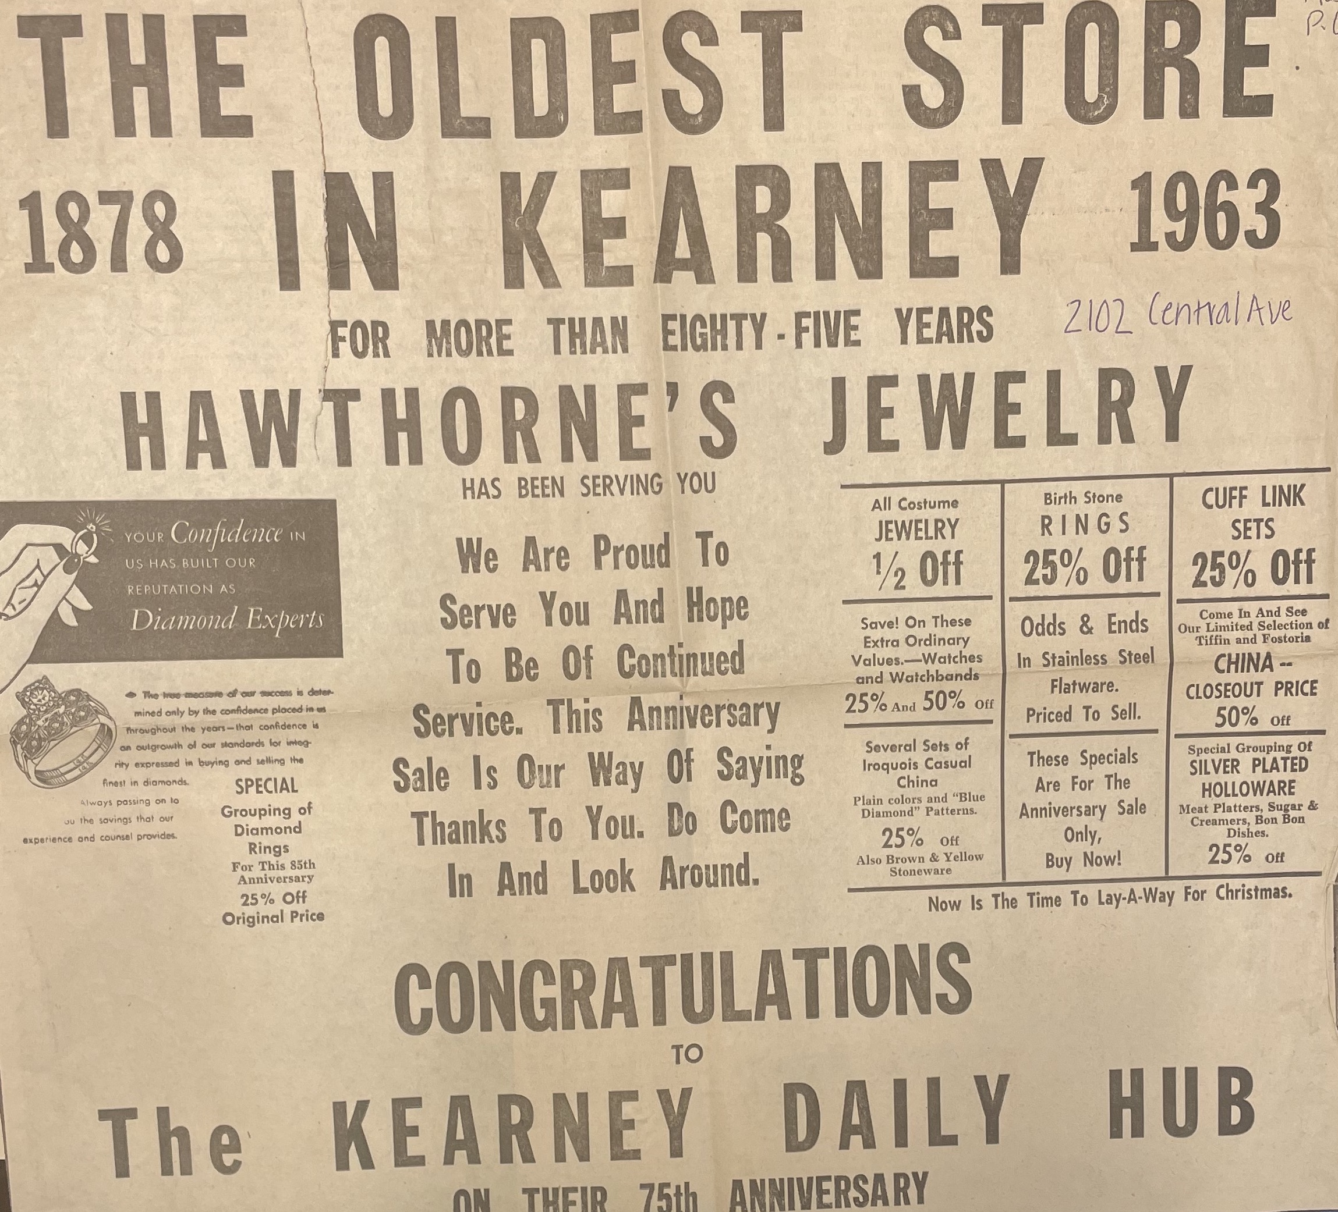
(Hub: 1963)
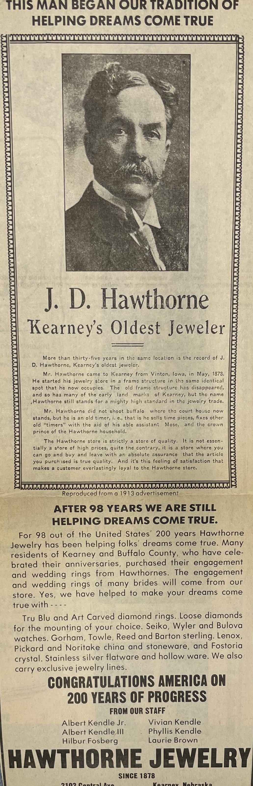
(Hub)

