The A.B.A Oil Company was located in Kearney, NE. Its advertisement can be seen on the World Theatre curtain. Not much information has been found about this business. If anyone has any information, please contact the BCHS. Thank you!
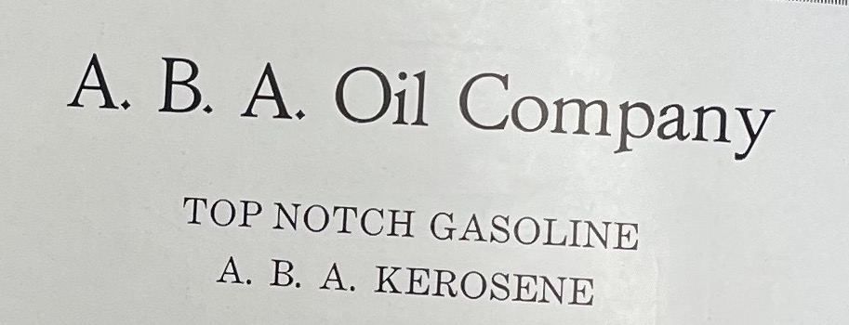
(Kearney High School Annual: 1920)

