A department store classic, J.C. Penney Co. first arrived in Kearney in 1920! Since then it has aided all members of the community to be appropriately dressed for any occasion. From having a float in the 50th Anniversary of the City of Kearney, itself, to students posing for ads in their yearbooks, J.C. Penney has always been present! Its advertisement can be seen on the Kearney Opera House and World Theatre curtains!
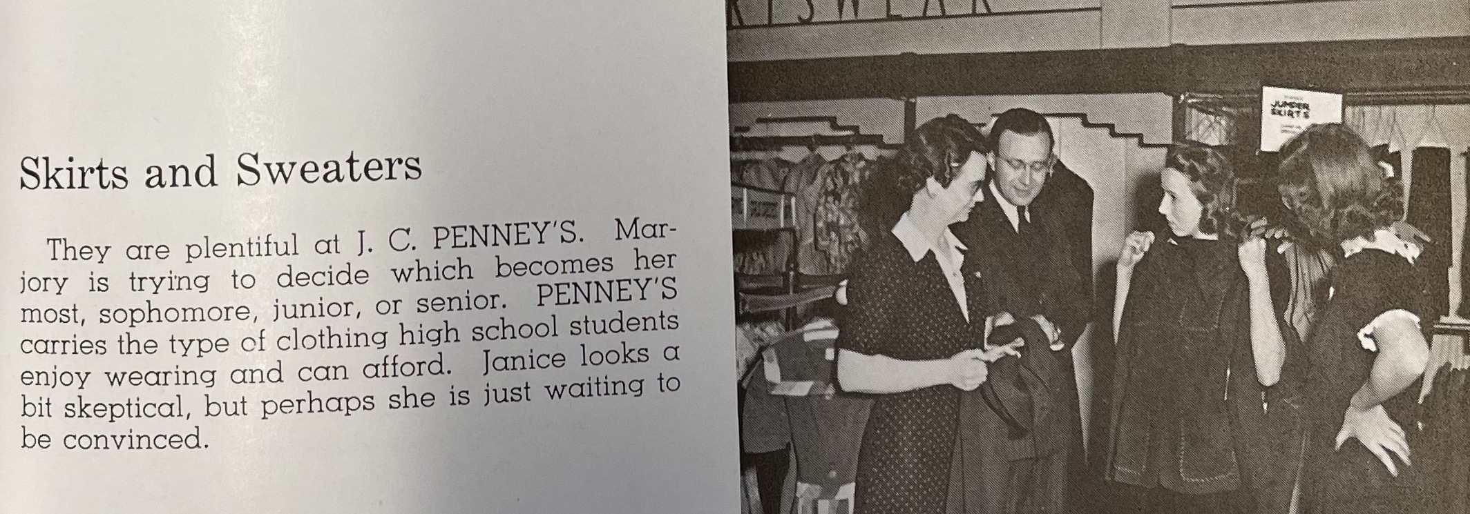
(Log: 1943)
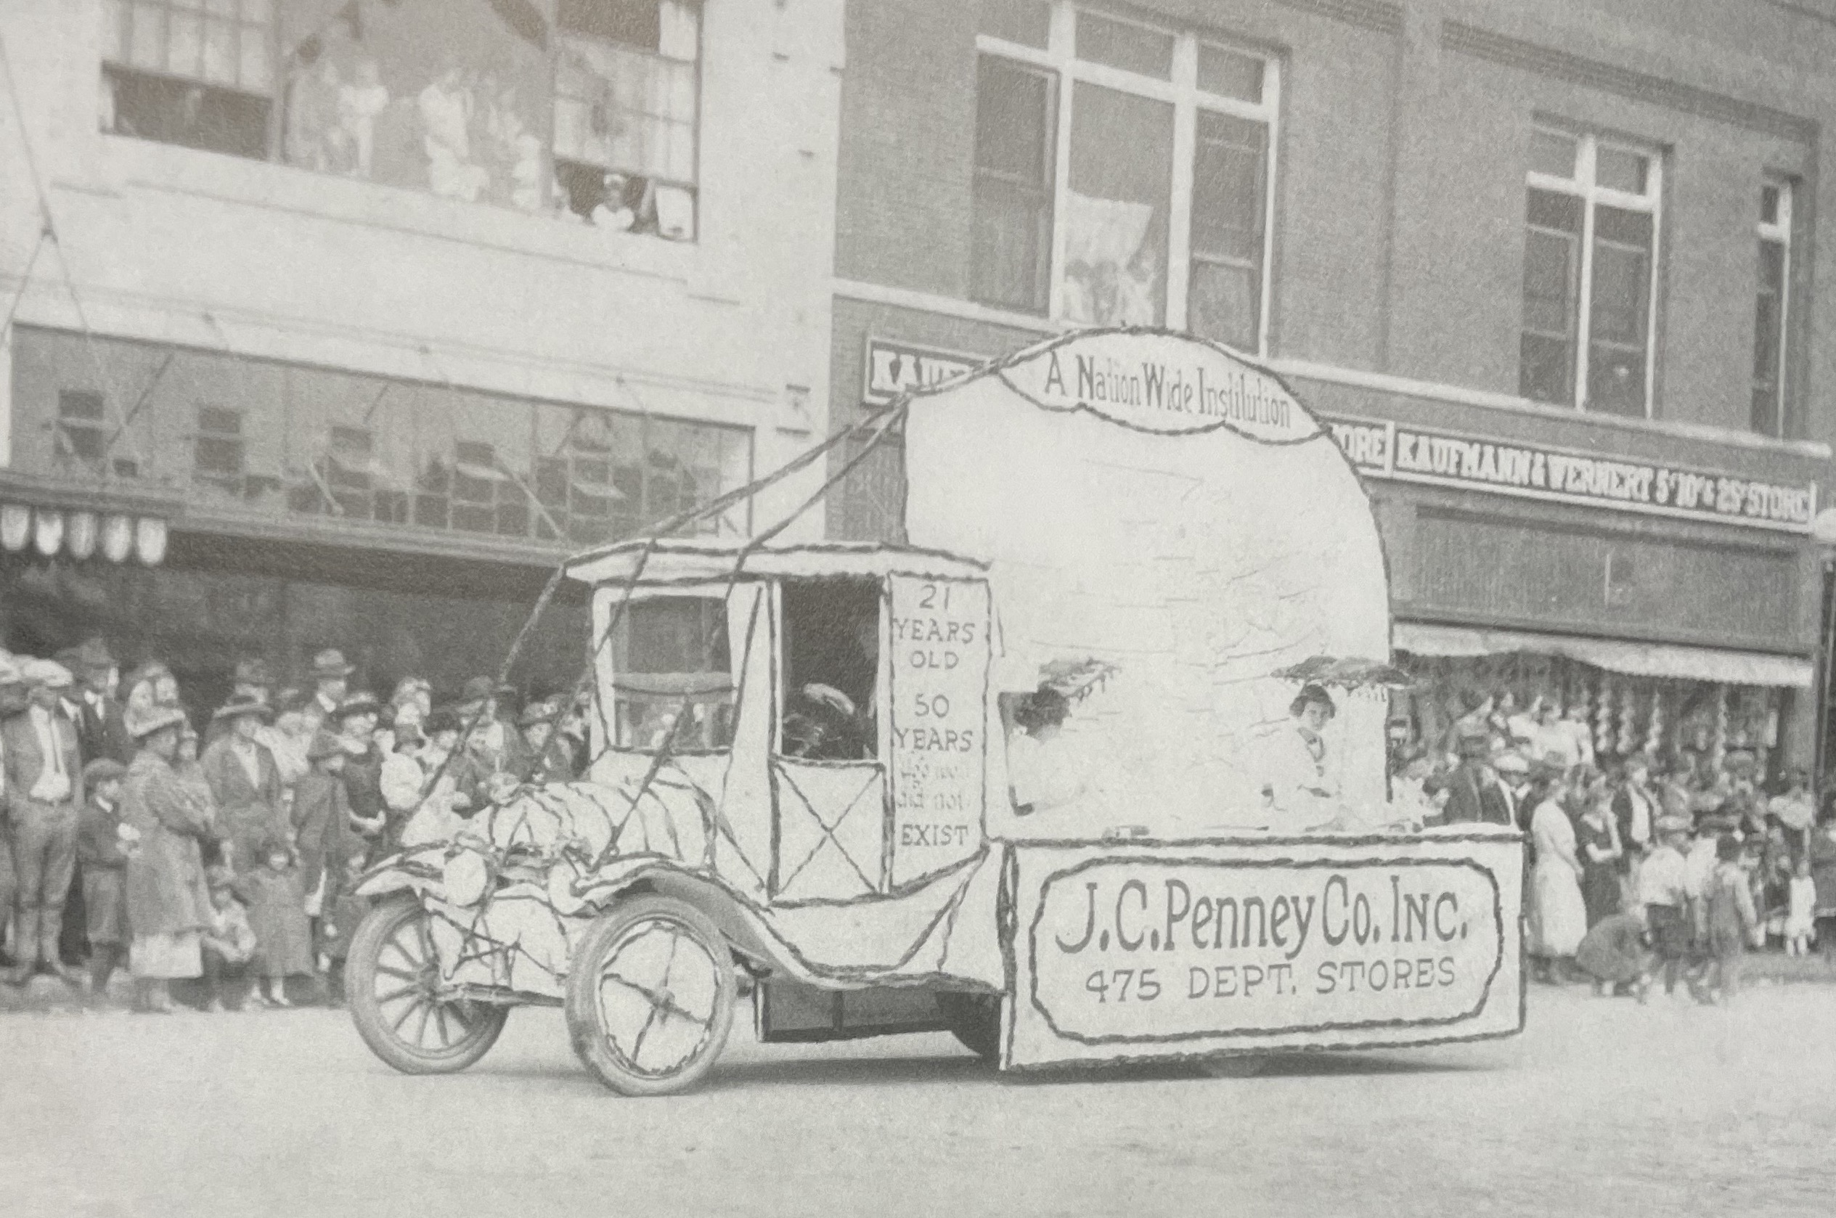
(Kearney Memories: 1923)

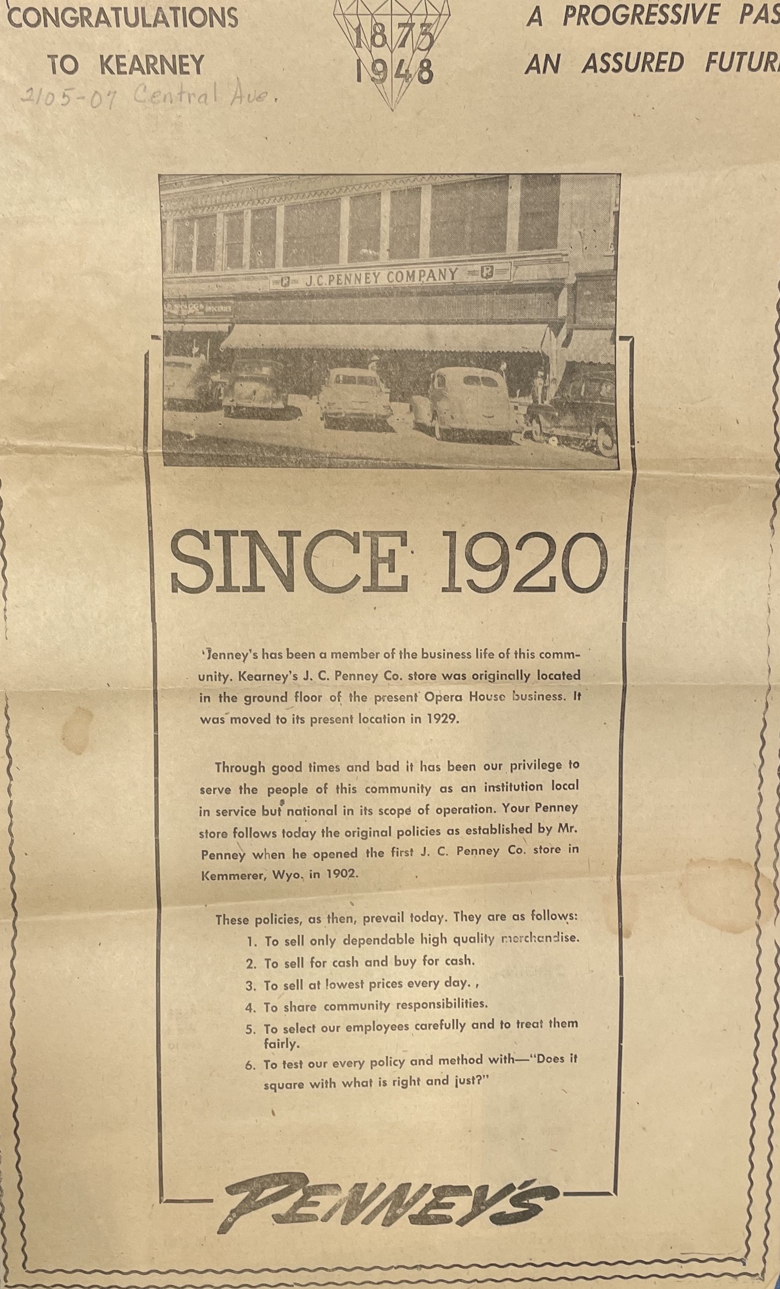
(Hub: 6/7/1948)

