The Platte Valley State Bank and Trust Company was located in Kearney, NE and opened in 1944. Some of its past presidents/CEOs include Joseph W. DeBord and Mark Sutko. The original building is today the location of KGFW. It eventually turned into the First National Bank in 2014. Its advertisement is located on the Kearney Area curtain.
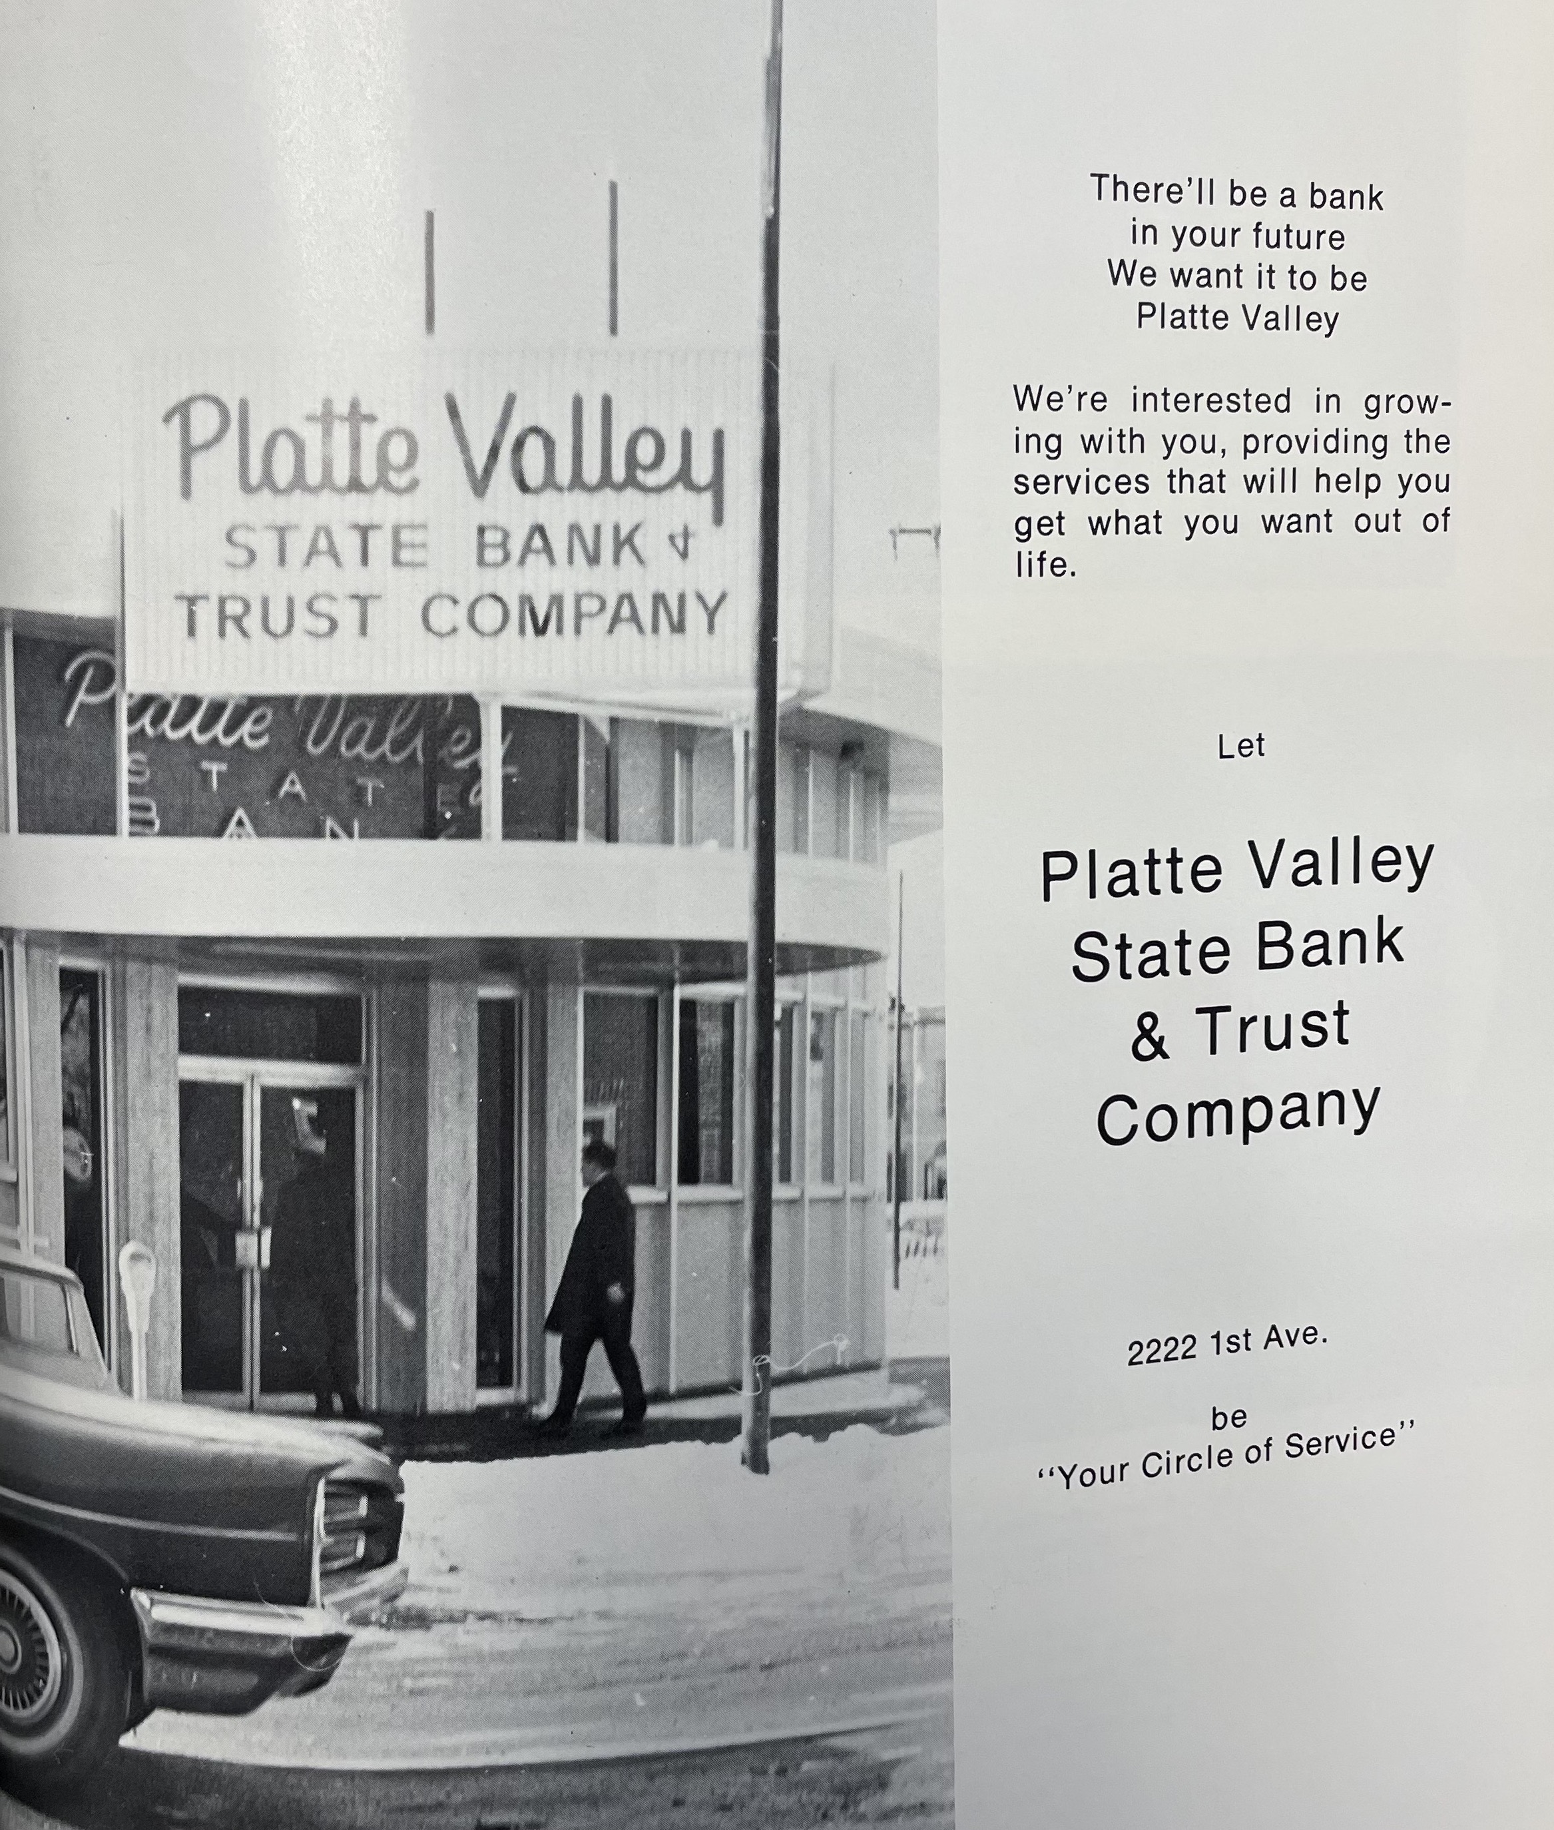
(Log: 1969)
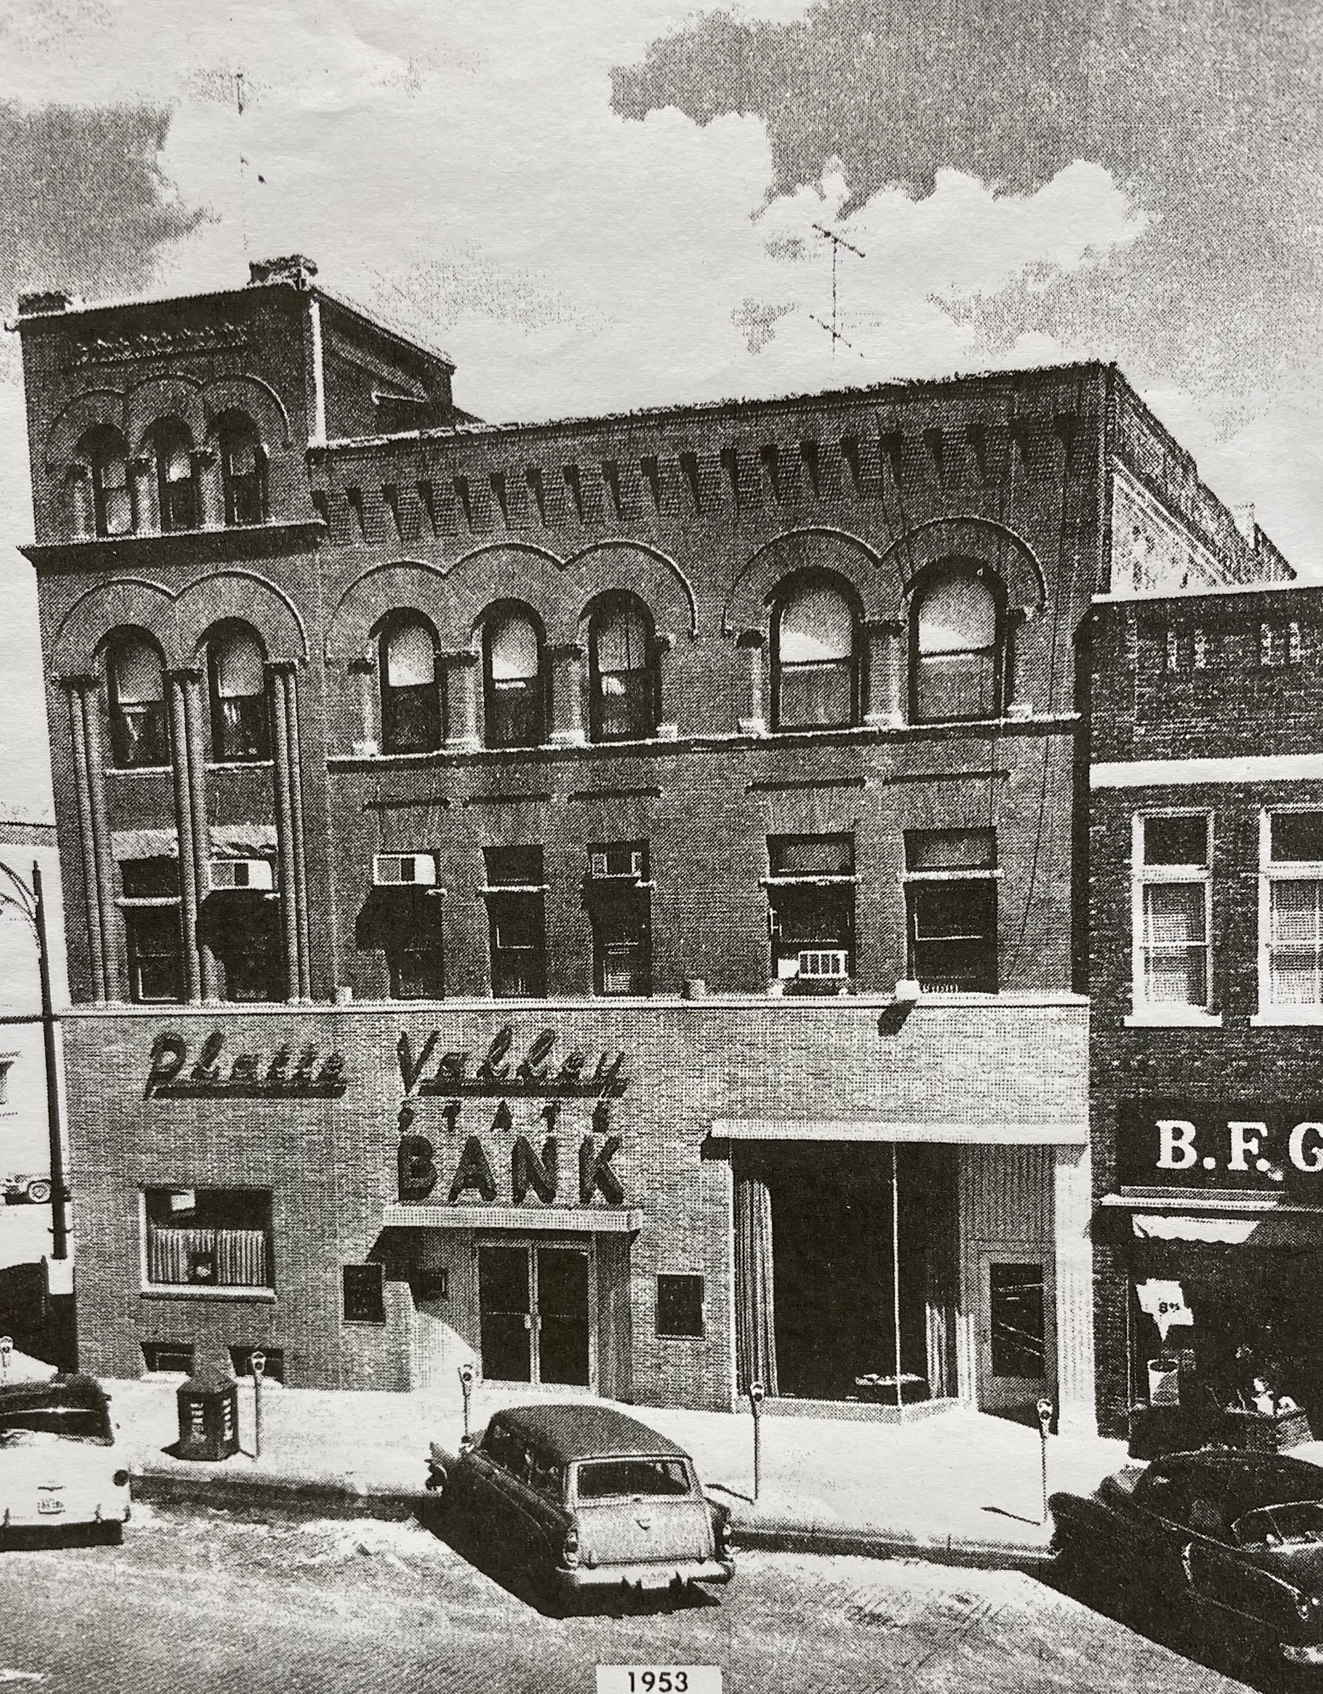
(Hub: 7/18/1963)

