Starting in 1910, Kearney Laundry and Dry Cleaning Works was located at 15 W 23rd St. The owner, George Downing came to Kearney in 1887 and opened his business in 1892 with a partner. His son, W.K. was born in 1907 and eventually came to own the business. Ironically, S. Cunningham (whom the current Cunningham’s Bar and Grill is named after), had the building made to house his newspaper business. When an economic recession hit in the early 1890s, the newspaper business failed, and the laundry works took over (Kearney Hub: 3/1/75). W.K. owned and operated the Laundry Works until the 1960s. Its’ advertisement appears on the Kearney Opera House Curtain.
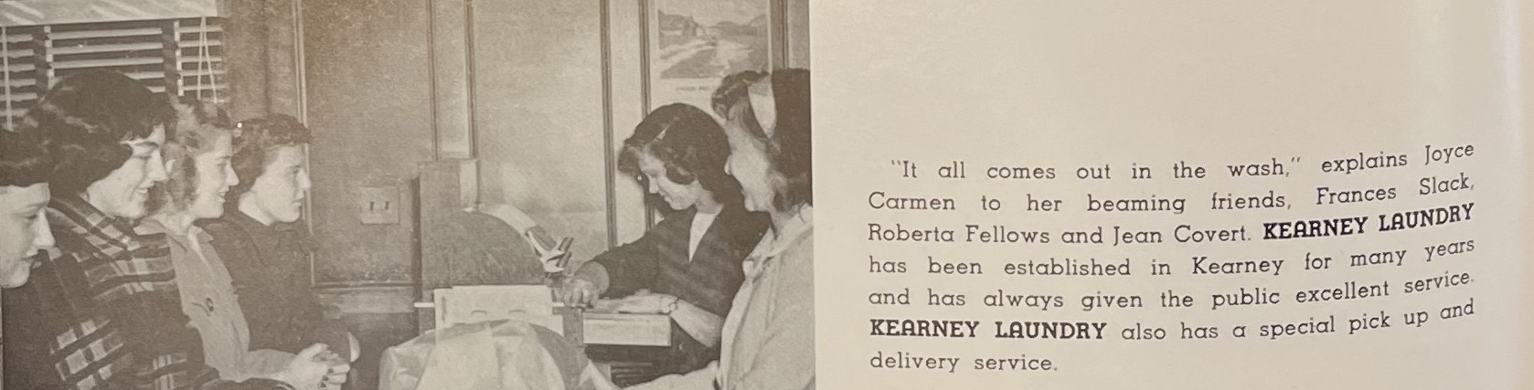
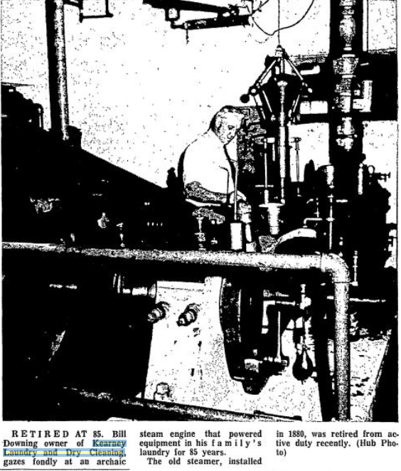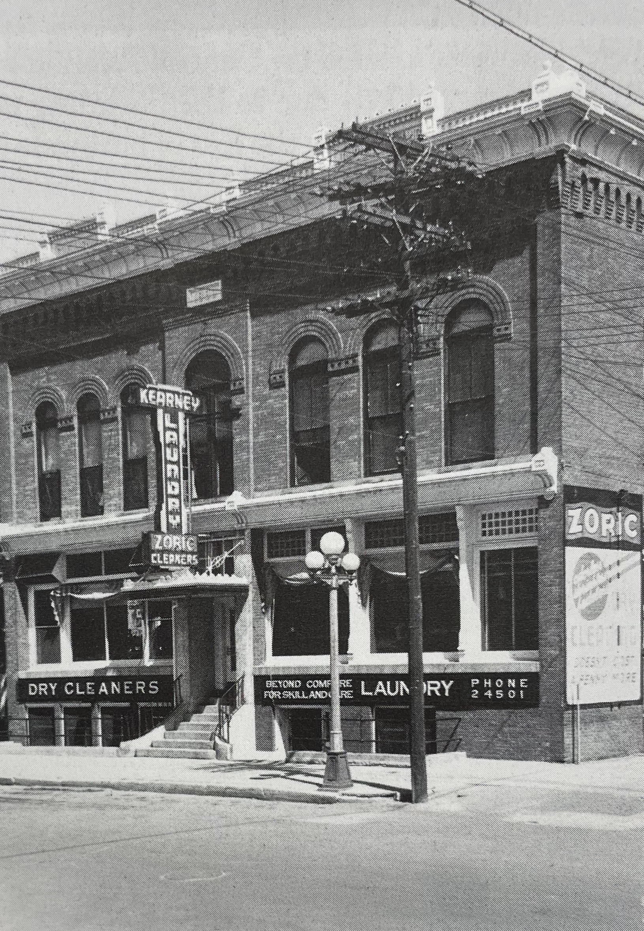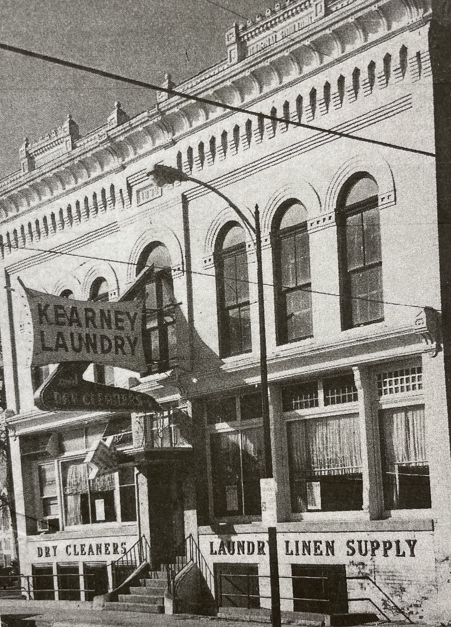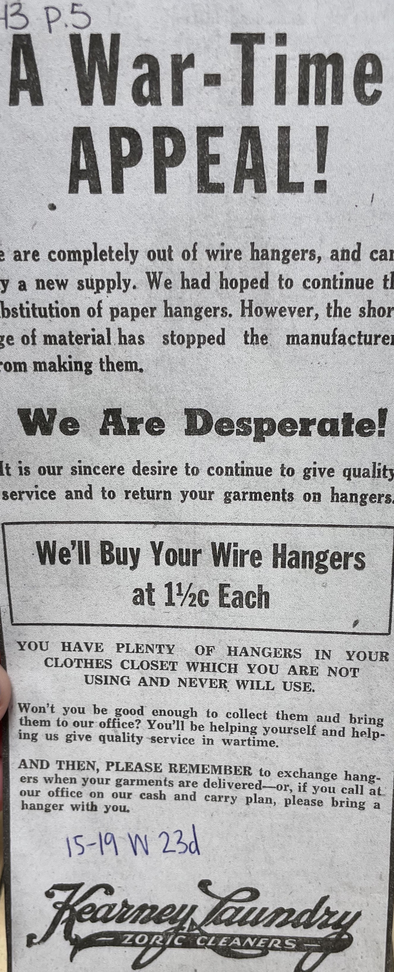

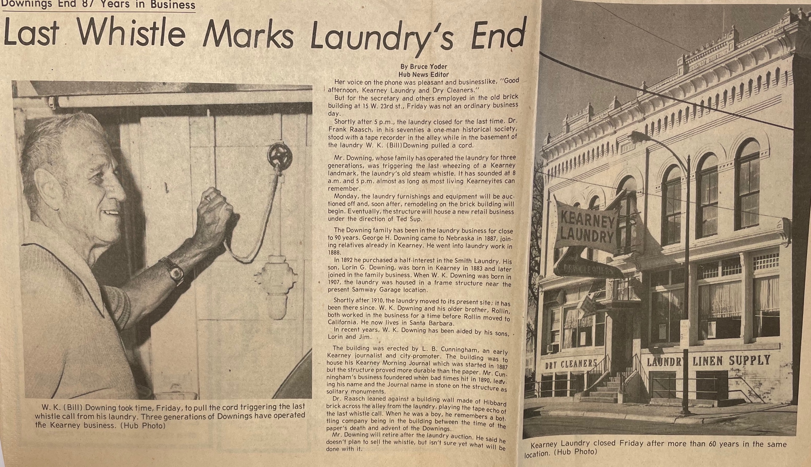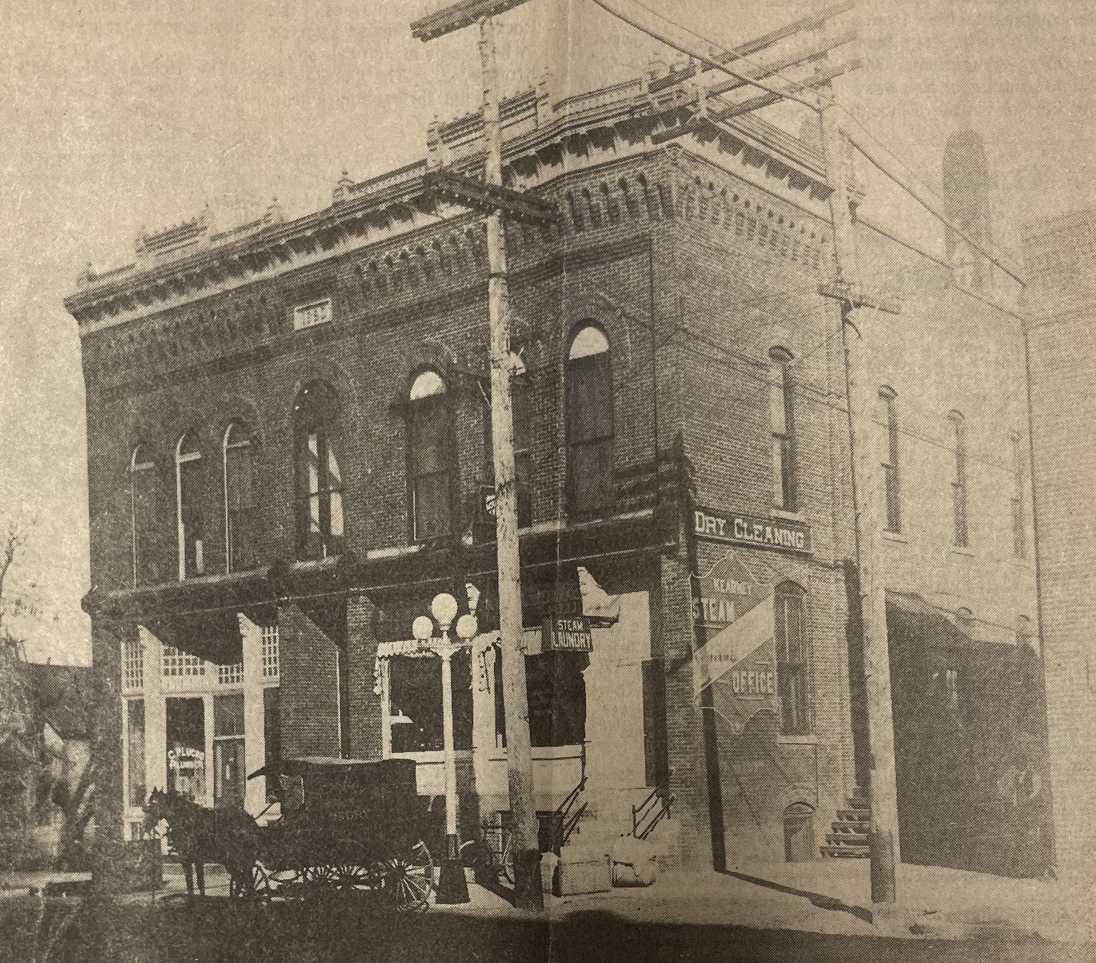
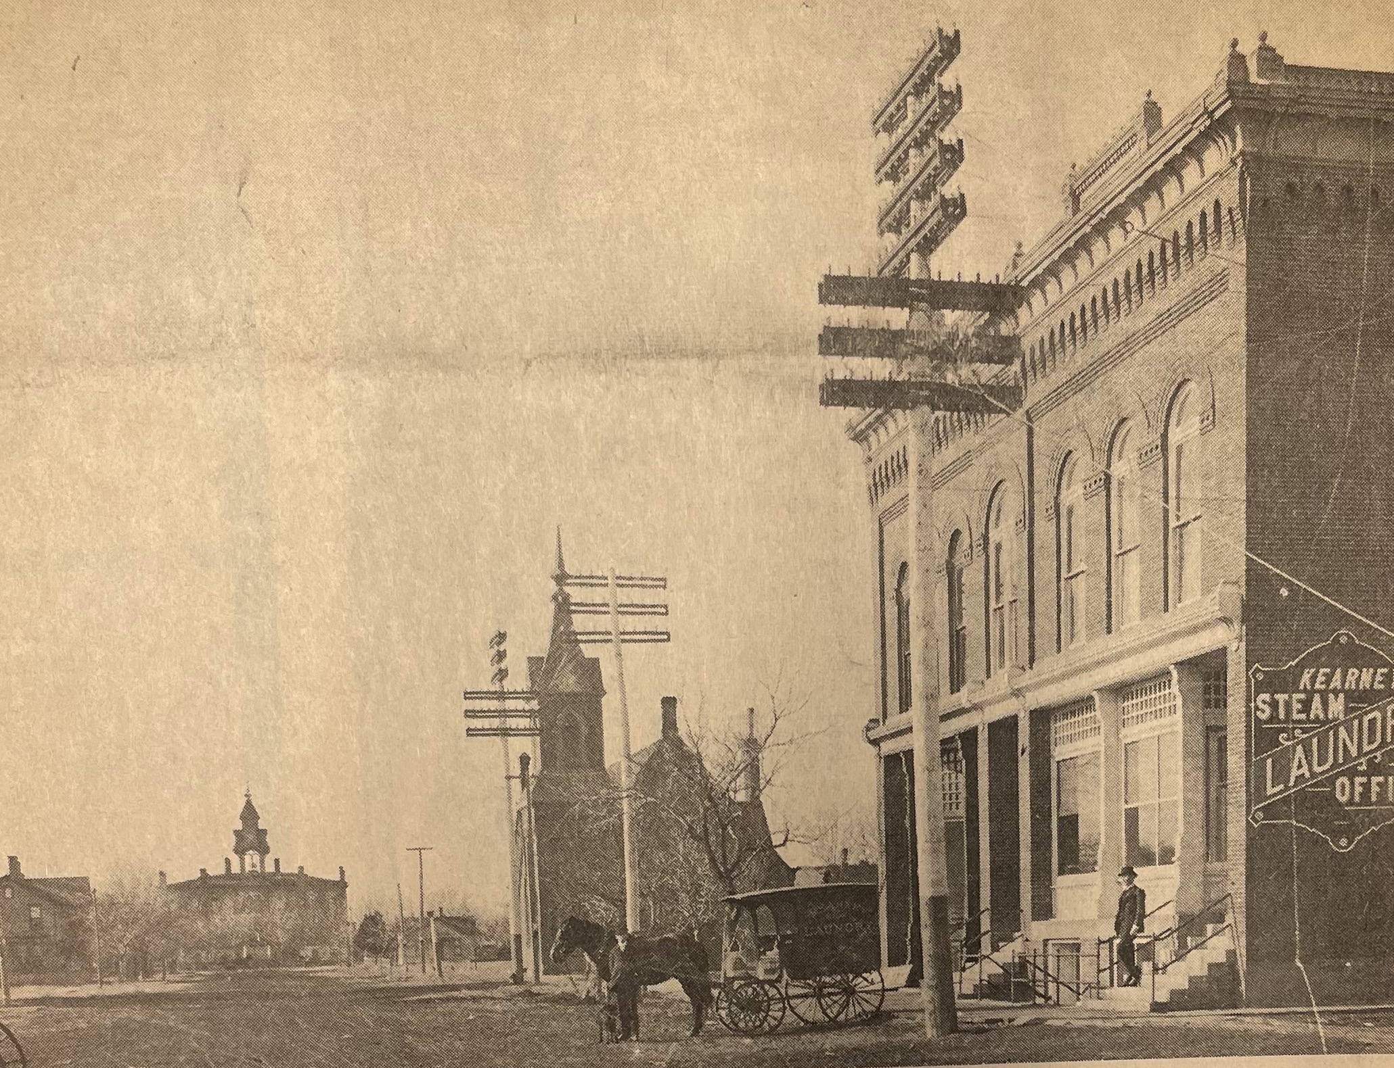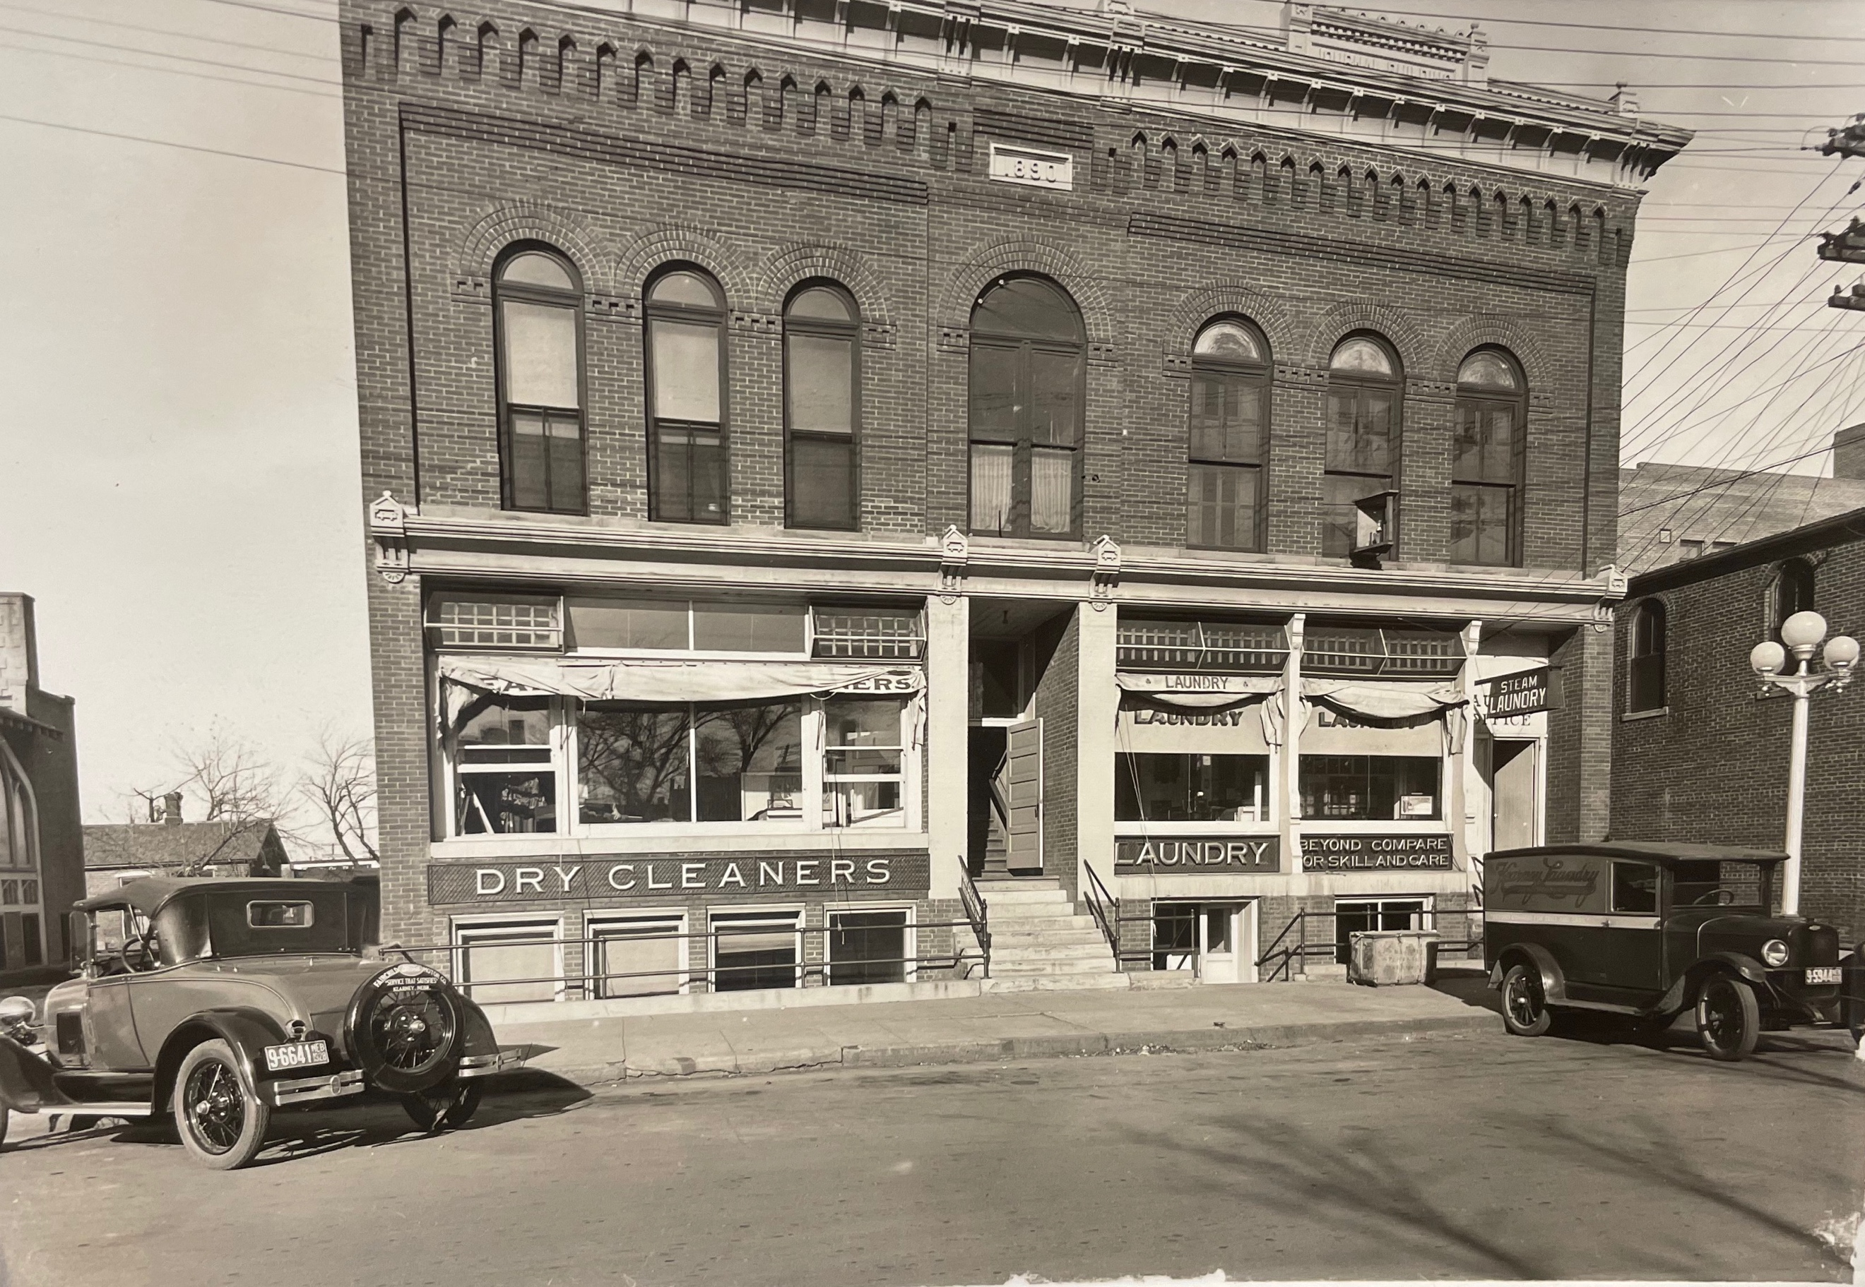
*Photos acquired from the Log: 1949 edition, Kearney’s Historic Homes (by Brian Whetstone, Jessie Harris and the BCHS), and the Kearney Hub.

