The Club House Stores were located in Kearney, NE. Originally owned by J.S. Saunders, by the 1930s the business took on the name of Frederickson Club House Cash Grocery (Hub: 11/26/1934). According to the Kearney Hub (1/31/1935) the stores were bought by Sam H. Cline (a previous meat cutter) and the Frederickson brothers; H.L. and H.E. That same year, it became a part of the Skaggs store chain (Hub: 9/17/35). Its advertisement can be seen on the World Theatre curtain.
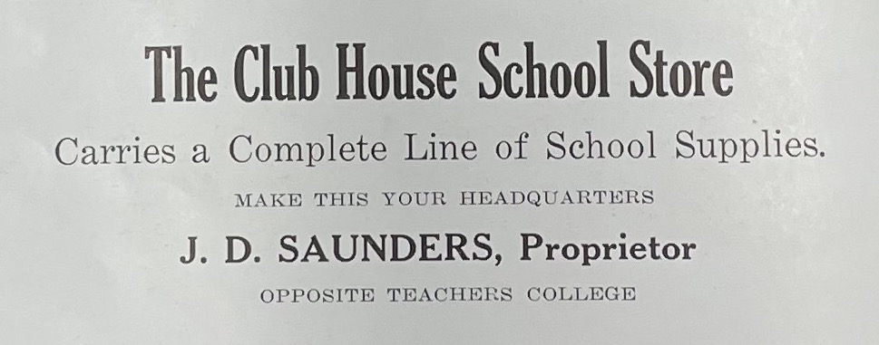
(Blue and Gold: 1923)

