The A.C. Killian Clothing Company was located in Kearney, NE. It was a prominent clothing store that could suit any occasion. Its advertisement is located on the World Theatre curtain.
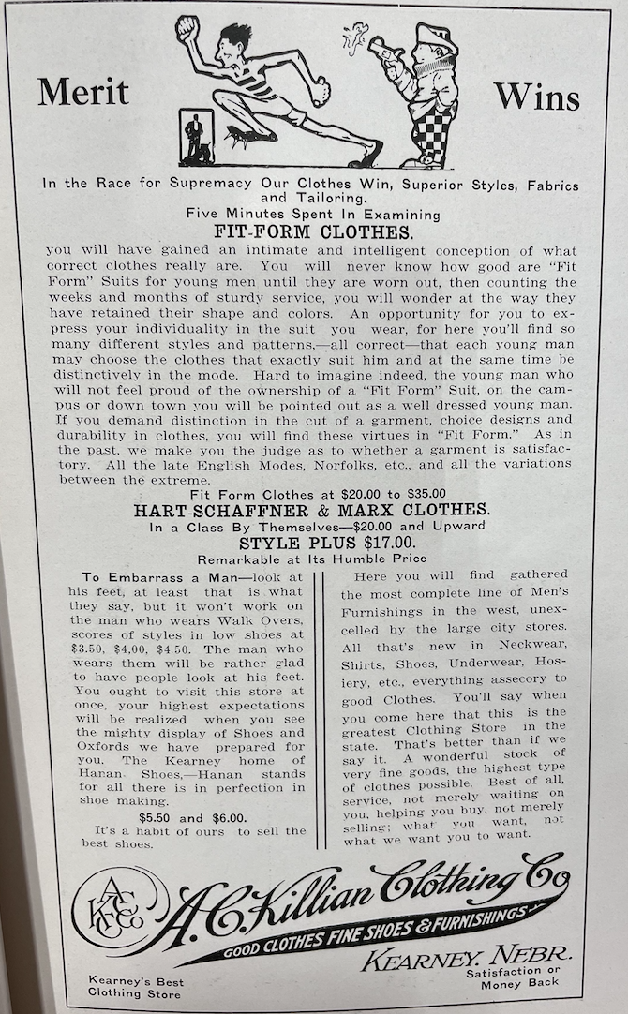
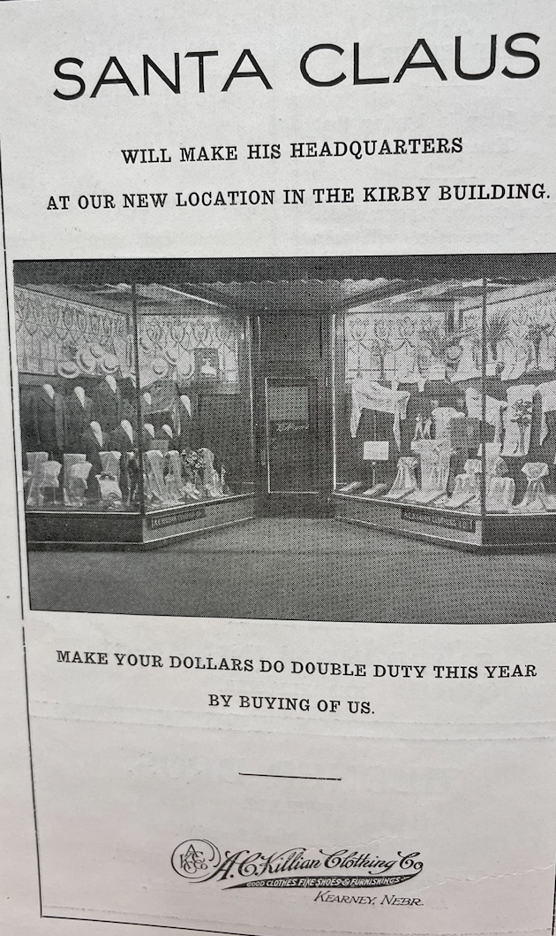
(Echo: 1914)

